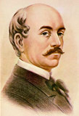
Vasile Alecsandri

Poet, playwright and politician of the 19th century

He was born on 21st July 1821 in Bacau, in the principality of Moldavia. He died on 22nd August 1890 in Mircesti, Romania.

He was the first Romanian writer who adhered to the European spirit of the century and to the intellectual movement without neglecting the Romanian traditions and customs.

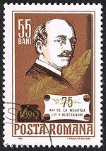
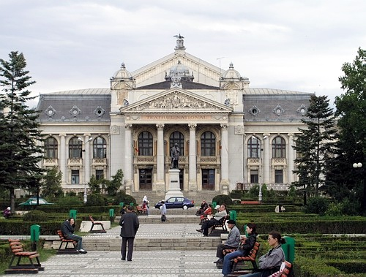
The writer had an important role in the creation and the evolution of the modern Rumanian State. Citizen and patriot, it was militant of foreground in the revolution of 1848 and during the union of the Romanian principalities (1859).
1827 - he studies in private in company of a teacher come from the area of Maramures.
1828 - his father, a rich person trade buys the field of Mircesti.
1828-1834 - he makes his first studies at Iasi with the boarding school “François Cuénim” with Mihail Kogalniceanu, who will become the Prime Minister of Romania.
1834 - in July he leaves for Paris.
1834-1839 - studies chemistry, medicine and law in Paris. He starts writing French poems.
1839 - Alecsandri leaves Paris for a long voyage in Italy at Florence, Rome and Venice. In December 1839 he returns to Iasi.
1840 - He has the debut in the literary magazine “Dacia literara” (“The Literary Dacia”) with the short story “Bouquetière of Florence”.


He becomes the director of the National Theatre in Iasi.
November 1840 - he creates his first play, “Farmazonul DIN Harlau” (“The Wizard of Harlau”).
June 1841 - he publishes three French poems (in the magazine “Spicuitorul moldo-roman”). During the summer he wanders trough the mountains of Moldavia, where he discovers the beauty of the songs and the popular poems which become his principal source of inspiration.
1844-1845 - his plays become successful for the public.

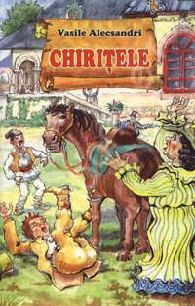
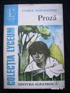
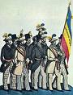
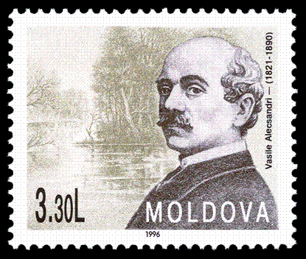
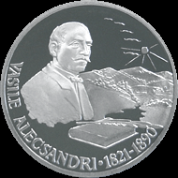
He starts his political activity as a diplomatic which imposes him as an European personality.
1848 - Alecsandri leaves for Cernauti, in Bucovine. There he tries alongs with his friends to organize a revolutionary movement with the aim changing the reigning of prince Sturza and to proclaim the Union of the Romanian Principalities.
He becomes the secretary of the revolutionary committee of Cernauti. He leaves Bucovine for Paris in order to gain the leaders of the political life and French public opinion to support the cause of the Union of the Romanian principalities by conducting a campaign in the Parisian press.
1849 - from Paris he starts to collaborate with the magazine “Bucovina” of Cernauti where he publishes original poems, popular poems and the essay “The Romanian and their poetry”.
In Paris he gests in contact with the exiled Romanian revolutionists, particularly with Nicolae Balcescu, recently arrived in France after having escaped from the Austrians at the time of the failure of the Revolution in Transylvania.
1852 - his first comedy “Chirita in provincie” has a great success.
1853 - Alecsandri publishes in Paris his first volume of folk-inspired poems (“Doine ;I lacramioare”. He travels to Toulouse, Marseilles, Gibraltar, Tangier, Tétouan, Seville, Grenade, Madrid, it returns to Paris in diligence with ¨Prosper Merimé with whom he binds a true friendship.
He sets out again on a journey to London then to Belgium and Germany.
1859 - Alecsandri is named Foreign Minister of Wallachia.

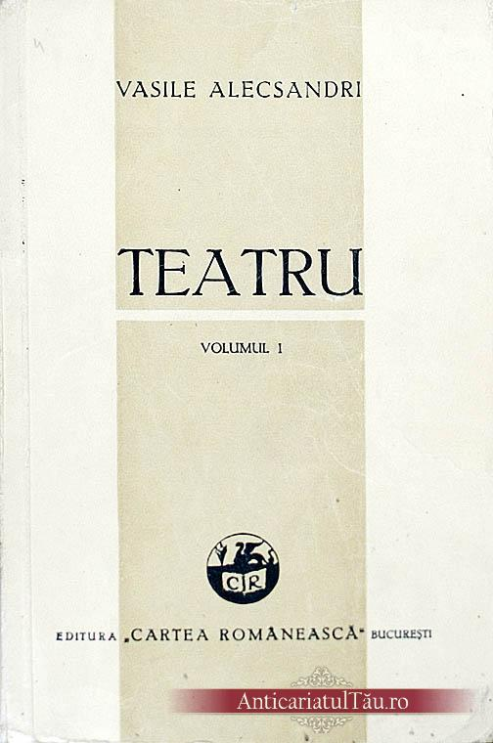
He is in charge of the Romanian Diplomatic Agency of Paris (until May 1862).
1863 - he accomplishes with Napoleon III a diplomatic mission entrusted by prince Cuza. Alecsandri returnes the visit to Napoleon III and to the Foreign Minister (Thouvenel).
In Italy he meets King Victor-Emmanuel.
His diplomatic activity is very intense; he often goes to Cernauti, his beloved place, where he is celebrated as writer.
1867 - he leaves for Paris and meets his friend Al.Cuza, the former reigning prince of Romania, dethroned in February 1866 and visits the World Fair.
He is named member of the Academic Company which will become the Romanian Academy thereafter.
Traveling between Paris and Moldavia, he often returns in Cernauti and writes and publishes the majority of his dramatic and political works.
After the war of 1877 one proposes to him an extraordinary diplomatic mission in Berlin, then the post of Minister of Romania in Rome, but he refuses.
His poem “The Song of the Latin People” gets the first price at the contest of poetry of Montpellier.
1885 - he is named minister of Romania in France.
1887 - he receives the French Academic Palms.
1899 - he returns in Mircesti, at his domain in Moldavia.

1890 - Alecsandri, as he was very sick refuses to be elected president of the Romanian Academy and dies on August 22 in Romania.


