Task 1 : Find a word to complete the blanks
Industrial maintenance ¹ ….………………..….. a lot of different activities, for instance working on industrial digital computers also known as programmable logic controllers (PLCs) or on variable ² ….………………drives. It may be the perfect job for you if you know how to use different gauges, how to take different
³ ….………………..….. using manometers, micron metres and are capable of hooking up to furnaces and air-conditioning ⁴ ….………………..…...
Being a maintenance ⁵ ….………………..….. means that you will do something different every day provided you know all the ⁶….………………..….. that comprise a machine, all the way from basic relays to wiring
⁷ ….………………..….. to the most advanced controls. It is true that it is a difficult field to ⁸ ….……………….. for but there is a lot of opportunity as the job market for industrial maintenance is exploding right now. With a little bit of ⁹ ….………………..….., a maintenance technician can expect to make between 20 and 30 dollars hourly, which is a ¹⁰ ….………………..….. you can support a family with. With a little bit of overtime, your wage can increase significantly.
Task 2 : Which of the words in bold do the follow pictures correspond to?
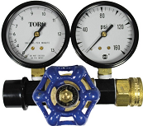 | 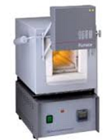 | 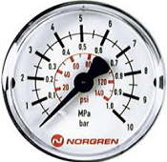 | 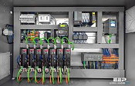 | 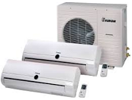

Task 1 : Find a word to complete the blanks
Industrial maintenance ¹ ….………………..….. a lot of different activities, for instance working on industrial digital computers also known as programmable logic controllers (PLCs) or on variable ² ….………………drives. It may be the perfect job for you if you know how to use different gauges, how to take different
³ ….………………..….. using manometers, micron metres and are capable of hooking up to furnaces and air-conditioning ⁴ ….………………..…...
Being a maintenance ⁵ ….………………..….. means that you will do something different every day provided you know all the ⁶….………………..….. that comprise a machine, all the way from basic relays to wiring
⁷ ….………………..….. to the most advanced controls. It is true that it is a difficult field to ⁸ ….……………….. for but there is a lot of opportunity as the job market for industrial maintenance is exploding right now. With a little bit of ⁹ ….………………..….., a maintenance technician can expect to make between 20 and 30 dollars hourly, which is a ¹⁰ ….………………..….. you can support a family with. With a little bit of overtime, your wage can increase significantly.
Task 2 : Which of the words in bold do the follow pictures correspond to?

Task 1 : Find a word to complete the blanks
Industrial maintenance ¹ ….………………..….. a lot of different activities, for instance working on industrial digital computers also known as programmable logic controllers (PLCs) or on variable ² ….………………drives. It may be the perfect job for you if you know how to use different gauges, how to take different
³ ….………………..….. using manometers, micron metres and are capable of hooking up to furnaces and air-conditioning ⁴ ….………………..…...
Being a maintenance ⁵ ….………………..….. means that you will do something different every day provided you know all the ⁶….………………..….. that comprise a machine, all the way from basic relays to wiring
⁷ ….………………..….. to the most advanced controls. It is true that it is a difficult field to ⁸ ….……………….. for but there is a lot of opportunity as the job market for industrial maintenance is exploding right now. With a little bit of ⁹ ….………………..….., a maintenance technician can expect to make between 20 and 30 dollars hourly, which is a ¹⁰ ….………………..….. you can support a family with. With a little bit of overtime, your wage can increase significantly.
Task 2 : Which of the words in bold do the follow pictures correspond to?

