1. Read the following extract

1  5  10  15 | 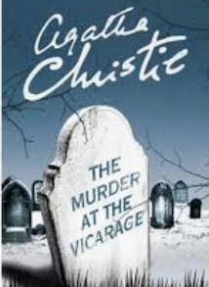  Griselda Clement, the vicar’s wife, is organising a tea party at the vicarage of Saint Mary Mead. She and her husband are discussing who they are going to invite.  “My duty”, said Griselda, “my duty as the Vicaress. Tea and scandal at four-thirty.”  “Who’s coming?”  Griselda ticked them off¹ on the fingers with a glow of virtue on her face.  “Mrs Price Ridley, Miss Whetherby, Miss Hartwell, and that terrible Miss Marple.  “I rather like Miss Marple,” I said. “She has a least, a sense of humour.” […]  “She is the worst cat in the illage,” said Griselda “And she always knows every single thing that happens – and draws the worst interference from it.  I wonder what we shall have for tea,” said Griselda, seating herself on my writing-table. “Doctor Stone and Miss Cram, I suppose, and perhaps Mrs Lestrange. By the way, I called on her yesterday, but she was out. Yes, I’m sure we shall have Mrs Lestrange for tea. It’s so mysterious, isn’t it, her arriving like this and taking a house down here, and hardly ever going outside it? Makes one think of detective stories. You know - ‘Who was she, the mysterious woman with the pale, beautiful face? What was her past story? Nobody knew. There was something faintly² sinister about her.’ I believe Dr Haydock knows something about her.”  “You read too many detective stories, Griselda,” I observed midly.  Agatha Christie, “Murder at the Vicarage” (1930)  1. Compter un à un 2. légèrement

a. Find the vicaress’s favourite activity. Why does she say ‘My duty’ (l. 1)
b. Focus on the enumeration of people. Why are they likely to to gossip about Miss Marple and Miss Lestrange?
c. Why is the newcomer’s family name (Lestrange) particularly relevant?
d. “You read too many detective stories” (l. 15). What opinion does the narrator have of Griselda?
e. Look at the map of Saint Mary Mead and say why Miss Marple’s house is well-located:
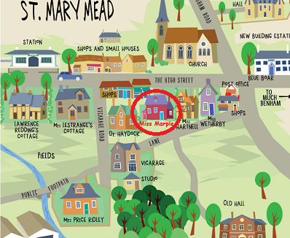

f.
a) Identify the type of narration : a description – a monologue – a dialogue
b) Who is speaking?
c) Pick out at least four dialogue tags.
…………………………… …………………………… …………………………… ……………………………

What tense is used? Why?

g. Miss Marple is a fictional old lady who lives in the village of Saint Mary Mead and spends her time solving crimes as an amateur detective. Do you know any other famous English detectives? You may look for fictional characters from novels, films or TV series.

