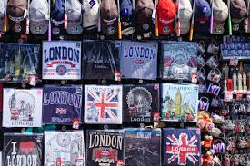
Souvenirs

The word ‘souvenir’ comes from the French word meaning remembrance or memory. Souvenirs are often keepsakes, mementos or any item that tourists buy for the memories they bring back. They can also be gifts and novelties with a strong historical, cultural or traditional meaning, brought back home for friends, relatives and work colleagues.
They can be bought in specialized stores near tourist monuments, in museums, resorts, train stations or airports. They often have some kind of outdated, timeless or kitschy aesthetic as they combine different cliché images about a country, its prominent figures or symbols.

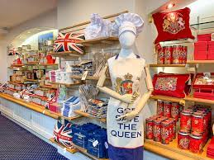
You are commissioned to create your own souvenir as a reminder of the events the British monarch has been going through. You will work on the aesthetic of your souvenir to keep it in line with the existing objects.
Start from a trend board on A3-sized paper on which you will list and analyze briefly different souvenirs from the UK. Based on this preliminary step, develop on search boards three leading ideas revolving around one of the following axes : memorabilia commemorating the life and reign of Queen Elizabeth II or memorabilia celebrating the reign of the new King. Don’t forget to take into account all the characteristics you highlighted while building your trend board.
Finally, on an A4-sized presentation board, you will fully exploit one of your previous axes. Present your souvenir by giving all its characteristics, the link with the person it pays tribute to and that with its final user(s).
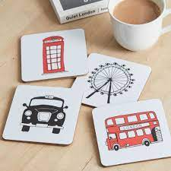
List of souvenirs or memorabilia you may choose from (one item only):
- cups / mugs
- plates / coasters
- key-rings
- snow globes

Axes :
- Memorabilia commemorating the life and reign of Queen Elizabeth II.
- Memorabilia celebrating the ascension of King Charles III to the British throne

Schedule:

• _ _ _ _ / _ _ _ _ _ / _ _ _ _ : creation of the trend board
- Oral comprehension
- Bill of specifications
- preliminary phase & trend board

• _ _ _ _ / _ _ _ _ _ / _ _ _ _ : creation of the search boards
- Lexical search
- Secondary phase
>The trend board with all the characteristics of your souvenir will have to be completed during the mid-term holiday.

• _ _ _ _ / _ _ _ _ _ / _ _ _ _ : identifying and developing the relevant axes
- completion of the search boards
- Vocabulary exercises about the characteristics to develop
- Selection of the final axis to develop & creation the final trend board

Due dates:

_ _ _ _ / _ _ _ _ _ / _ _ _ _ (end of the lesson):
- a trend board listing typical souvenirs and their characteristics
_ _ _ _ / _ _ _ _ _ / _ _ _ _ :
- Three A4-sized trend boards listing the different proposals for your commemorative or collectable memorabilia
- An A4-sized presentation board fully developing one of the three axes.
November 28th (end of the lesson):
- Completion of the presentation board

Assessment criteria:

A3-sized trend board :
- relevance and graphic qualities of the selected images / illustrations
- layout (composition and annotations)
- accuracy of the vocabulary

A4-sized search boards ;
- Originality and relevance of the axes developed.
- Creativity in keeping with the topic
- Adequacy between the proposals and the defined constraints as defined on the trend board.
- Graphic and plastic quality of the communication means
- Accuracy and relevance of the written description

Final A4-sized presentation board:
- Relevance and efficiency of the chosen axis
- Care and quality in the presentation of the final proposal
- Accuracy and relevance of the written explanations

Objectives

- Using the relevant vocabulary of souvenirs and memorabilia
- Collecting and gathering useful information
- being able to identify, develop and exploit axes / a proposal / leading idea
- Presenting a final proposal / leading idea both graphically and in writing

