What did racial segregation mean ?

1.Compare the two maps in your notebook.
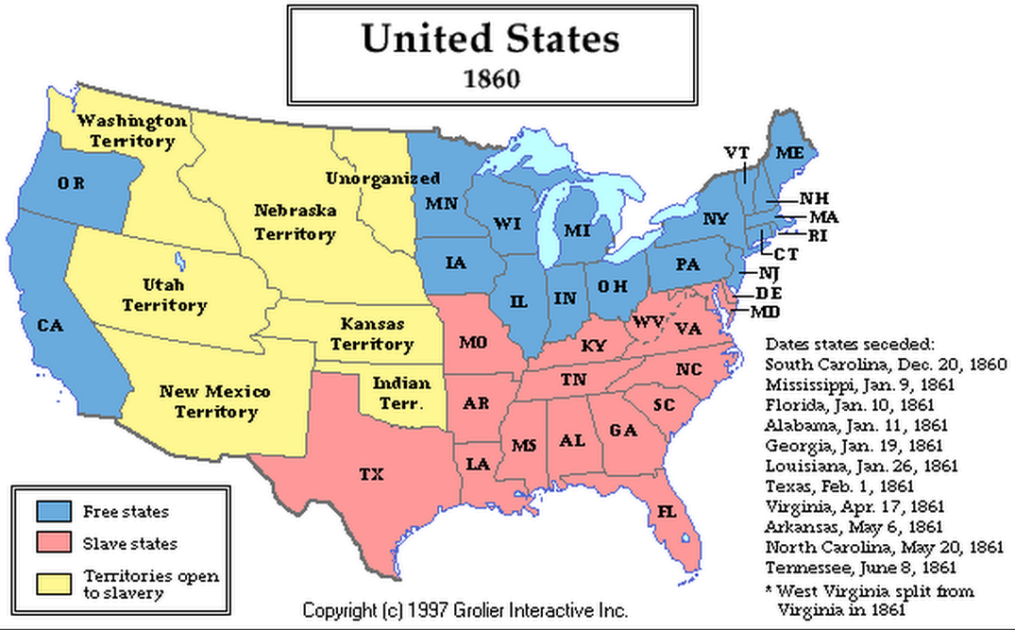

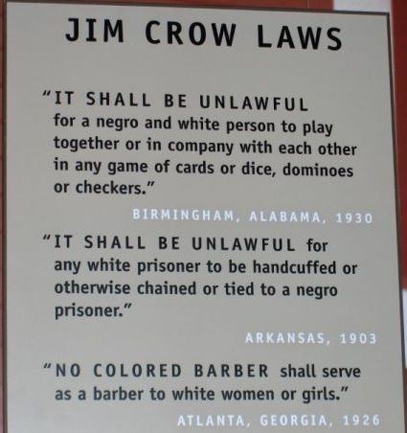
Let's remember : slavery was abolished in ..............
Yet, the fight is not over.

The Jim Crow Laws ( lasted from 1876 to 1965 )
Describe the picture in your notebook.

Voc : a sink

Atlanta, Georgia – in the middle of the twentieth century.

