WRITING A BIOGRAPHY OF G.A.ESCOFFIER

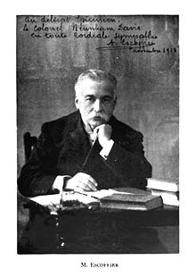

1.Put the following headlines at the right place to focus the 3 main stages in Escoffier’s career
Escoffier’s contribution- Early life- From Nice to Paris and London

1.
Name | Georges Auguste Escoffier
Profession | A French chef, restaurateur and culinary writer
Date of birth | 28 October 1846
Place of birth | The village Villeneuve-Loubet,near Nice
2.
In 1859 | Apprentice at his uncle's restaurant
In 1865 | Work at Le Petit Moulin Rouge restaurant in Paris.
During the Franco-Prussian war in 1870 | Join the army as a chef and develop the technique of canning food
In1888 | Meet Cesar Ritz, a Swiss hotelier.  The two are hired by a wealthy british businessman Richard D'Oyly Carte.  They start to work at the luxury establishment, the Savoy hotel in London
In 1893 | Create many dishes.  Invent the pêche Melba
In 1898 | César and Escoffier both leave the Savoy Hotel. People say they are responsible for the disappearance of £3400 of wine and spirits.  They establish the Paris Ritz
In 1899 | They run the new Carlton Hotel in London
3.
Escoffier’s achievement | One of the codifiers of French haute cuisine.  Simplify and modernize Auguste Carême's elaborate and ornate style  Is Referred to by the French press as king of chefs and chef of kings

