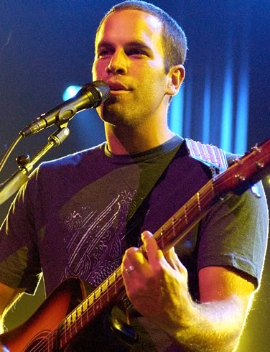
Sing Along activity

Better Together By Jack Johnson

1. Listen to the lyrics and fill in the space with the correct word

There's no ………………….………. of words
I could put on the back of a ………………………,
No ……………….. that I could sing
But I can try for your …………………,
Our ……………………., and they are made out of real …………………….,
Like a ……………………… of photographs,
With sepiatone loving,
Love is the ………………………..
At least for most of the ………………………… in my heart
Like ………… are we here? And ………….. do we go?
And …………… come it's so hard?
It's not always ………………..,
And sometimes life can be deceiving,
I'll tell you one thing, its always ………….……. when we're together

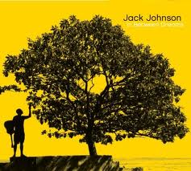

[Chorus:]

MMM, it's always better when we're together
Yeah, we'll look at the stars when we're together
Well, it's always better when we're together
Yeah, it's always better when we're together

2. Match the lines with the words that follow.

A. And all of these moments ____ | 1. Too many things I have to do,
B. But I know that they'll be gone, ____ | 2. Or places we got to be
C. And brings new things, ____ | 3. Just me and you
D. That they'll be gone too, ____ | 4. I was somewhere in-between
E. But if all of these dreams might find their way ____ | 5. Just might find their way into my dreams tonight
F. I'll be under the impression, ____ | 6. When the morning light sings
G. With only two, ____ | 7. But tomorrow night you see
H. Not so many things we got to do, ____ | 8. Into my day to day scene
I. We'll sit beneath the mango tree now ____

[Chorus]

3. Put the lines in order from 1-9

____ And there is no combination of words I could say
____ You look so pretty sleeping next to me
____ I believe in memories
____ We're better together
____ But there is not enough time,
____ Hey now, and when, I wake up,
____ But I will still tell you one thing,
____ And there is no, no song I could sing
____ They look so, so pretty when I sleep

