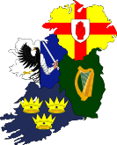
GROUP 2 : SOME HISTORICAL FACTS ABOUT IRELAND
Complete the sentences with the correct verbs given under each photo.

3200 BC | Newgrange ____________________ built during the Neolithic period.  So Newgrange is older than Stonehenge or the Egyptian pyramids!
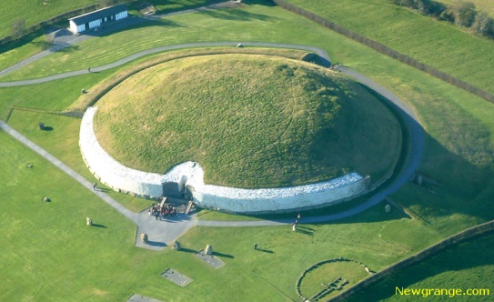
BE
456 | Saint Patrick ____________________ the Irish to Catholicism.  Saint Patrick ____________________ patron saint of Ireland.  The Irish ____________________ many monasteries.
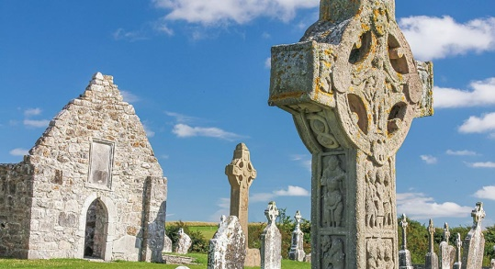
BUILD / BECOME / CONVERT
1171 | Henry II ____________________ in Dublin in 1171.  The Anglo Normans ____________________ around Dublin.  The Normans ____________________ a lot of castles, roads and ports  all over Ireland.
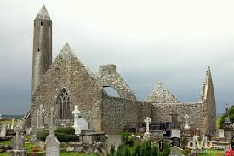
BUILD / SETTLE / SET FOOT
16th Century | Ireland ____________________ England’s first colony under the Tudors.  English Protestant settlers __________________ rich lands in the North.  Irish Catholics ____________________ of their land.  The native Irish ____________________ hostile towards England.
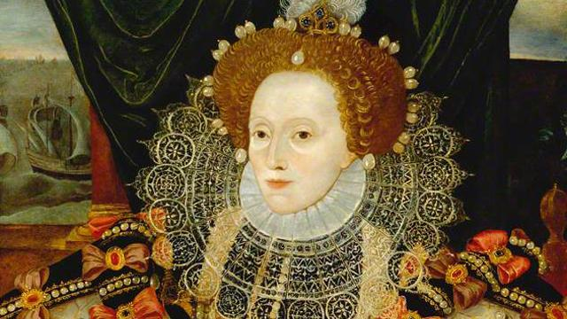
BE DISPOSSESSED / BE GIVEN / BECOME / BECOME
1649 | Cromwell crushed the Irish Catholics.  Catholics __________ forbidden to go to Catholic schools.  Catholics __________ treated as second class citizens.  Thousands of Irish __________ sold as slaves to the West Indies.
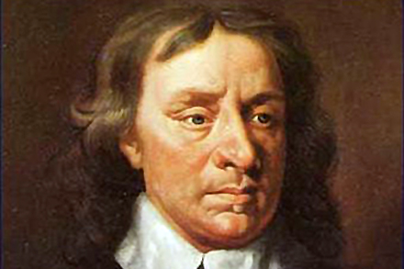
BE (x3)
1846-1849 | The potato crop failed for 3 consecutive years (the potato was the only source of food for the Irish peasants).  There __________ a Great Famine.  20% of the population __________ to the USA.  One million people __________ of starvation.
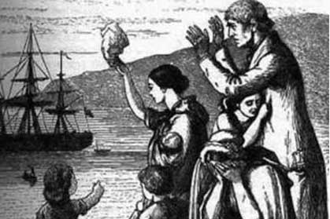
BE / EMIGRATE / DIE
1916 | The English sent troops to repress the Easter Rising (the rebellion of republicans fighting in Dublin for an independent Irish Republic).  15 republican leaders _____________________ by the English.  These leaders ____________________ heroes and martyrs.  The idea of an independent Ireland __________________ by many Irish.
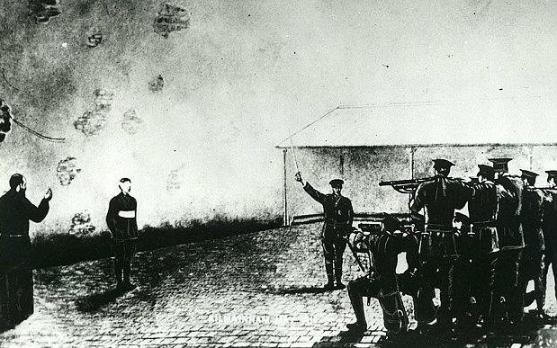
BE EXECUTED / BE SUPPORTED / BECOME
1921 | Southern Ireland became an independent nation.  But Ireland _____________________ into two parts: Northern Ireland  (Ulster) and the Republic of Ireland (Eire).  Southern Ireland ___________________ the Republic of Ireland in 1949.  The Republic of Ireland _____________________ the European Community in 1972.
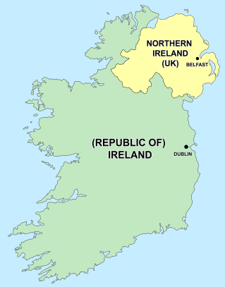

BE DECLARED

BE DIVIDED

JOIN
The 70s | British troops refused to protect Catholics during riots (émeutes) between Catholics and Protestants in Ulster.  ‘The Troubles’, including bombings _______________________.  British troops _____________________ as a tool of the Protestant majority.  The IRA (= the Irish Republican Army) _____________________ recruit younger and younger ‘soldiers’.
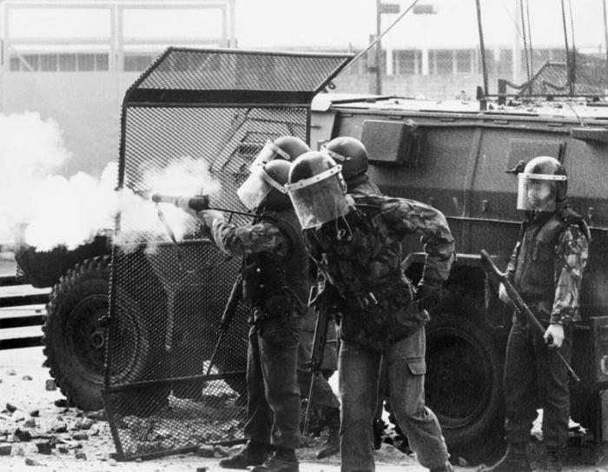
BEGIN / BE ABLE TO / BE CONSIDERED
1998 | The Northern Ireland peace process _____________________.  The accord _____________________ after 30 years of conflict.
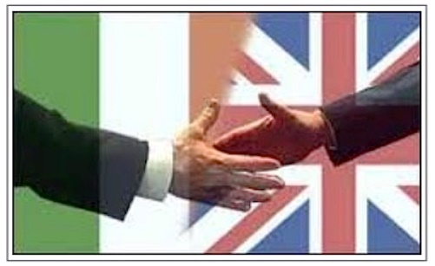
BE REACHED / BE VOTED

