L'apprenti- Journaliste : Réaliser un article de journal
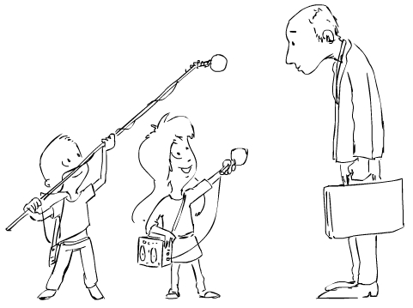
/20

Élèves-reporters :_____________________________________
_______________________________________________________________________

Rédigez une ou deux phrases afin de présenter La classe :___________________
___________________________________________________________________________
____________________________________________________________________________________________________________________________________________
Présentez le professeur en charge de la classe (nom, disciplines enseignées ) : ________________________________________________________________________________________________________________________________________________________________________________________________________________________________________________________________________________________

Présentez l'élève interrogé (nom,prénom, âge) : ___________________________________________________________________________________________________________________________________________Question n° 1 : __________________________________________________________________
_____________________________________________________________________________
Réponse : _____________________________________________________________________
______________________________________________________________________________ ___________________________________________________________________________
____________________________________________________________________________
Question n° 2 : __________________________________________________________________
____________________________________________________________________________
Réponse : _____________________________________________________________________
_____________________________________________________________________________ __________________________________________________________________________________________________________________________________________________________Question n° 3: __________________________________________________________________
_____________________________________________________________________________
Réponse : _____________________________________________________________________
______________________________________________________________________________ ___________________________________________________________________________
____________________________________________________________________________
Question n° 4 : __________________________________________________________________
____________________________________________________________________________
Réponse : _____________________________________________________________________
_____________________________________________________________________________ __________________________________________________________________________________________________________________________________________________________Question n° 5 : __________________________________________________________________
____________________________________________________________________________
Réponse : _____________________________________________________________________
_____________________________________________________________________________ __________________________________________________________________________________________________________________________________________________________

- En classe, de manière individuelle, je rédige un texte afin de présenter ce que j'ai retenu :
‼ Je fais attention à l'orthographe et à la ponctuation !!
_____________________________________________________________________________ __________________________________________________________________________________________________________________________________________________________
_____________________________________________________________________________ __________________________________________________________________________________________________________________________________________________________
_____________________________________________________________________________ __________________________________________________________________________________________________________________________________________________________
_____________________________________________________________________________ __________________________________________________________________________________________________________________________________________________________

