Classe de 3ème Séquence : I want to break free

Reading about Rosa Parks

1) Cut out these paragraphs and put them in the right order (= remets les paragraphes dans le bon ordre):

A) Rosa worked as a seamstress. It was very tiring sitting at a sewing machine and sewing all day. To get to work she rode the bus.
B) Her mother, Leona, homeschooled her until she was eleven, then she attended a private school.
C) During this time in America blacks did not enjoy the rights they have today. Rosa remembered living in fear when she was a child as a result of the insults and prejudices against people of her race.

D) Black people could not sit just anywhere they wanted in the bus. They had to sit in the back of the bus. If white people were already sitting in the front of the bus, the black person had to pay the fare, get off the bus, and reenter at the back door. Sometimes the bus driver just drove off and left them before they could get back on at the back door. If the bus filled up with people, the driver would ask a black person to move so he could reposition the movable sign which divided the black and white sections.

E) She didn't plan the incident, but when it happened, she decided to stand up for her rights. She was tired of being humiliated and treated unfairly. She was not the first black person to refuse to move on a bus, but when the event happened to her, civil rights leaders knew they had found someone to champion their cause. Rosa was a person who was above reproach, and people could not find fault with her character.

F) She attended college, but had to drop out to care for her grandmother who became ill. Later she cared for her mother. She married Raymond Parks, who was a barber. They were active in the National Association for the Advancement of Colored People, the NAACP (pronounced "N double A C P").

G) A group was formed and 35,000 handbills were distributed calling for a boycott of the buses. This meant the blacks would refuse to ride the buses unless they were desegregated and they could sit anywhere in the bus. And refuse they did! For more than a year, 381 days, they boycotted the buses. They carpooled, rode in cabs, and walked to work.

H) When Rosa Parks was born, she was named Rosa Louise by her parents. Her father was a carpenter and her mother was a teacher. Her parents separated when she was two years old, and she with her mother and brother moved to her grandparents' farm.
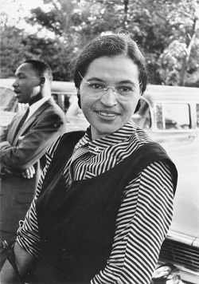
I) On December 1, 1955 after a hard day at work, Rosa was riding the bus home when the driver asked her and three black men to move to make more room in the white section. The three men moved, but Rosa refused. A police officer came, arrested her and took her to jail. She was bailed out that evening.

