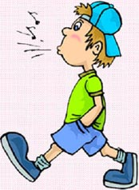
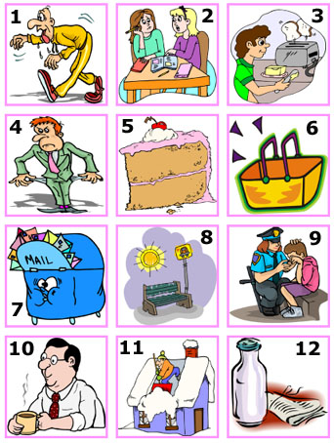
A / AN is used before countable nouns in the singular.
I’ve got a red jacket.
She’s got an umbrella.

A / AN is not used before uncountable nouns unless we use an expression of quantity that make the uncountable noun countable. Some of these expressions are:
A bunch, a piece, a jar, a bottle, a bar, a tube, a glass, a dozen, a kilo, a can, a tin.
There is a kilo of sugar.
I’ve got a jar of jam.

SOME/ANY are used before plural countable nouns and before uncountable nouns;
She’s got some pencils.
Is there any sugar in the bowl?
SOME is used in affirmative sentences and also in questions that are offers or requests:
Would you like some tomato sauce?
ANY is used in negative sentences and questions.
I haven’t got any cheese.
Is there any butter in the fridge?

A/AN

SOME / ANY
NO is sometimes used instead of not … any. When “no” is used to replace “any” in a sentence you must remember that the verb can´t be in the negative. We must always use it in the positive form to avoid making a double negative.

Ex: I haven’t got any money.
Or:
I have no money.
We can´t say:
I haven’t no money.
There isn’t any sugar.
Or: There is no sugar.
Not: There isn’t no sugar.

NO

A -Rewrite the following sentences using “no”.

- There isn’t any bread left.
Ex: There is no bread left.
- There aren’t any people at the library.
………………………………………………………………………………………………
- He hasn’t got any English books.
………………………………………………………………………………………………
- There isn’t a reason to get angry.
………………………………………………………………………………………………
- Paul hasn’t got any computer games.
………………………………………………………………………………………………
- There aren’t any good programmes on TV.
………………………………………………………………………………………………
- Linda hasn´t got any chance to pass the exam.
………………………………………………………………………………………………
- The kids haven’t got any money
………………………………………………………………………………………………

B -Fill in the blanks in the questions and then answer them using the word in brackets.

- Is there …………. Wine in the bottle? . (some)
Ex: Yes, there is some.
- Have you got …………… coins? (no)
……………………………………………………………………………..
- Are there ………. men waiting in the bank? (any)
……………………………………………………………………………..
- Has she got …………… umbrella? (one)
No,…………………………………………………………………………..
- Is there ……….. furniture in the office?. (some)
……………………………………………………………………………..
- Have you got …………… coffee? (no)
……………………………………………………………………………..
- Are there ………. teachers in the room. (some)
……………………………………………………………………………..
- Has she got …………. friends? (no)
……………………………………………………………………………..
C -Look at the pictures and fill in the blanks using “a/an”, “some” , “any” or “no”.

- I’m very thirsty. I need to drink _________ water.
- I went to the library but I didn’t find ______ interesting books.
- Would you like _________ toast for breakfast?
- The man has _________ money. He´s completely broke.
- There is _________ piece of cake in the fridge for you.
- There are _________ apples in the basket. It´s empty.
- Are there ________ letters in the mail box? – Yes, it’s full.
- Are there ____ people at the bus stop? -No, there aren’t _________ .
- _______ policewoman helped the child who had got lost.
- Mark likes to have ______ coffee during the break at the office.
- Was there _______ snow on the roof? – Yes, a lot.
- I have ______ bottle of milk delivered to my house every day.

