Indoor activities : drawing , painting , singing, dancing,
reading (books), watching TV, surfing on the Internet,
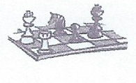
listening to music, playing video games, playing board games
(Monopoly), playing chess , playing cards,

playing the piano, the guitar, the violin, the saxophone,
the drums 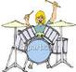, etc.

Water sports : sailing 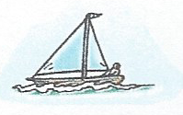, windsurfing, 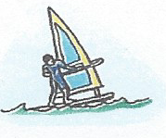, swimming, etc.
Winter sports : skiing, snowboarding 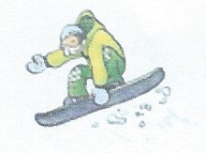, etc.
Outdoor sports : horse-riding 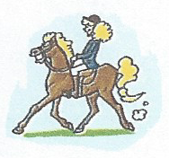, rock-climbing 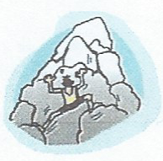
jogging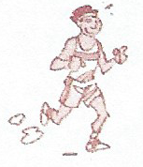, roller-skating, skateboarding,
cycling / riding a bike 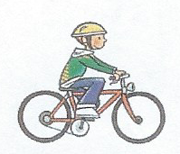, playing football / tennis/
volleyball, etc.
Other sports : doing judo / aikido / karate, playing tennis / table tennis, etc.

