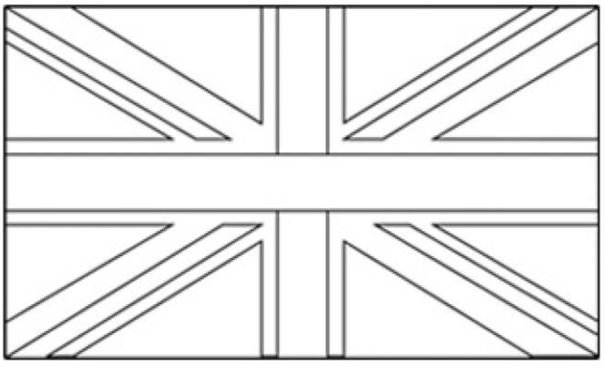 |  |  | 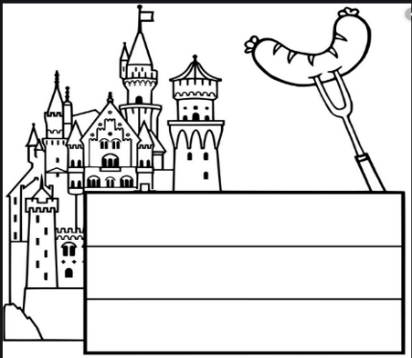
Name : ………………………………………………………………………………….  Surname : ……………………………………………………………………………..  Birthday : …………………………………………………………………………….  Brothers and sisters : ……………………………………………………………  Your city : ………………………………………………………………………………  Schoolyear : ………………………………………………………………………  I have lunch : ………………………………………………………………………  Telephone number : …………………………………………………………………  Hobbies : …………………………………………………………………………… |  | Name : ……………………………………………………………………………………  Vorname : ……………………………………………………………………………….  Geburtsdatum : ………………………………………………………………………  Geschwister : ………………………………………………………………………….  Wohnort : ……………………………………………………………………….………  Meine Klasse : …………………………………………………………………………..  Ich esse mittags : …………………………………………………………………….  Telefonnummer : ………………………………………………………………………  Hobbys : …………………………………………………………………………………….

