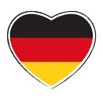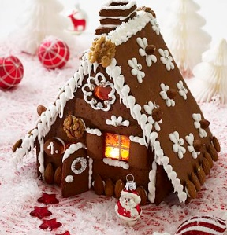

|  |  |  |  |  |  |  |
| --- | --- | --- | --- | --- | --- | --- |
| **Adventskalender** |  | **Adventskranz** |  | **Kerze** |  | **Plätzchen** |
|  |  |  |  |  |  |  |
| **Weihnachtsmarkt** |  | **Nikolaus** |  | **Stern** |  | **Weihnachtskarte** |
|  |  |  |  |  |  |  |
| **Glocke** |  | **Schlitten** |  | **Geschenk** |  | **Kirche** |
|  |  |  |  |  |  |  |
| **Schneemann** |  | **Engel** |  | **Weichnachtsmann** |  | **Weihnachtspyramide** |
|  |  |  |  |  |  |  |
| **Tannenbaum** |  | **Kugel** |  | **Ochs und Esel** |  | **Hirte und Schaf** |
|  |  |  |  |  |  |  |
| **Winter** |  | **Christbaum** |  | **Krippe** |  | **Christkind** |

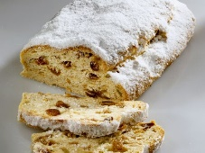

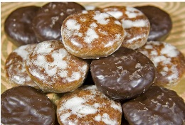

**Frohe Weihnachten !**

|  |  |  |  |  |  |  |
| --- | --- | --- | --- | --- | --- | --- |
|  |  |  |  |  |  |  |
|  |  |  |  |  |  |  |
|  |  |  |  |  |  |  |
|  |  |  |  |  |  |  |
|  |  |  |  |  |  |  |
|  |  |  |  |  |  |  |
|  |  |  |  |  |  |  |
|  |  |  |  |  |  |  |
|  |  |  |  |  |  |  |
|  |  |  |  |  |  |  |
|  |  |  |  |  |  |  |