Task 1. Match them up !

1. It provides simple simple information about procedures for accomplishing specific tasks.
2. It coaches the user on how to use a product effectively and efficiently
3. It includes useful information about the operation and maintenance of a device but also about the device specification
a) a user guide b) a user manual c) an instruction manual

Task 2. Read the following document and say what it is : a, b or c. (if possible, justify your answer)

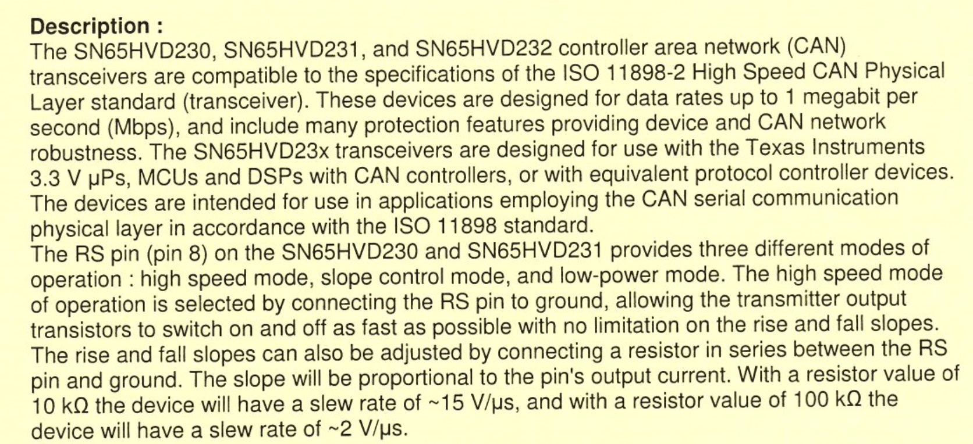
Task 3. Show you know ! Find in the text equivalents for the following French words or expressions.
a. un appareil de contrôle b. la robustesse
c. employer d. proportionnel
e. le courant
What do you call this kind of words? Can you find other examples in the text?

Task 4. Find synonym words or expressions in the text.
a. velocity, acceleration : b. characteristics :
c. apparatus, equipment : d. produced or created for (2 words):
e. an amount, a quota :

Can you guess the French for : data rates / a slew rate?

Task 5. What does the acronym ISO stand for?
a. Information System Operation b. International Standards Organisation c. Internal Service Office

Can you find words to complete the following sentence? I…………………. S……………….. mean that consumers all over the w………………. can have confidence that the d…………… or products they use, are safe, reliable and of good quality.

Task 6. Trans- is a Latin prefix which means ‘across’, ‘through’ or ‘beyond’. Find the following words and their French equivalents
a. Trans- + receiver = .................................…..........… (in French : ......................…......…….)
b. Trans- + emitter = .................................…..........… (in French : ......................…......…….)
c. Trans- + resistor = .................................…..........… (in French : ......................…......…….)

