The Fall of the House of Usher – page 2 / End of part 1 – Proposition de corrigé

1. The picture that best corresponds to Roderick Usher is picture b). Indeed, the man in this picture has large blue eyes, beautifully shaped lips, a well-shaped nose and yet, there is some kind of strangeness in his face.
The man in picture a) looks much too young and too healthy unlike Roderick Usher who is supposed to look sickly.
The man in picture c) looks much too old and is bald / balding contrary to Roderick Usher whose hair are supposed to be of a great softness.
Finally, the man in picture d) is too young and he is black whereas Roderick Usher’s skin is said to be white-grey.

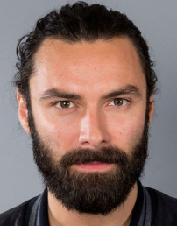  a) | 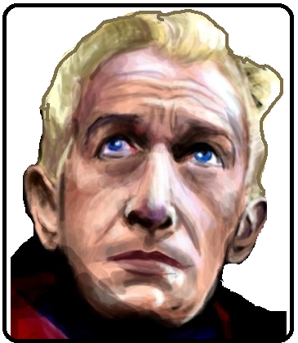  b) | 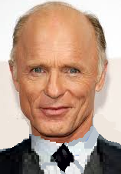  c) |   d)

2. a) Lines 84-93 - The narrator notices the duality that manifests itself in his friend’s reactions. Copy out the following table and fill it in.
Normal reactions | Signs of nervousness
Changes came  His actions were first too quick  His voice was slow and trembling with fear | Changes went  His actions were then too quiet  His voice changed to a strong, heavy, carefully spaced, too perfectly controlled manner

b) Many people today suffer from the mental disorder known as ‘bipolar disorder’. Search for information on the net and explain in your own words what it consists of.
Bipolar disorder is a life-long mental health condition that is extremely difficult to live with. Indeed, your mood is likely to change within weeks, days or even hours. These extreme mood swings cause unpredictable changes in your behaviour. You may feel euphoric, full of energy /stamina or invulnerable, which makes you take unnecessary risks, even financial ones. Binge-buying is one of the many side effects it can have, for instance. Then during the next phase or cycle, you may feel sad, depressed or even suicidal.

3. Roderick Usher has always been prone to some sort of morbid nervousness. Here are some examples:
- “... this resulted from his attempt to quiet a very great nervousness. I had indeed been prepared for something like this, partly by his letter and partly by remembering him as a boy.” (l. 85-87)
- “ he said, a family sickness, and one from which he could not hope to grow better” (l. 96-97)

4. Lines 94-105 - Here is the definition of ‘Hyperaesthesia’ : unusual or pathological sensitivity of the skin or of a particular sense. What form(s) does Roderick’s hyperaesthesia take? What impact does it have on his daily life?
Roderick Usher’s hypereasthesia takes many forms and affects his five senses.
- Taste : his gustatory sense is so exacerbated that he can only eat ‘tasteless food’.
- Smell : his increased olfactory acuity makes it difficult for him even to smell flowers : “...all flowers smelled too strongly for his nose”
- Sight : “...his eyes were hurt by even a little light”
- Hearing : “ ... there were few sounds which did not fill him with horror”
- Touch: “...In his manner, I saw at once, changes came and went.”
This increase in the sensitivity of his senses must be particularly difficult for Roderick to put up with / to live with as he seems to be servilely affected. As a result, he has no other option but to spend most of his time in a quiet, darkened room free from stimuli. It also means that he has no social life.

5. Lines 106-112 – What is Roderick Usher obsessed with? Which stylistic device does Poe use to emphasize it?
Roderick Usher is obsessed with the fear of dying. Poe emphasize this by repeating the words ‘terror’ ‘horror’ and ‘fear’ several times.

