How do you define your skills?
Most people have more skills than they think. Indeed, the things that they do well and the things they do all the time can be the basis of marketable job skills. Having the right words to describe them is necessary when you write a resume in order to convince a prospective employer.
1. Complete column b. with the following adjectives : Alert – Autonomous – Cool-headed – Creative and imaginative – Decisive – Determined – Focused – Hard-working – Helpful – Flexible - Meticulous – Open and receptive –Organized – Proactive – Punctual – Quick-witted – Reliable – Responsible – Sociable – Tactful

a) If you ... |  | b) …, you are a(n) … person | c)
1. | ... keep your promises and do what you say you will do,
2. | ... can think of ten different ways to do something,
3. | ... have good working habits,
4. | ... like completing a task no matter how difficult it is,
5. | ... care about your co-workers and never hurt their feelings,
6. | ... can arrange 150 paper files alphabetically in just a minute,
7. | ... like teamwork and planning events or parties,
8. | ... can make decisions for other people if need be,
9. | ... like trying new things,
10. | ... enjoy working on your own or developing your own ideas,
11. | ... explore new paths on a regular basis because your bosses trust you
12. | ... can solve any problem very easily,
13. | ... always get to work on time,
14. | ... always do your prep work consciously,
15. | ... don’t panic in crisis situations when colleagues around you do,
16. | ... can sum up a contract after hearing it only once,
17. | ... can concentrate on the same task for hours,
18. | ... don’t mind sorting others’ problems out,
19. | … can cope with changes under any circumstances,
20. | … are ready before something happens and seize opportunities,

II. Here is a list of skills for your resume. Write the letter that corresponds to each adjective in column c).
A. Make the right decisions & deal with problems efficiently
B. Carry out personal projects
C. Communicate well and enjoy working with people.
D. Complete tasks on time.
E. Concentrate on what is important
F. Enjoy learning new things.
G. Follow directions and schedules efficiently.
H. Get the job done right
I. Always find a way to solve difficult problems
J. Know how to build healthy relationships
K. Learn quickly and accurately.
L. Make decisions and stick to them
M. Organize and sort things out effectively
N. Take commitment seriously
O. Take a leadership role when appropriate.
P. Understand immediately the ins and outs of a situation
Q. Work well as a team member
R. Work well under pressure
S. Take initiative
T. Adapt easily to a new environment or a new situation
III. Circle all the expressions that enable you to talk positively about your skills
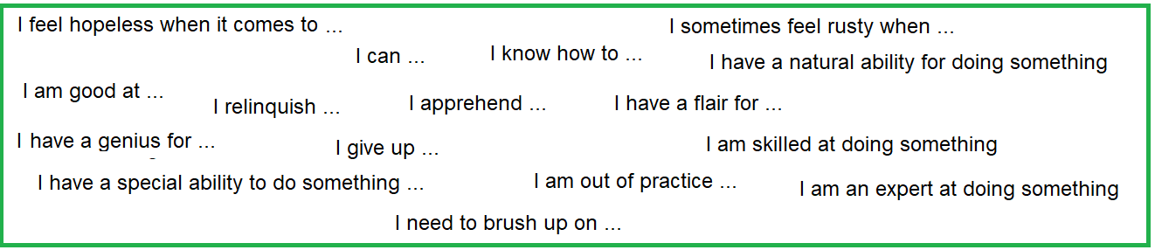
IV. Make a few sentences to talk about your skills and competencies. First give one of your qualities and justify it, for instance : I am punctual, indeed I always complete tasks on time.

