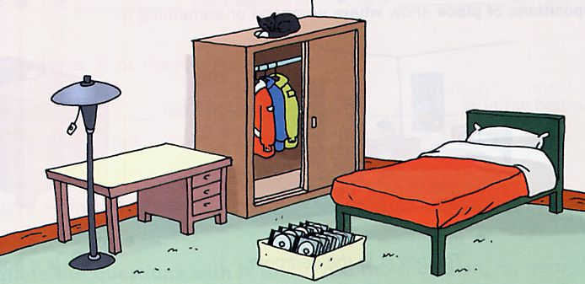

**Singular**

(+) There is a chair.

(-) There isn’t a bathroom

(?) Is there a shirt

**Plural**

(+) There are [some] chairs.

(-) There aren’t[any] bathrooms.

(?) Are there [any] shirts

**Complete the sentences using There is or There are:**

This is my flat.

_______two bedrooms and a living-room. ___________also a kitchen and _________a bathroom.

In the living-room_________six chairs and a sofa. _____________ a big table too. Besides __________a clock on the wall,___________a lamp and_______a shelf full of books.

**_________________________**

**_________________________**

**_________________________**

**_________________________**

**_________________________**

**_________________________**

**_________________________**

**_________________________**

**_________________________**

**_________________________**

**_________________________**

**_________________________**

**_________________________**

**_________________________**

**Describe the picture using There Is or There Are**

**Complete with "is" or "are".**

There ... a sofa next to the table.

There ... many cushions on the sofa.

There ... two bedrooms in my house

There ... many people in the school.

There ... some water in the jar.

There ... four birds outside.

There ... a piano in my house.

There ... two planes in the sky

There ... a dog in the river.

There ... four cups on the table.

**There is/There are is a common phrase in English, used to indicate that something "exists" or is in a certain location.**

**The structure is:**

**There + verb to be**

“is” for SINGULAR nouns ; “are” for PLURAL nouns