
A trailer

1/ Watch the beginning of the document twice and take notes :

Where? : …...................................................................................................................
Who? : ….........................................................................................................................
What are they doing? : …...........................................................................................
What about their feelings at the end of the scene ? Why ? : …......................
…..............................................................................................................................................................................

Toolbox : electric barbed wire/waiə/ = barbelés / wooden houses = maison en bois / hut = cabane / spaceship = vaisseau spatial / hover over = planer au dessus

2/ Focus on the images first.
a) Who? ➔ …..................................................................................................................................................
➔ …........................................................................................................................................................
➔ ….........................................................................................................................................................
➔ ….........................................................................................................................................................

b) How do the young people look? : …............................................................................................................
c) Where? : ….......................................................................................................................................................

d) Focus on the colours of the scene ?: …......................................................................................

e) Circle the adjectives describing the atmosphere of the scene :

cheerful = / sad / worrying / frightening / weird / realistic / cold

Now listen to the presenter and fill in the blanks :

….............................,
The …...................... has …......................... to …........................... one ….........................young man and woman for the …................ of …....................... district 12 in the 74th …..................hunger ….................
What is « District 12»? : …..................................................

Toolbox : gather= rassemblé / disguised = déguisé/ hug = serrer qn dans ses bras

3/ Write down the names of the main characters.


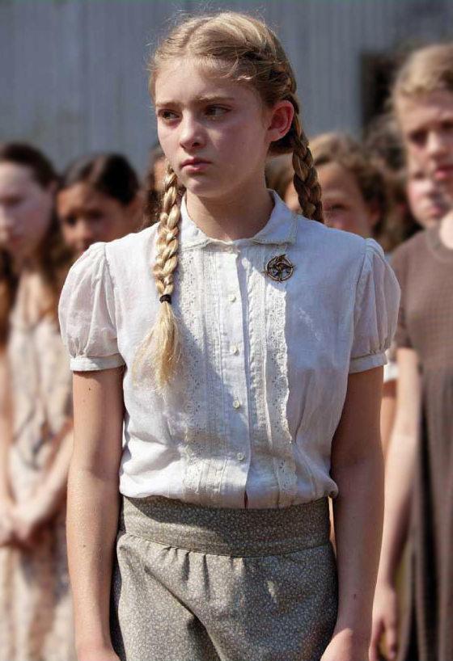


…........................ …................................ …............................ …......................................

- What's happening in this scene ? Reorder the sentences.

…...................She volunteers to take her sister's place.
…...................The heroine's friend is trying to reassure her.
….......................The presenter selects the heroine's sister to participate in the games.
….......................A young boy is selected to represent District 12 too.
…......................The heroine looks stunned (=very surprised) and panic-stricken.

4/ Find an adjective describing the city ? : …...........................................

Find 2 key words: …......................... …........................................
Why is it important for the games? …...........................................................................................
…............................................................................................................................................................

Toolbox : audience = le public/be dressed-up = être bien habillé/ broadcast = diffuser

5/ Complete the sentences :

The white-haired man is probably …..............................................................................................................
All candidates are.................................................................................................................................................
Katniss is a good …...........................................................................

- Now listen and complete the sentences :

Each …..............the …......................... districts of Panem shall …...........................up a tribute one …........................ ….................. and …................................ between the …....................... of ….......... and …........................... to be …...............................in the art of ….............................. and to be ….............................. to …................................ to the …...........................................

6/ Watch the end of the trailer and talk about what you see.

Toolbox : a countdown = un compte à rebours / arena /ə'ri:n ə /

Title of the film : …..........................................................................
What type of fim is it ? : ….................................................................

Complete the recap on the trailer of the film.
Each year the 12 districts of Panem offer ….................................... and …..................................... between the age of …............................. and …....................................... who are selected by lottery to …................................ in The Hunger Games.
The 24 …....................................... are trained to........................................................................on live TV.
When her sister Primrose is ….................................................to represent District 12,the heroine,Katniss is …................................... and she …................................... to take her …................................. She will participate in the games with …............................................................
A team of people make them …................... …........................before being presented to the ….............................. because the games are …...................................... everywhere.
All the candidates undergo intense training because the games are dangerous and brutal.
Katniss is a good …................................. She is lifted into the ….......................... and the games officially ….........................

