Video the American Civil Rights movement
1865 : end of the Civil war and end of slavery and yet a long struggle awaited African American to get equal rights
1870 all eligible male citizens were able to vote however blacks were discouraged to , either by violence or by legal means
1896 the Supreme Court ruled to maintain racial segregation in private businesses ( Plessy vs Ferguson ) . it was broadened to include schools. On May 18, 1896, the U.S. Supreme Court, with only one dissenting vote, ruled that segregation in America was constitutional.
“ separate but equal” Jim Crow Laws Blacks were treated as second-class citizens
1909 creation of the NAACP
Between 1910 and 1930 white supremacist group KKK saw its biggest extension . It was declared illegal in 1871 and unconstitutional by the Supreme Court with the Ku Klux Act passed in 1882.
1954 Brown vs the Board of Education : class-action suit to end segregation in schools
1955 : first integrated school
Ways of protests : marches, sit-ins,boycotts
1955 Rosa Parks and the Montgomery Bus Boycott
1957 a high school in Arkansas admitted a group of African American students “the Little Rock Nine”
1962 universities started integrating Black students
1963 The Birmingham Alabama campaign the beginning of a series of lunch counter sit-ins, marches on City Hall and boycotts on downtown merchants to protest segregation laws in the city.
Over the next couple months, the peaceful demonstrations would be met with violent attacks using high-pressure fire hoses and police dogs on men, women and children alike -- producing some of the most iconic and troubling images of the Civil Rights Movement. President John F. Kennedy would later say, "The events in Birmingham... have so increased the cries for equality that no city or state or legislative body can prudently choose to ignore them." It is considered one of the major turning points in the Civil Rights Movement and the "beginning of the end" of a centuries-long struggle for freedom.

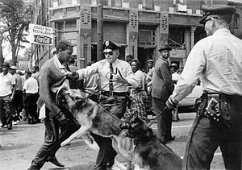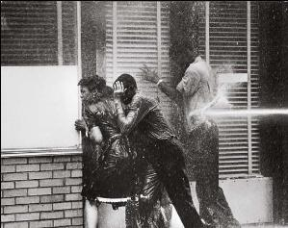
June 19th 1963 Kennedy proposed a Civil Rights Bill to Congress ( a bill is a proposed piece of legislation, once it is voted and passed , it becomes an Act), approved in 1964 by president Lyndon Johnson , Kennedy being assassinated in 1963 ,November 22nd.
1963 March on Washington of August
1965 Voting Rights Act put an end to the prejudiced voting system ( such as literacy tests or they had to answer complex questions
August 11th 1965 L A Watts Riots
1960s : rise of the Black Power, 1966 ( dissolved in 1982 ) creation of the Black Panther Party , which followed Malcom X ‘s principles “ We want freedom by any means necessary” slogan I’m black and I’m proud.
1965, February 21st in Harlem NY Malcom X assassinated
April 1968,April 4th in Memphis, Tennessee MLK assassinated

