Indira is growing and changing fast but traditional views are still in place . Institutions like the caste system have been outlawed and yet the caste system and discrimination still occurs
There is a wealth gap of 60 % between people traditionally from the highest and lowest caste.
The caste system is a hereditary social hierarchy , « the Jati » that existed for nearly 2000 years, may be based , according to historians , in ancient Hinduism which delineates 4 major social classes ( varnas)
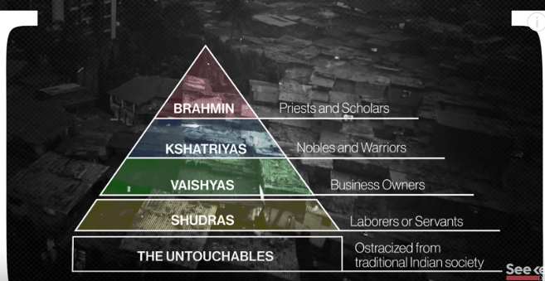

The Untouchables, now called the dalits do the most indesirable jobs, like cleaning sewers. They are considered impure and have been segregated from schools and religious temples,
The British wrote the Caste system into their laws according to some historians
1955 discrimination based on caste was outlawed
Later, the government created affirmative action, like quotas for certain jobs and university admissions
However, the system continues and the caste of a candidate for election is a deciding factor for many voters , marrying outside your caste is taboo in many rural areas ( the greatest part of India ) .

