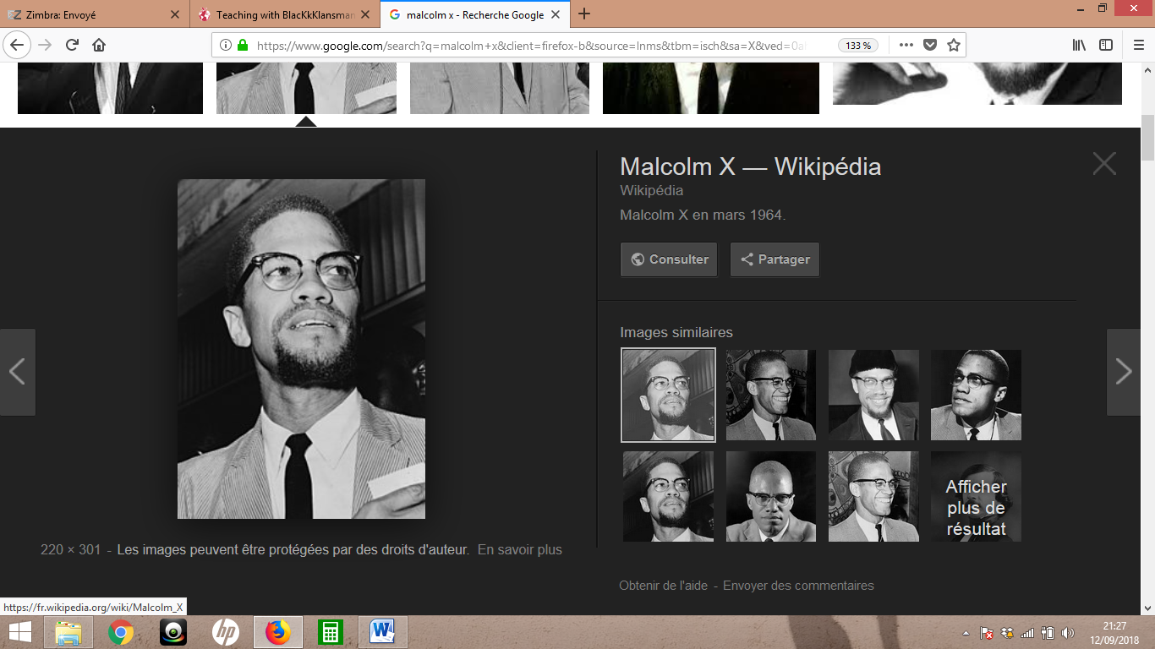 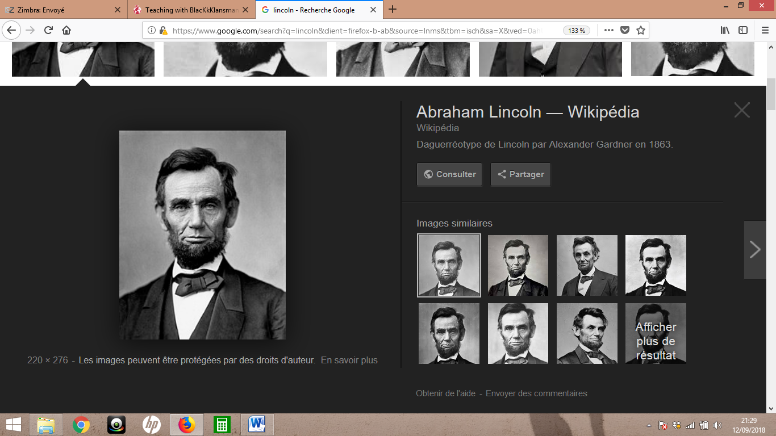 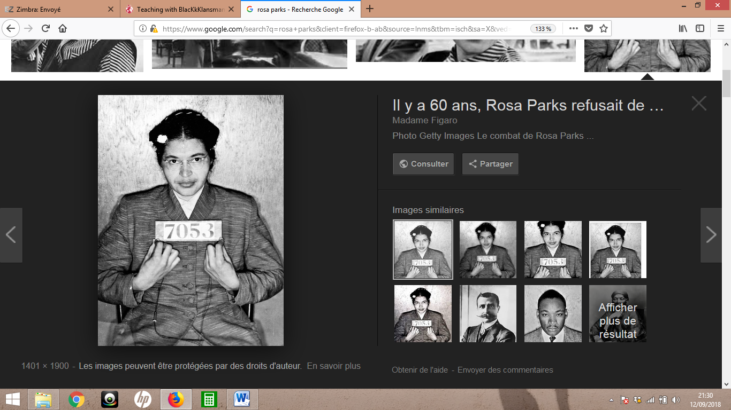 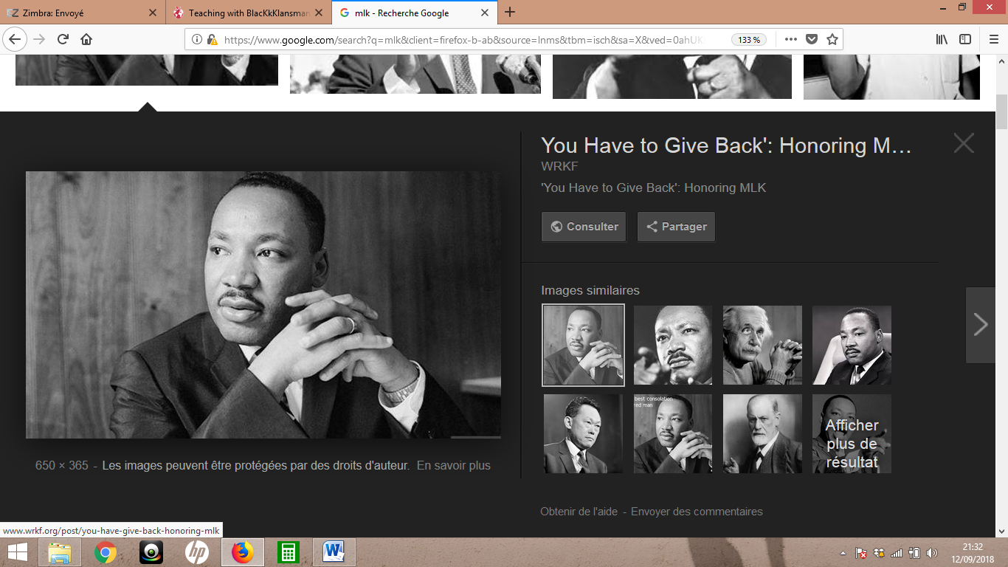

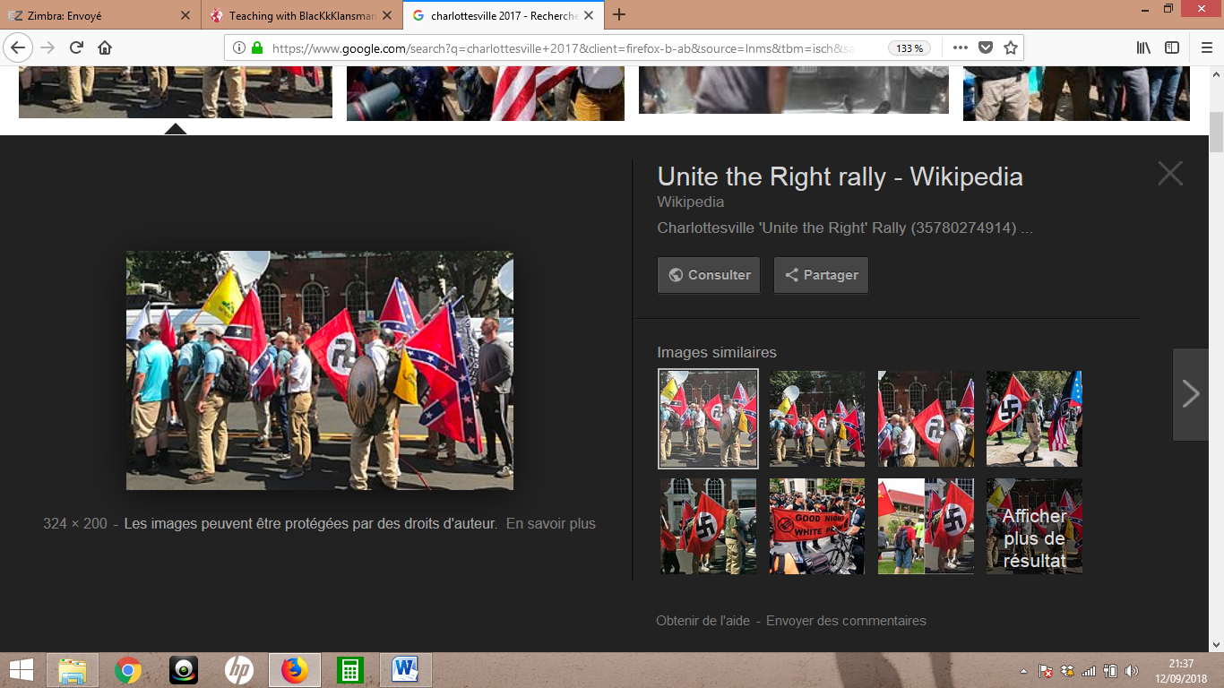 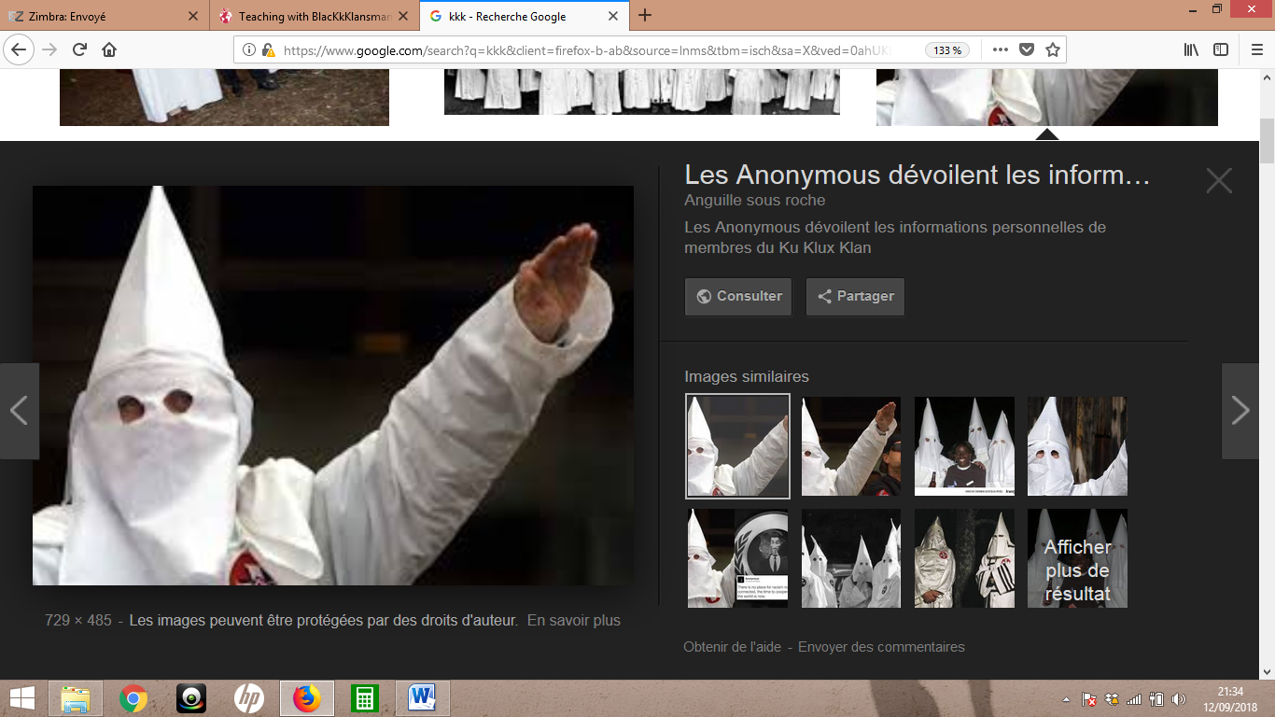

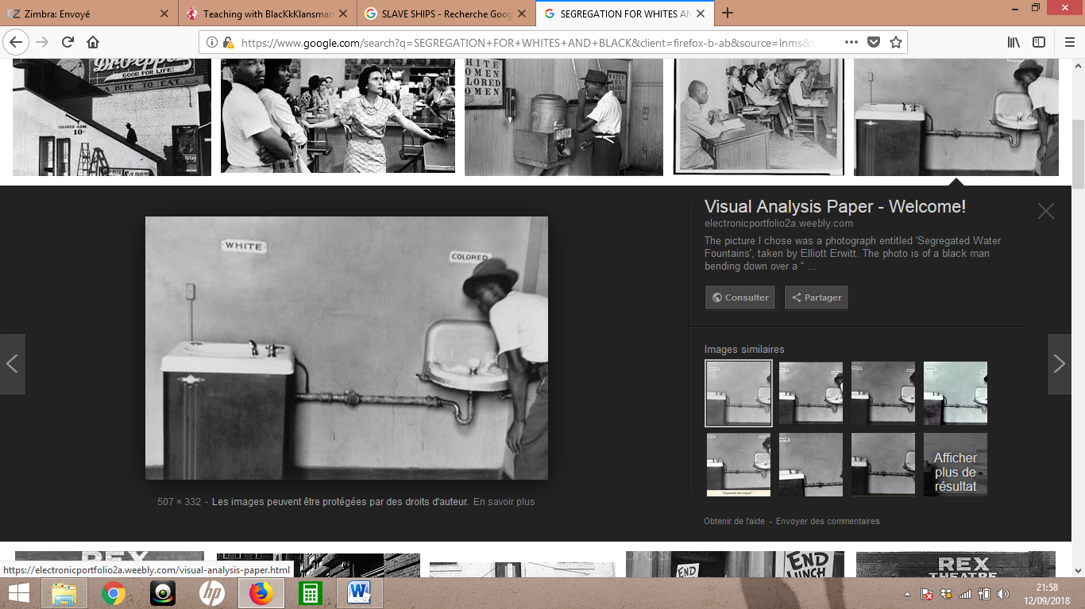 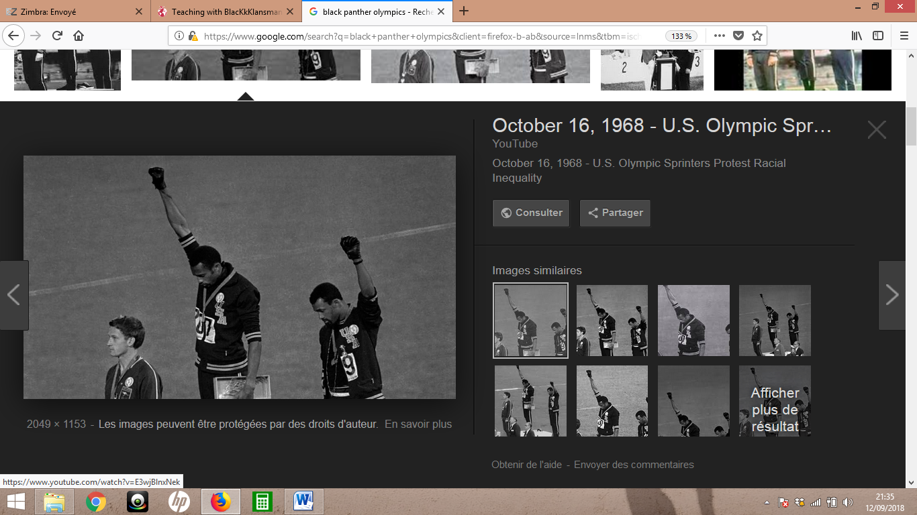 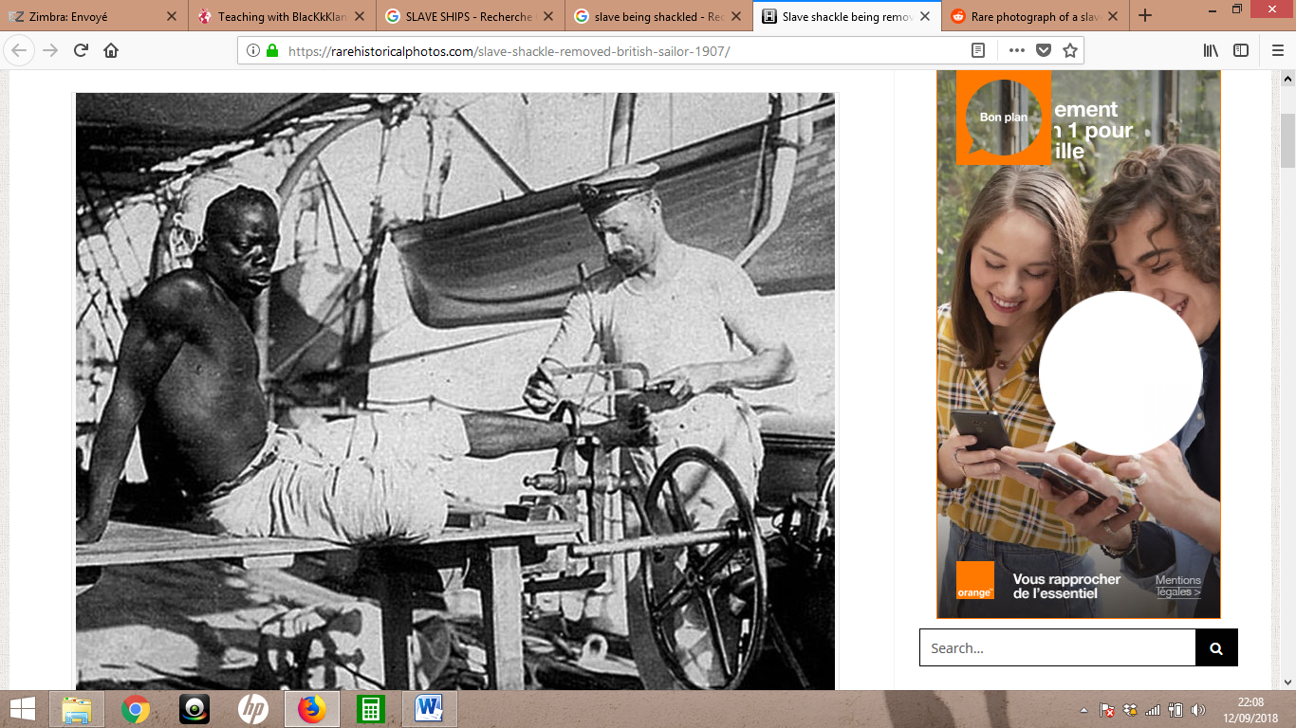 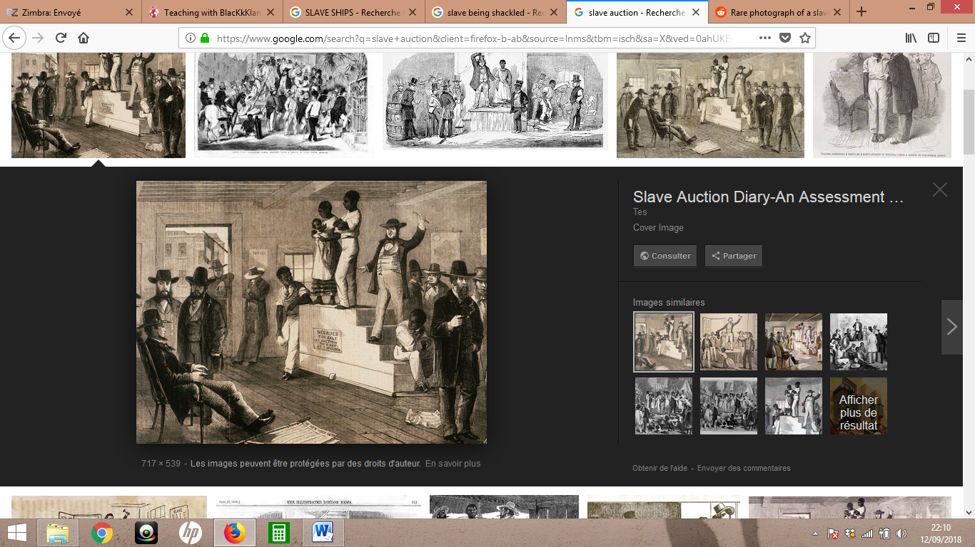

RESTROOM

BOYCOTT

MUSLIM

ASSASSINATED

CHARLOTTE

AUCTION

1907

W.A.S.P.s

SECEDE

PANTHERS

RESTROOM

BOYCOTT

MUSLIM

ASSASSINATED

CHARLOTTE

AUCTION

1907

W.A.S.P.s

SECEDE

PANTHERS

RESTROOM

BOYCOTT

MUSLIM

ASSASSINATED

CHARLOTTE

AUCTION

1907

W.A.S.P.s

SECEDE

PANTHERS