Overview of a few major literary genres
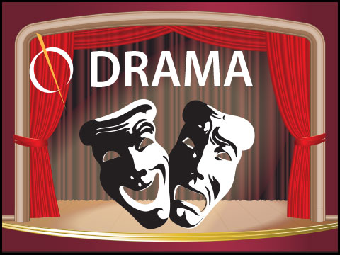  Ex: “Richard the Third” by William Shakespeare | Ex: “A Confederacy of Dunces”by John Kennedy Toole | 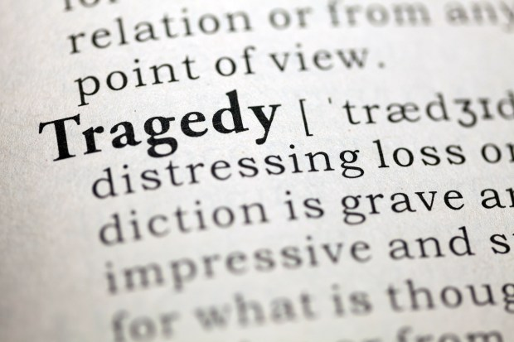  Ex: “Lord of the Flies”by William Golding
A play  On stage  Real characters  Visual  Dialogues / monologues | Everyday life  Humour  Happy ending  Stock characters  Ridicule | Unhappy ending  Fate  Death  Outside forces  Great characters
Ex: “The Great Gatsby” by F.Scott Fitzgerald | 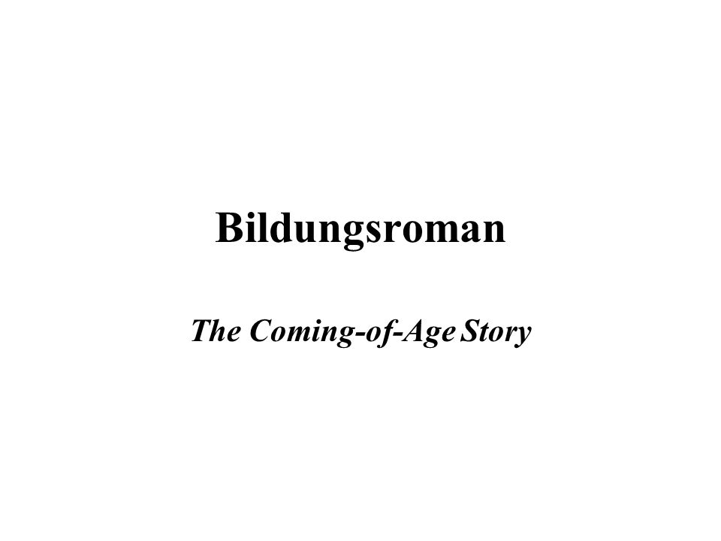  Ex: “A Prayer for Owen Meany”by John Irving | 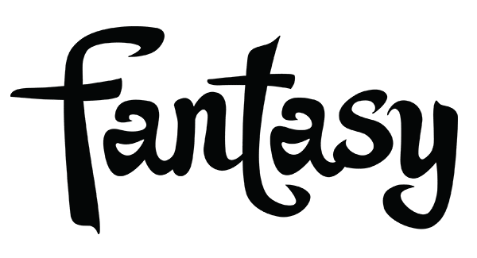  Ex: “A Game of Thrones” by George R.R Martin
Entertainment  Plot  Fictional characters  Point of view  Setting | From childhood to adulthood  Obstacles and misfortunes  Alienated / lonely character  Positive ending  maturity | Imaginary setting  Magic / extraordinary powers  Brave deeds  Good vs. Evil  Unusual characters
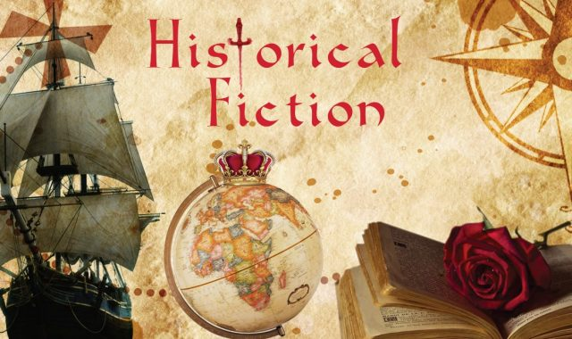  Ex:”Alias Grace” by Margaret Atwood | 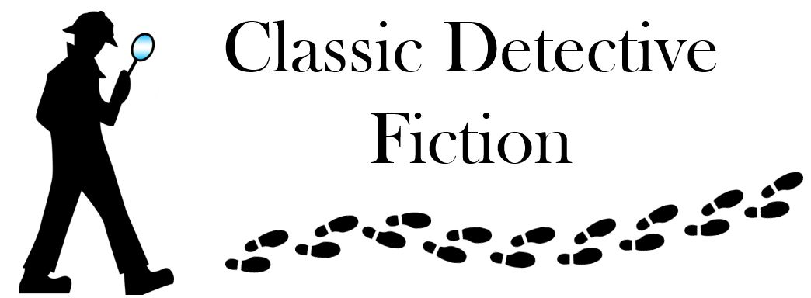  Ex:”Murder on he Orient Express” by Agatha Christie | 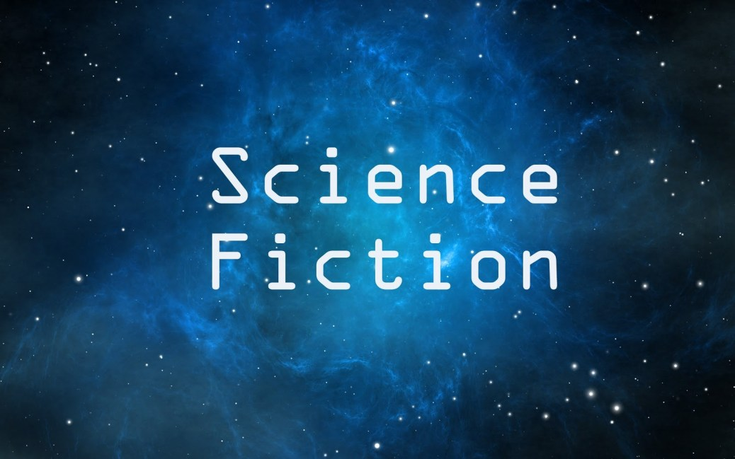  Ex: “The Time Machine” by H.G Wells
Past events / people  Inspired by great authors  Authentic details  Research  Grandiose sets | Crime / murder  Suspects / culprit  Red herrings / twists  Investigation  Atypical main character | Science and technology  Futuristic setting  Anticipation stories  Ordinary characters  Doomsday scenarios
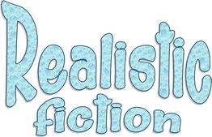  Ex: “To Kill A Mockingbird” by Harper Lee. | 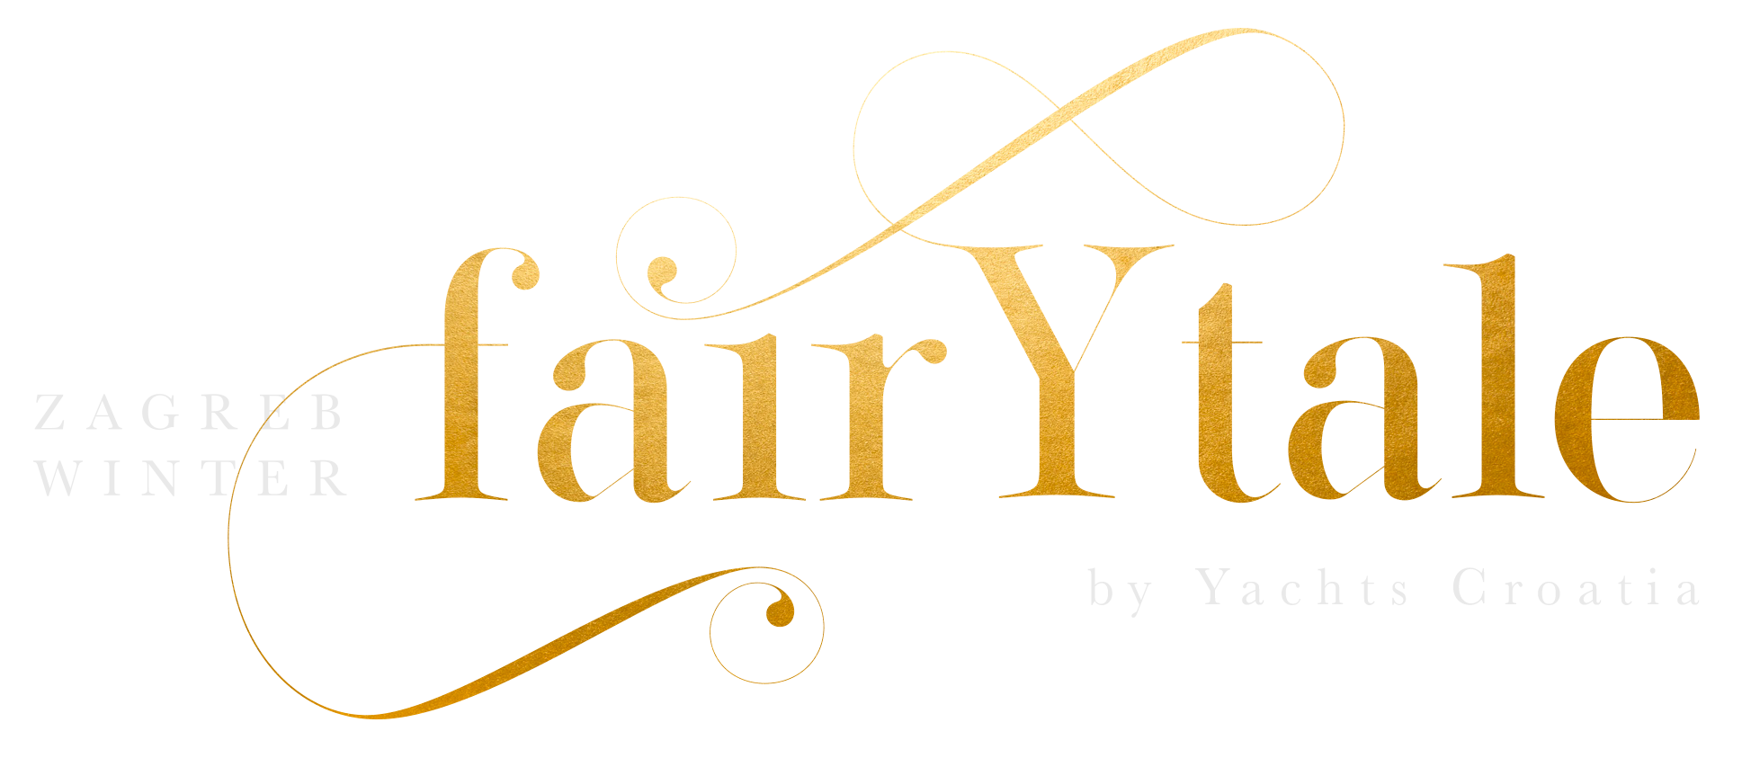  Ex:”Beauty and the Beast” by Gabrielle-Suzanne de Villeneuve | Ex: “Pride and Prejudice” by Jane Austen
Believable setting  Real life  Fictional characters  Could have happened  Present or recent past | Magic  Stock characters  Good vs. Evil  Royalty  Intended for children | Romantic relationships  Contemporary setting  Ordinary characters  Problems and complications  Satisfying ending
Ex: “A brief history of Time” by Stephen Hawking | Ex: “Churchill, a life” by Marin Gilbert | 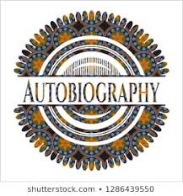  Ex: “Long walk to Freedom” by Nelson Mandela
True-life experiences  Specific audience  Clear purpose  Informational  Real people / events | About a real person  Based on facts  Told by another person  Biased  To criticise / to acclaim | 1st-person narrative  personal details  memoir / testimony  feelings / reactions  key incidents
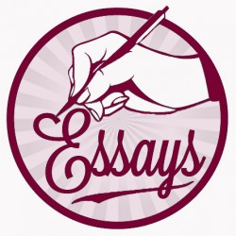  Ex: “The Nature of the Fun” by David Foster Wallace | 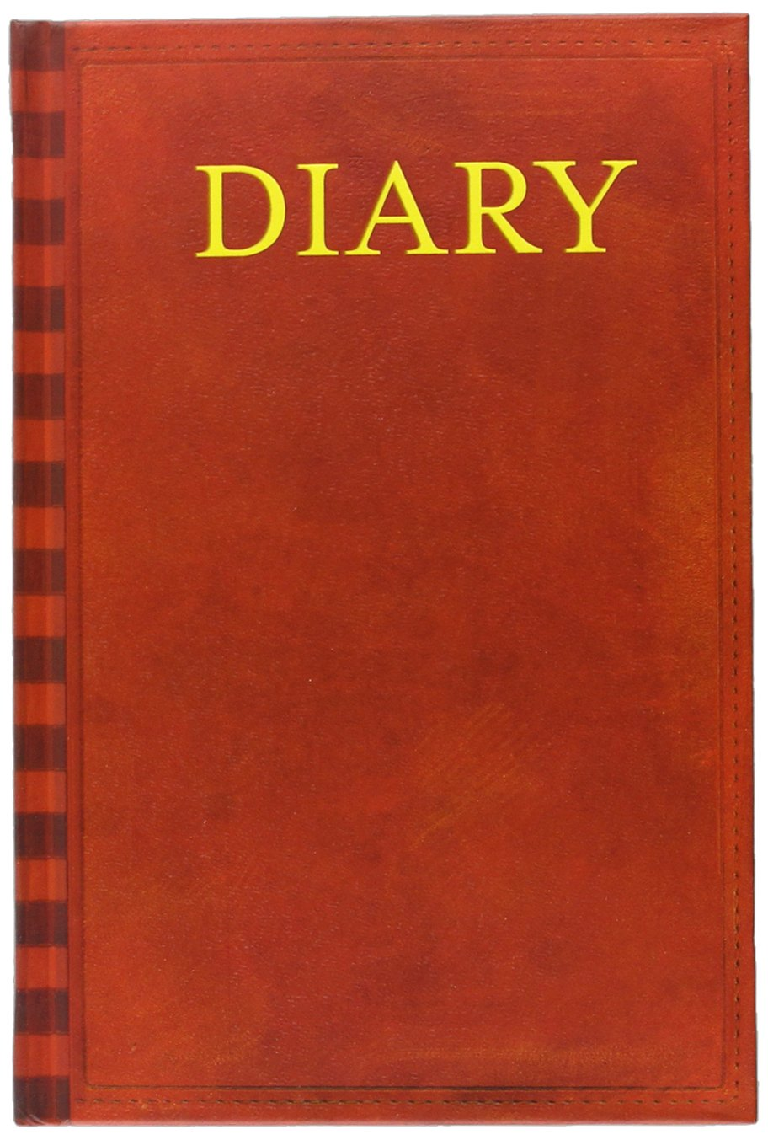  Ex: “The Secret Diary of Adrian Mole Aged 13 ¾” by Sue Townsend | 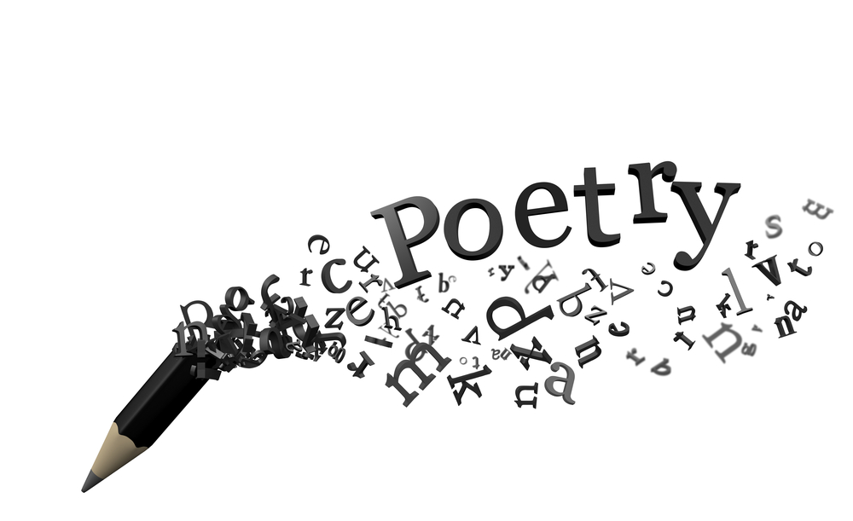  Ex:”Still I rise” by Maya Angelou
Thesis / antithesis  Point of view  Structure / organisation  Abstract topics  Formal tone | Daily entries  Personal / subjective  Everyday life account  1st-person narrative  Descriptive | Figures of speech  Symbols / imagery  Open / closed forms  Meter / rhythm  Tone
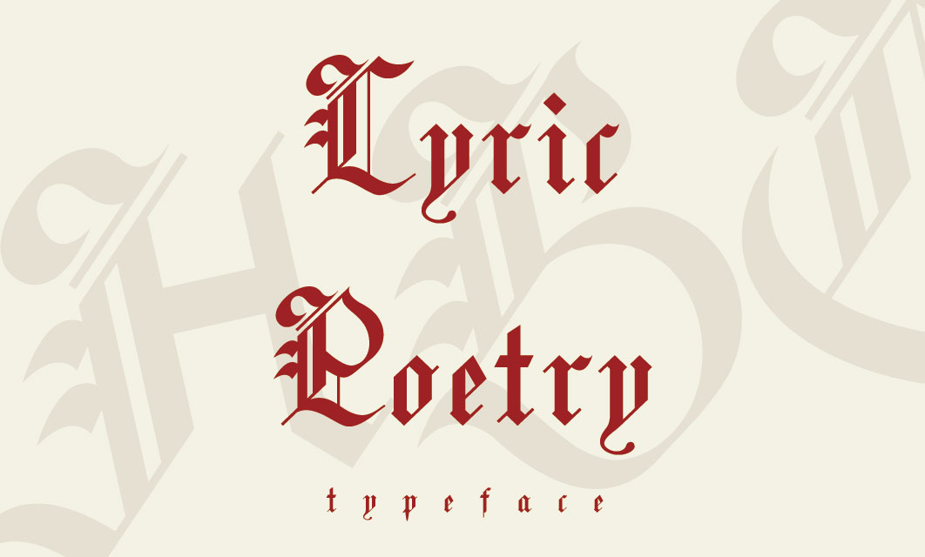  Ex: “ I felt a funeral in my brain” by Emily Dickinson | 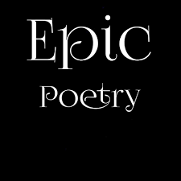  Ex: “Paradise Lost”by John Milton | 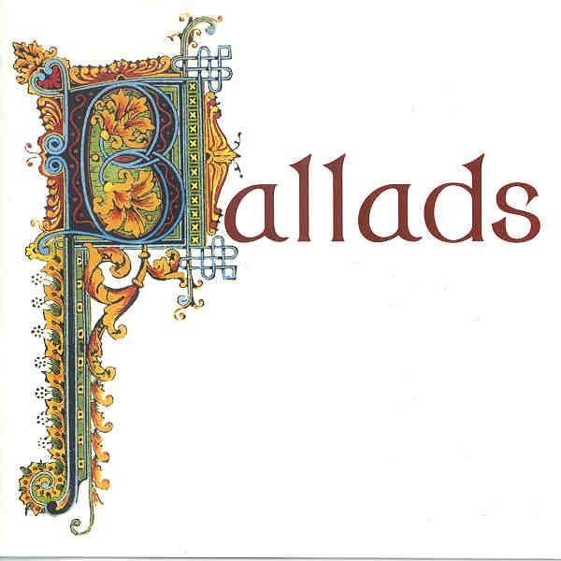  Ex: “La Belle Dame sans Merci” by John Keats
Emotions / feelings  Emphasis on nature  Descriptive  Musical quality  Rhymes | Narrative based on oral tradition  Outstanding heroes  Courageous deeds  Supernatural forces  Written in verse | Oral song-like poems  Narrative poems  Simple language  Repetition  3rd-person objective

