The art of seeing in Moon Palace
Chapter 4 pp 133-135
« It was a weekday morning … not to fall asleep”
Read this passage carefully at least twice
- Two readings of the paintings
- A realistic reading
- Draw the painting
- Pick out elements showing the painting is realistic:

- A non-representational reading
- In his second reading, Fogg focusses on a deeper meaning below the surface of the image. Pick out key sentences to prove this.
- Fogg asks himself what the painter Blakelock had intended while painting Moonlight. Explain.

- The narrator’s feelings
Show the evolution of Fogg’s impression while entering the museum and observing the painting

- The historical context
The context comes to confirm Fogg’s impression, 2 historical events are mentioned:
Find information on Custer / His last stand / the Wounded Knee massacre
Which sentence sums up Fogg’s final impression ?

- This painting as a cultural critique
What does Blakelock criticize in this painting?

- Quizlet : ways of looking (learn the vocabulary )
- Associate the vocabulary with the painting ( see example below)

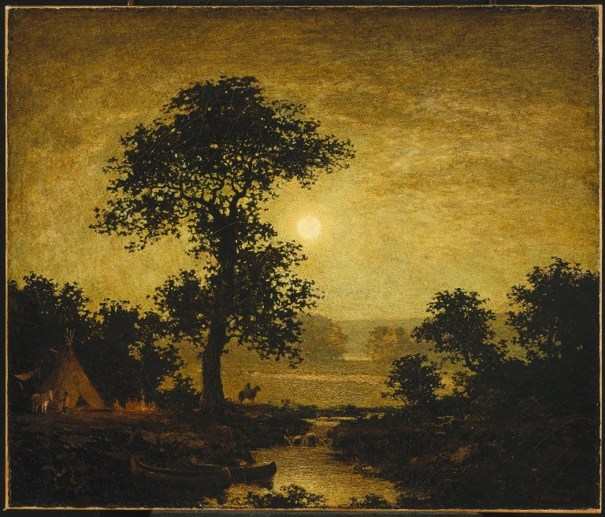
a perfectly round moon in the middle, pale white disc

