The British Isles

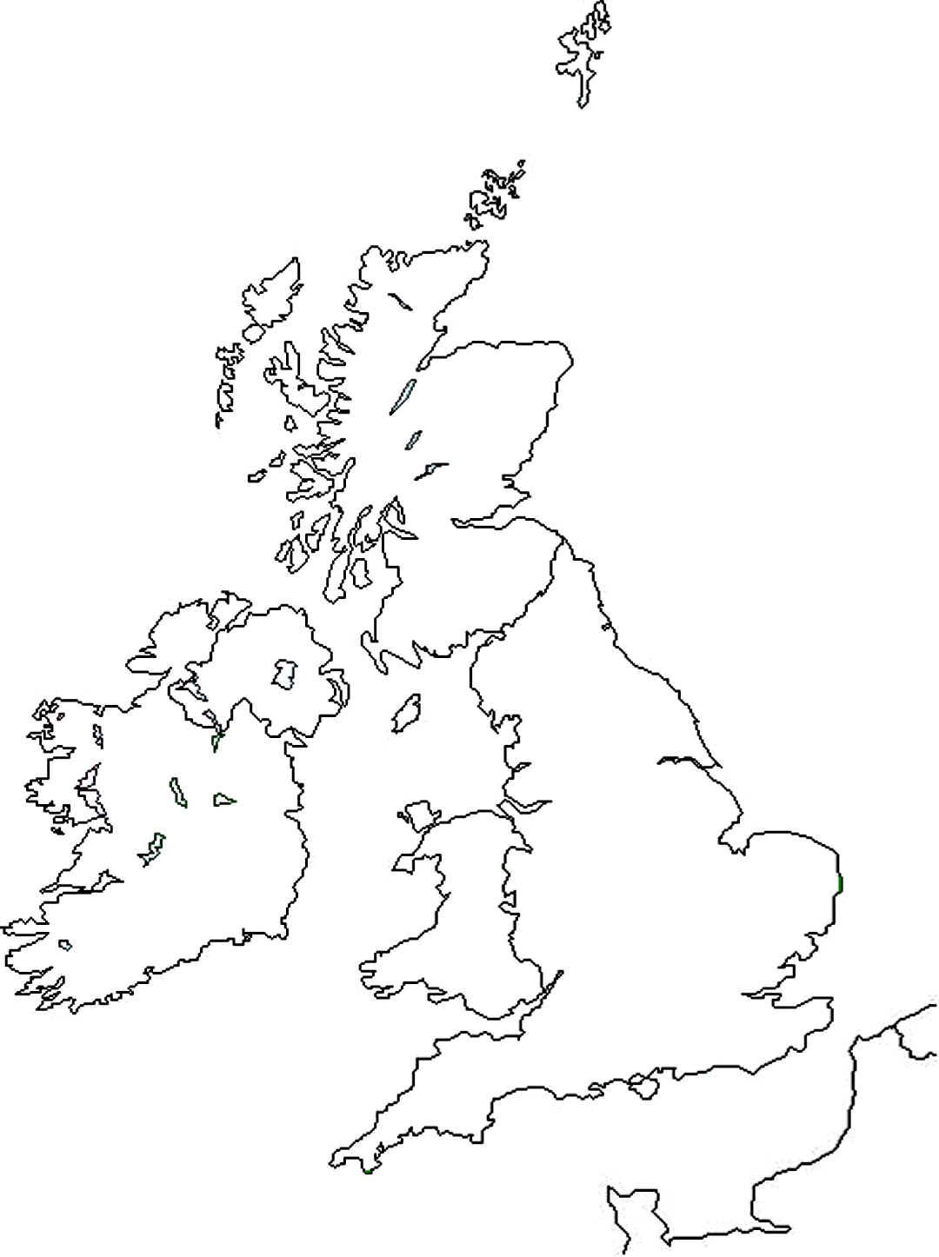

1. Colour the map: Scotland in orange / England in yellow / Wales in purple / Northern Ireland in green

Great Britain + Northern Ireland = __________________

1. Write in the right boxes: England – Scotland – Wales – Northern Ireland - Ireland
2. Write down the Capitals: Cardiff – London – Belfast – Edinburgh – Dublin
3. Colour the flags.

|  |  |  |  |  |  |  |
| --- | --- | --- | --- | --- | --- | --- |
| England england.gif | + | Scotland scotland.gif | + | Northern Ireland ireland1801.gif | = | United Kingdom UK.gif |
|  |  |  |  |  |  |  |

The Saint Patron of Wales is _________

1. Cut and stick the symbols in the right circle. A shamrock a rose a leek / a daffodil a thistle

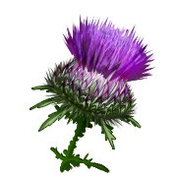C:\Documents and Settings\Valérie\Local Settings\Temporary Internet Files\Content.IE5\O9EZYVYD\MCj04303570000[1].wmfC:\Documents and Settings\Valérie\Mes documents\Mes images\Bibliothèque multimédia Microsoft\j0379997.wmf