Travail semaine du 11 mai
SÉQUENCE : Consumer society through art (suite)

Si tu peux, imprime le travail. Si tu ne peux pas imprimer, tu peux recopier les réponses
dans ton cahier.

Objectif: Comprendre un document inconnu = texte, image ou audio.

En terme de méthodologie, tu peux reprendre les amorces de phrases vues la dernière fois. Essaie de les mémoriser car elles te serviront jusqu'au lycée.
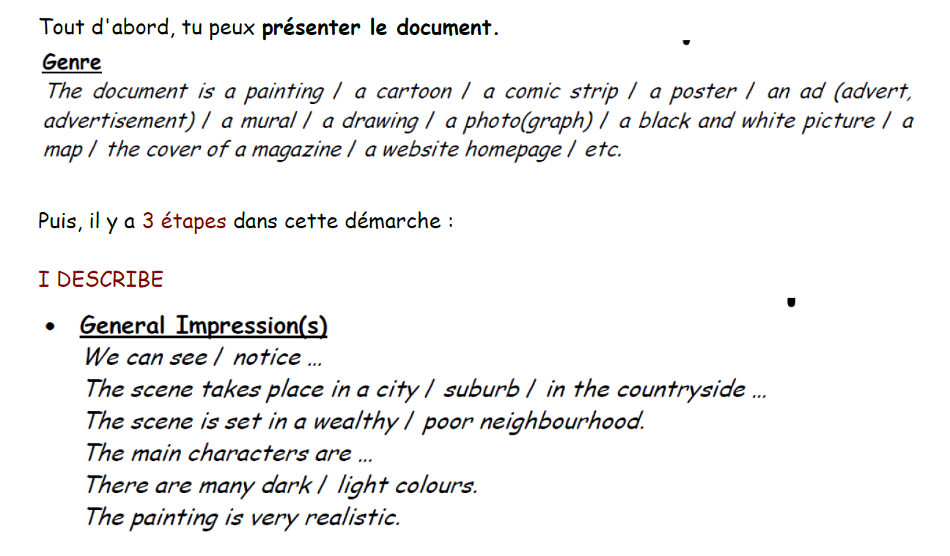
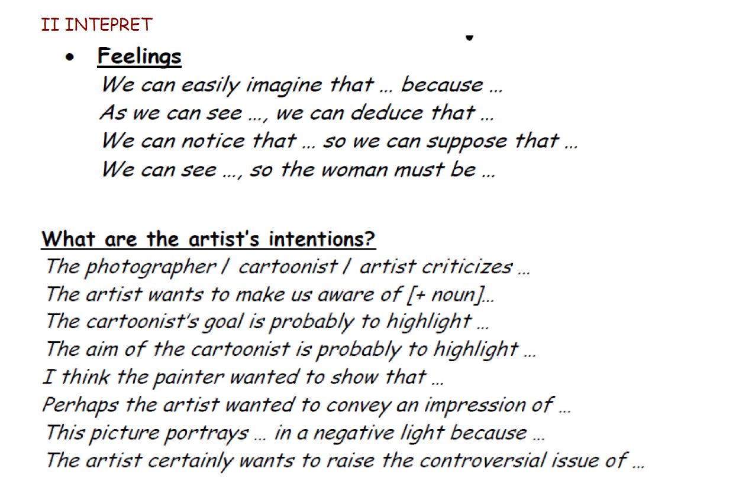

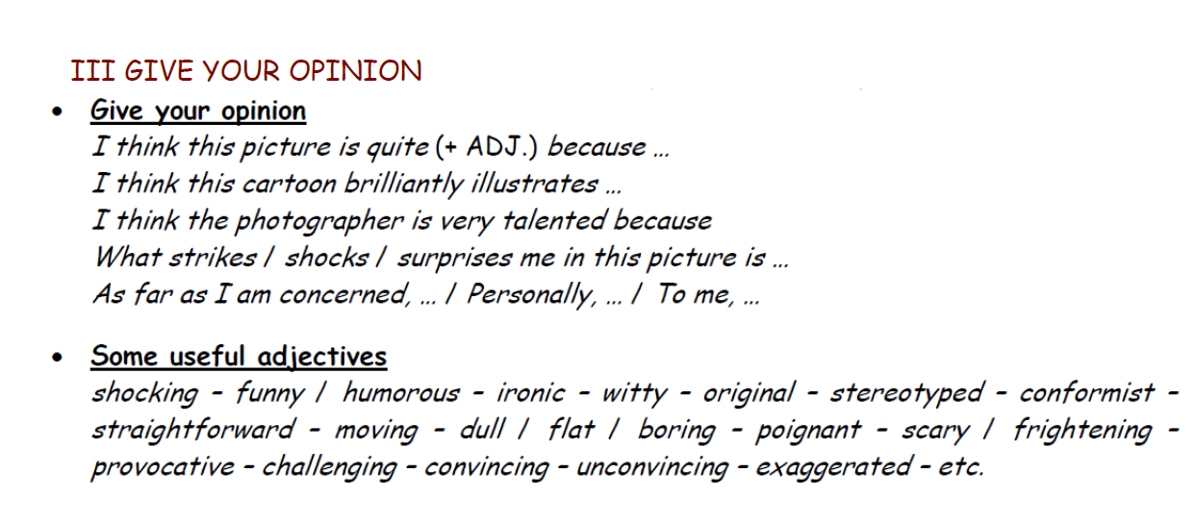
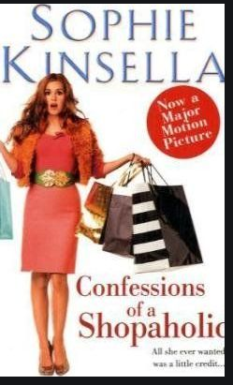
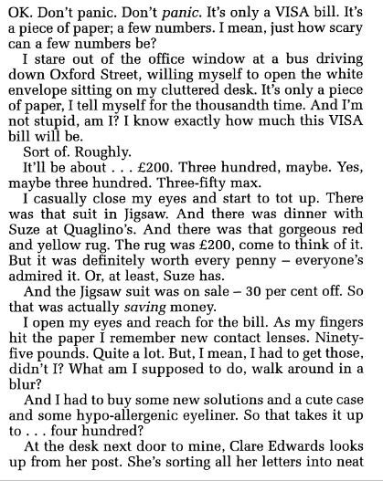
document 1 = a text

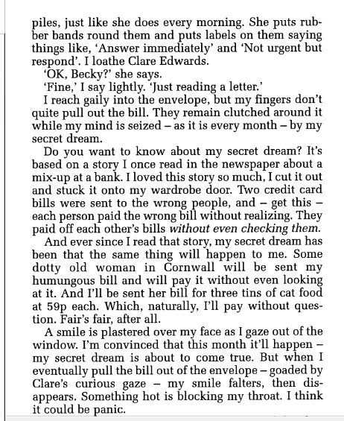
Extracted from “Confessions of a shopaholic” by Sophie Kinsella, 2001

- Present the document (date, author, title) and its main topic / theme ___________________________________________________________________________________________________________________________________________________________________________________________________________________________________________________
- Look at the title. What does the word “shopaholic” mean? If you didn't guess, look in a dictionary.
__________________________________________________________________________________________________________________________________________________________________________________________________________________________________________________

- What about the narrator? What does she like doing? What’s the problem?
______________________________________________________________________________________________________________________________________________________________________________________________________________________________________________________________________________________________________________________________________________________________________________________________________________________________________________________________________________________________________
- What is her secret dream?
____________________________________________________________________________________________________________________________________________________________________________________________________________________________________________________________________________________________________________________________________
- Do you like the text? Did you find it funny? Could you be a shopaholic like her? Give your opinion.
____________________________________________________________________________________________________________________________________________________________________________________________________________________________________________________________________________________________________________________________________

- Traduis le passage suivant. ( tu peux t'aider d'un dictionnaire)
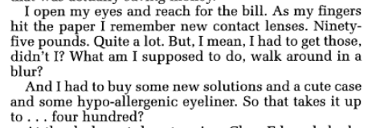
________________________________________________________________________________________________________________________________________________________________________________________________________________________________________________________________________________________________________________________________________________________________________________________________________________________________________________________________________________________________________________________________________________________________________________________________________________________________________________________________________________________________________________________________________________________________________________________________________________________________________________________________________________________________________

DOCUMENT 2 = LOOk at this sculpture in wax by Duane Hanson
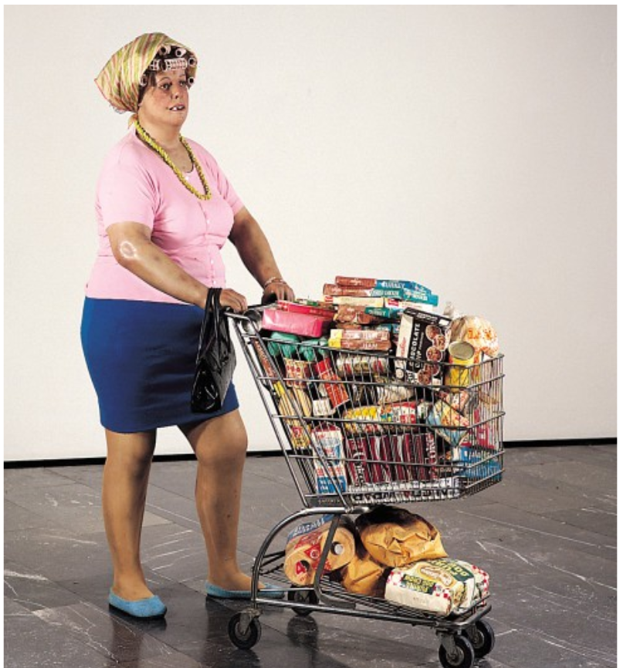
“ Supermarket Lady” (1969 ), a sulpture by Duane HANSON ( 1925/1996) ( exhibited in the museum of Aix-la-Chapelle , in Germany)

Help!
Description | Interpretation
Hair roller: bigoudi  Stack of products / items: pile de produits  Junk food : la nourrriture mauvaise pour la santé  Overweight : obèse  Tight: serré  Ugly: laid  Be full to the brim: être rempli à ras bord  a trolley = un caddie, un chariot | Harsh critiscism  Consumer society  Drawback /defect  Revolting  Realistic  To brainwash into doing something  To exaggerate  To denounce  To be aware of ± to know

- GATHER INFORMATION ON THE ARTIST = DUANE HANSON. https://en.wikipedia.org/wiki/Duane_Hanson
https://www.youtube.com/watch?v=Jc9ENdX9VWY

_______________________________________________________________________________________________________________________________________________________________________________________________________________________________________________________________________________________________________________________________________________________________________________________________________________________________________________________________________________________________________________________________________________________________________________________________________________________________________________________________________________________________
_______________________________________________________________________________________
- DESCRIBE THE SCULPTURE “Supermarket Lady”(you can use the help box)
____________________________________________________________________________________________________________________________________________________________________________________________________________________________________________________________
___________________________________________________________________________________
____________________________________________________________________________________________________________________________________________________________________________________________________________________________________________________________
___________________________________________________________________________________
____________________________________________________________________________________________________________________________________________________________________________________________________________________________________________________________
___________________________________________________________________________________
3. INTERPRET = Find out what the artist wants to show, to denounce.
____________________________________________________________________________________________________________________________________________________________________________________________________________________________________________________________
___________________________________________________________________________________
____________________________________________________________________________________________________________________________________________________________________________________________________________________________________________________________
___________________________________________________________________________________
____________________________________________________________________________________________________________________________________________________________________________________________________________________________________________________________
___________________________________________________________________________________

5. Describe your perfect trolley. If you could buy whatever you want in the supermarket what would you buy? Explain your choices.

___________________________________________________________________________________________________________________________________________________________________________________________________________________________________________________________
______________________________________________________________________________________________________________________________________________________________________

- If you think about healthy meals, what would you buy? In your own opinion, what is the danger of a consumer society?
___________________________________________________________________________________________________________________________________________________________________________________________________________________________________________________________
____________________________________________________________________________________________________________________________________________________________________________________________________________________________________________________________
___________________________________________________________________________________
________________________________________________________________________________________________________________________________________________________________________

document 3 = AUDIO

Choose one of the songs and tell me why you think this song well illustrates the dangers of consumer society
(Choisis une des 3 chansons et dis pourquoi selon toi elle illustre bien les dangers de la société de consommation)

SONG 1 https://www.youtube.com/watch?v=n9e6GTGzOiY

Citizen Fish - Panic in the supermarket

SONG 2 https://www.youtube.com/watch?v=1lyu1KKwC74

The Verve - Bitter Sweet Symphony

SONG 3 https://www.youtube.com/watch?v=QUntOdgpby8

Tracy Chapman - Mountains of things

___________________________________________________________________________________________________________________________________________________________________________________________________________________________________________________________
____________________________________________________________________________________________________________________________________________________________________________________________________________________________________________________________
___________________________________________________________________________________
________________________________________________________________________________________________________________________________________________________________________

VOCABULARY

Maintenant que tu as étudié plusieurs documents sur la société de consommation, retrouve ces mots de vocabulaire...

des bigoudis: ……………………………….. dépenser de l’argent: ………..................…………….
dénoncer: ………………………. accroc au shopping: ………………………………………
pas cher: ……………………………….. très cher =........................................
une facture: .............................
en solde: .......................... une réduction: ...............................
faire du lèche vitrine: ....................................................
être raisonnable: .........................................
je ne peux pas m’empêcher: ...........................................................
une marque: ..............................
une publicité: .............................................
un caddie: .....................................
la nourriture mauvaise pour la santé: .........................................
obèse : ...............................................
être rempli à ras bord: .................................................................
réaliste:...................................... ironique: ….............................
être conscient de :.........................................

