PRISE DE PAROLE EN CONTINU ET INTERACTION

1.Read the text : Prince of Peace
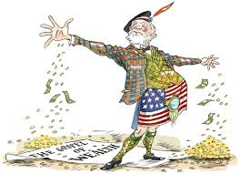
Andrew Carnegie
was born in Dunfermline in Scotland,
came over to the States in an immigrant
ship worked as bobbinboy in a textile factory
fired boilers
clerked in a bobbin factory at $2.50 a week
ran round Philadelphia with telegrams as a Western Union Messenger
learned the Morse code was telegraph operator on the Pennsy lines
was a military telegraph operator in the Civil War
and always saved his pay;
whenever he had a dollar he invested it.
Andrew Carnegie started out buying Adams Express and Pullman stock
when they were in a slump;
he had confidence in the railroads,
he had confidence in communications,
he had confidence in transportation,
he believed in iron.
Andrew Carnegie believed in iron; (…)
Andrew Carnegie believed in oil;
Andrew Carnegie believed in steel;
always saved his money
whenever he had a million dollars he invested it.
Andrew Carnegie became the richest man in the world and died. (…)
Andrew Carnegie gave millions for peace
and libraries and scientific institutes and endowments and thrift
whenever he made a billion dollars he endowed an institution
to promote universal peace
always
except in time of war.
John Dos Passos, The 42nd Parallel, 1930
Missions Tmle P23
Answer the following question :
To what extent can you say that Andrew Carneggie is a typical american hero ?
Préparation :5 mn
Passage : 5mn
Entretien :5mn

