4eme : activity 4 : crime scene

Picture description :
- Watch video 1 and video 2 on the blog
- Look on WORREFERENCE for the vocabulary on the picture (arrows = flèches) and write it :

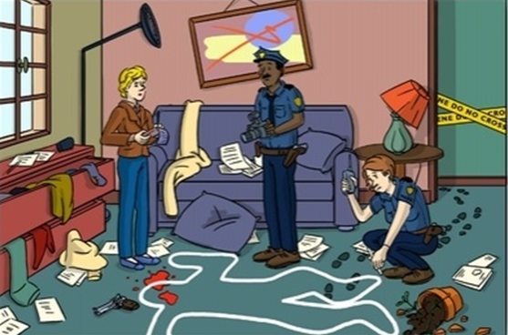
- With the help of video 1 and 2 describe the picture in 10 lines minimum. Be very precise and follow the steps of video 1 (suis les étapes de video 1) and send it to englishprof25@hotmail.fr :

