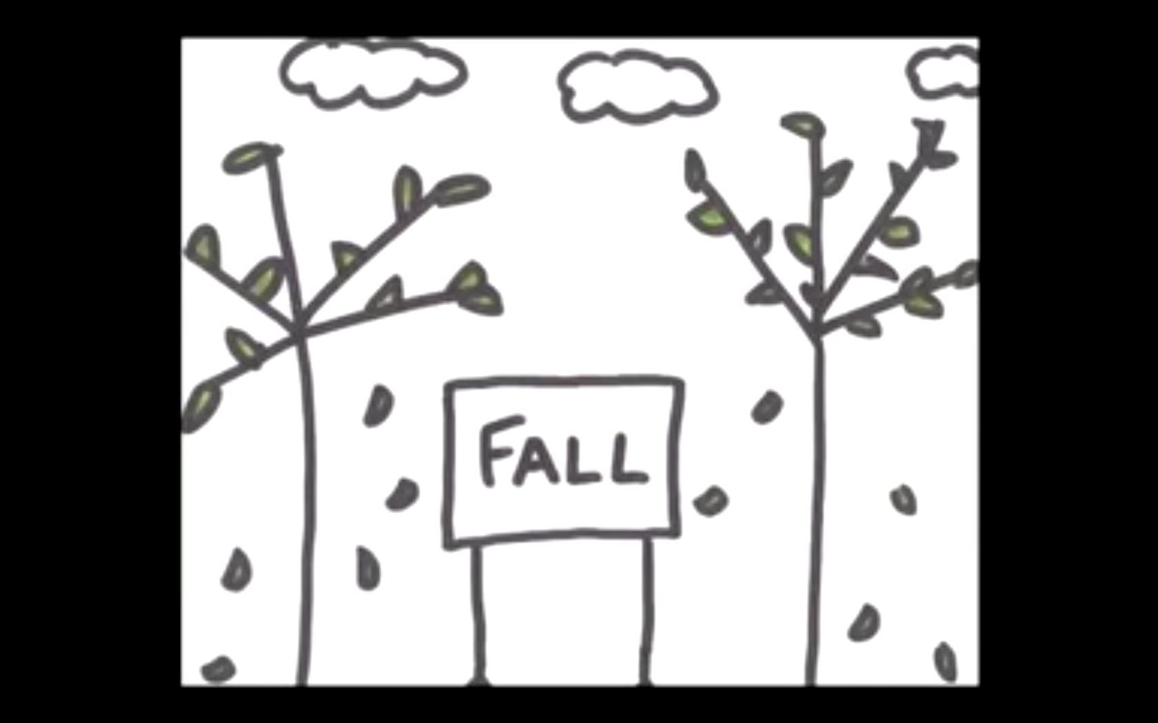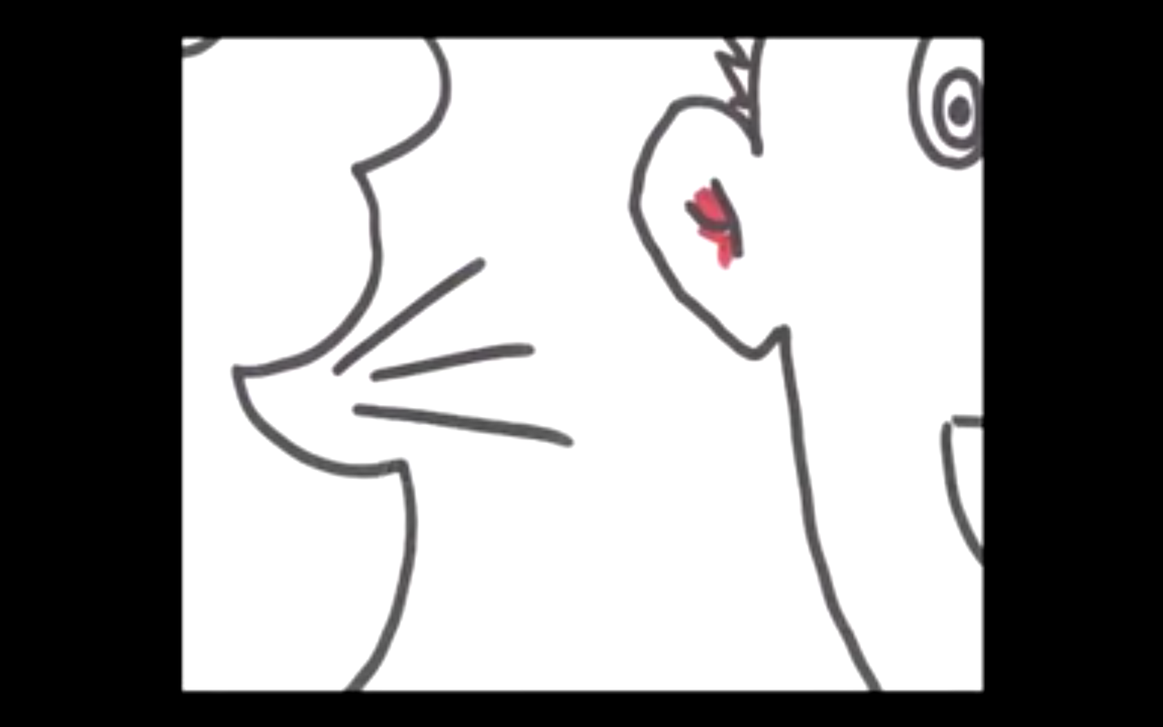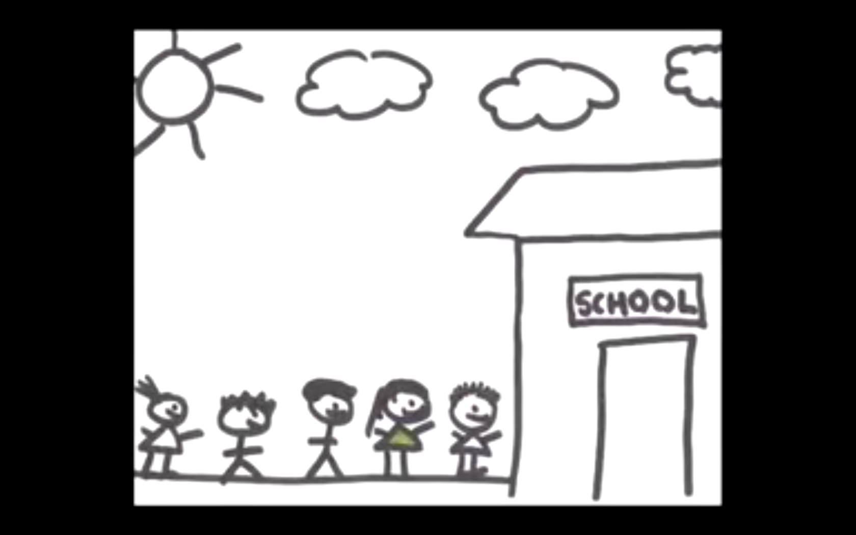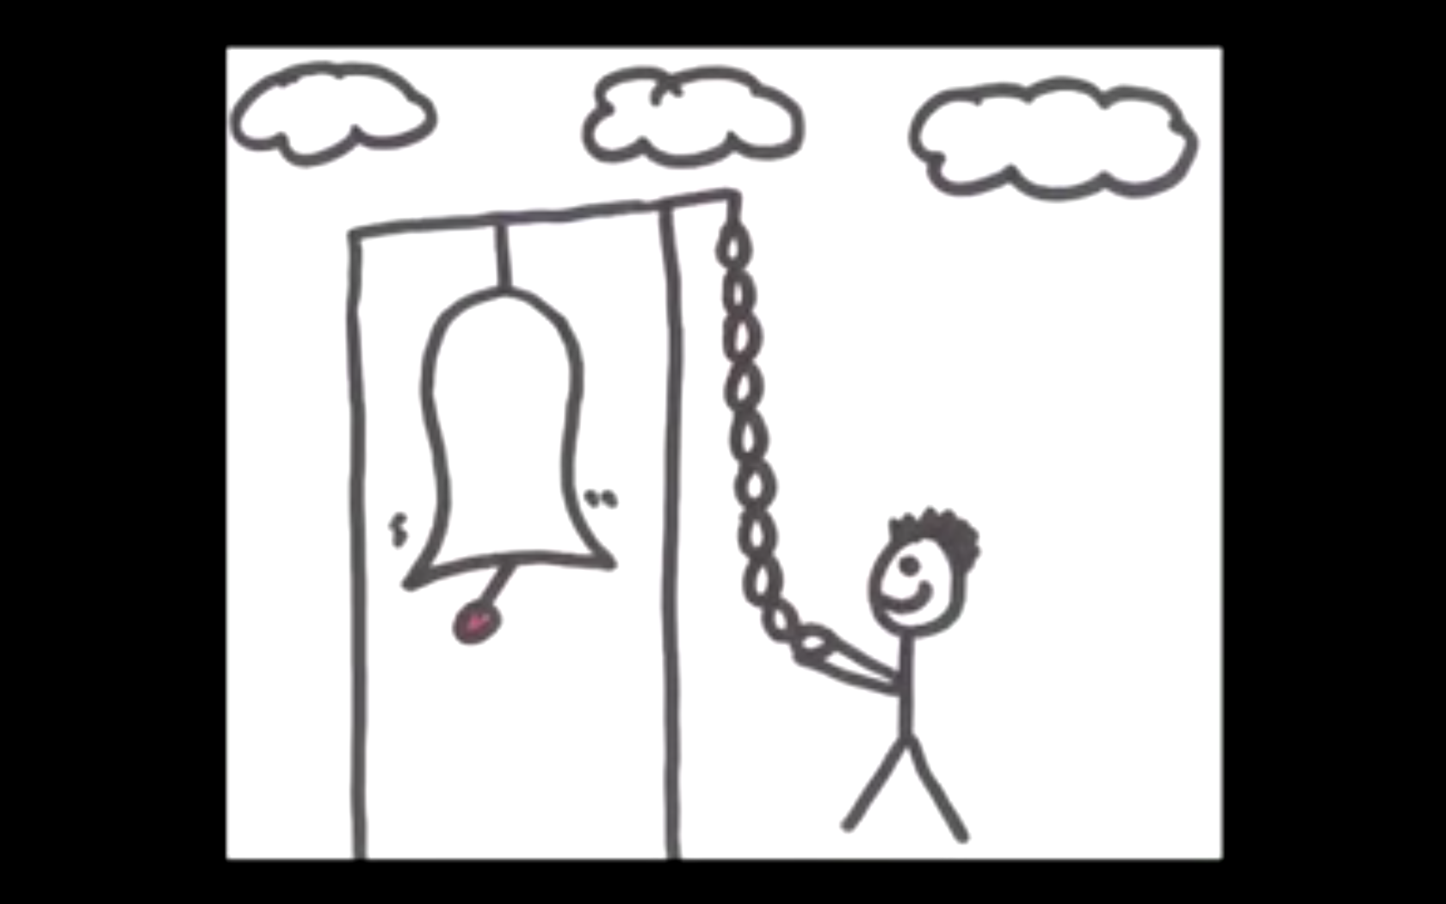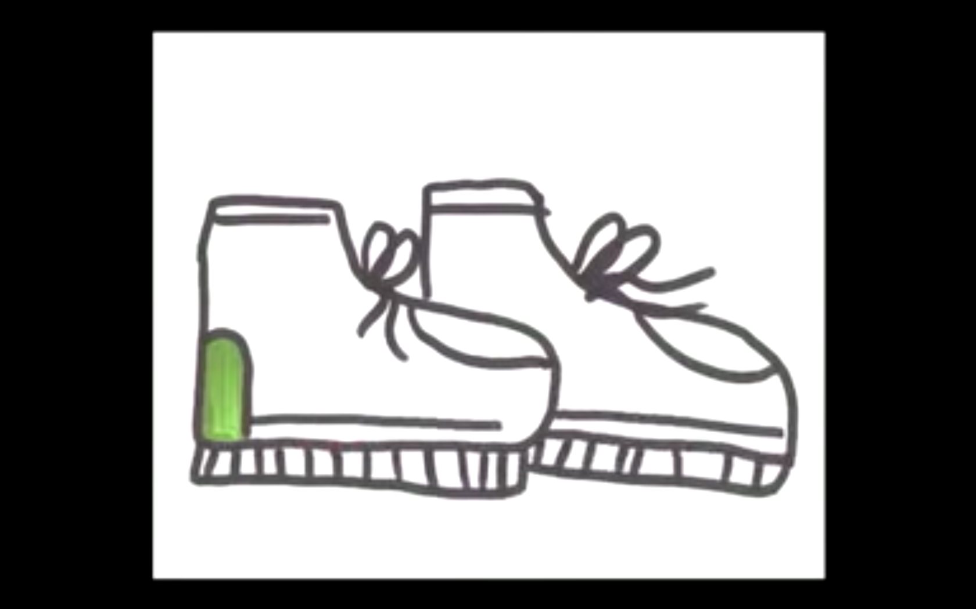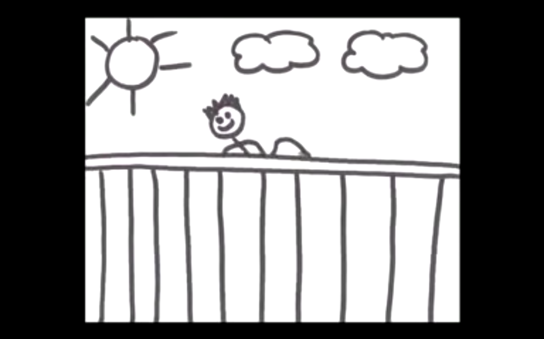
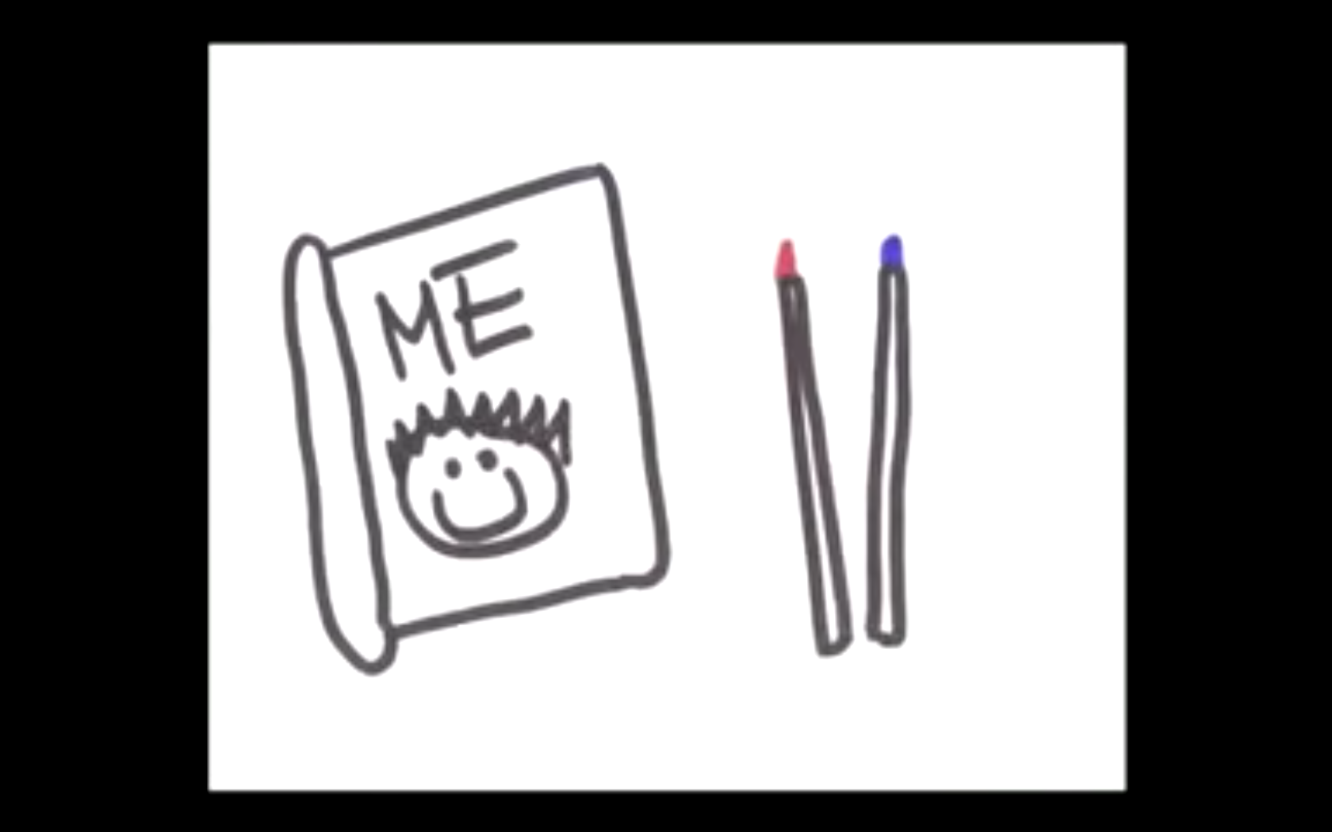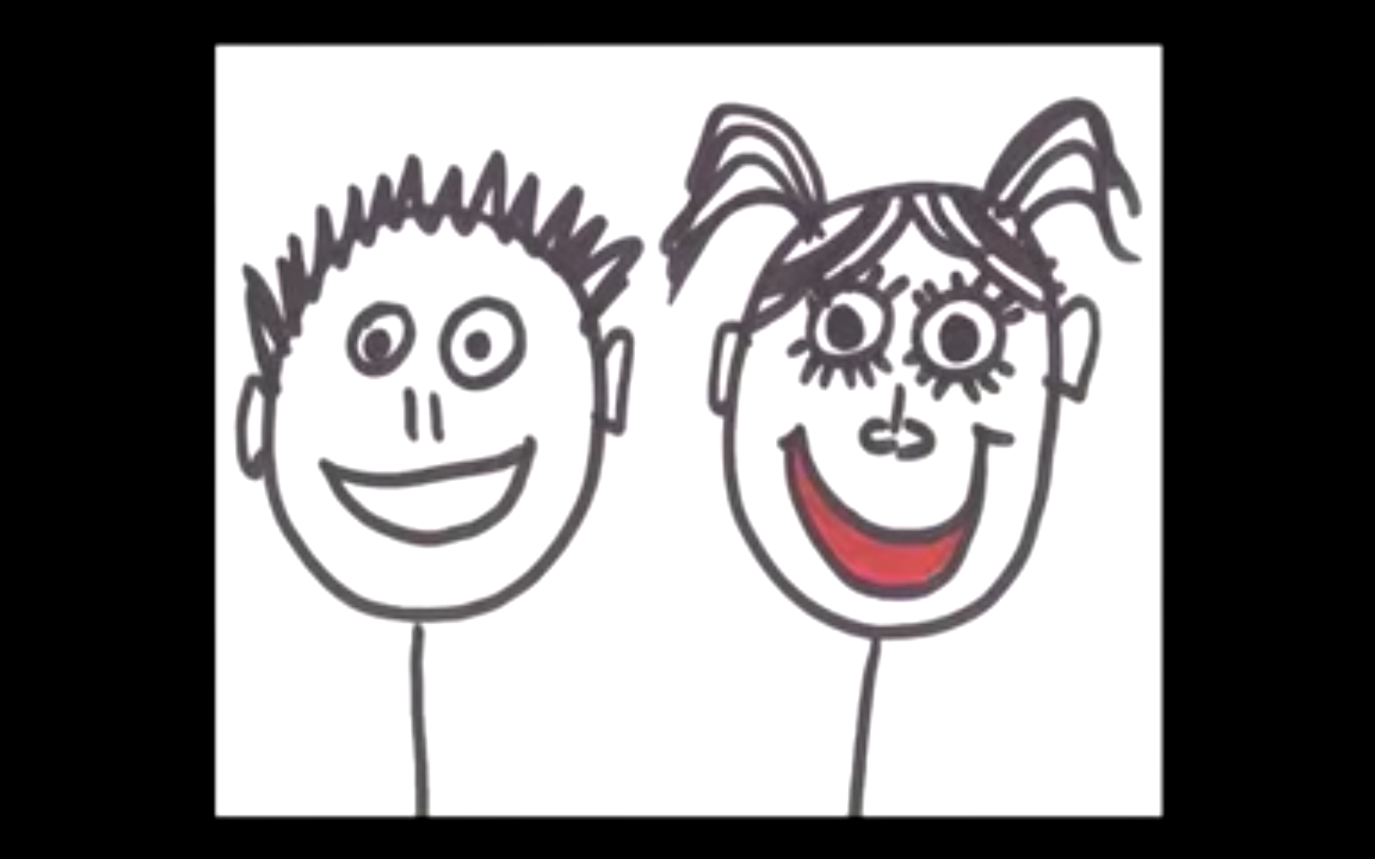

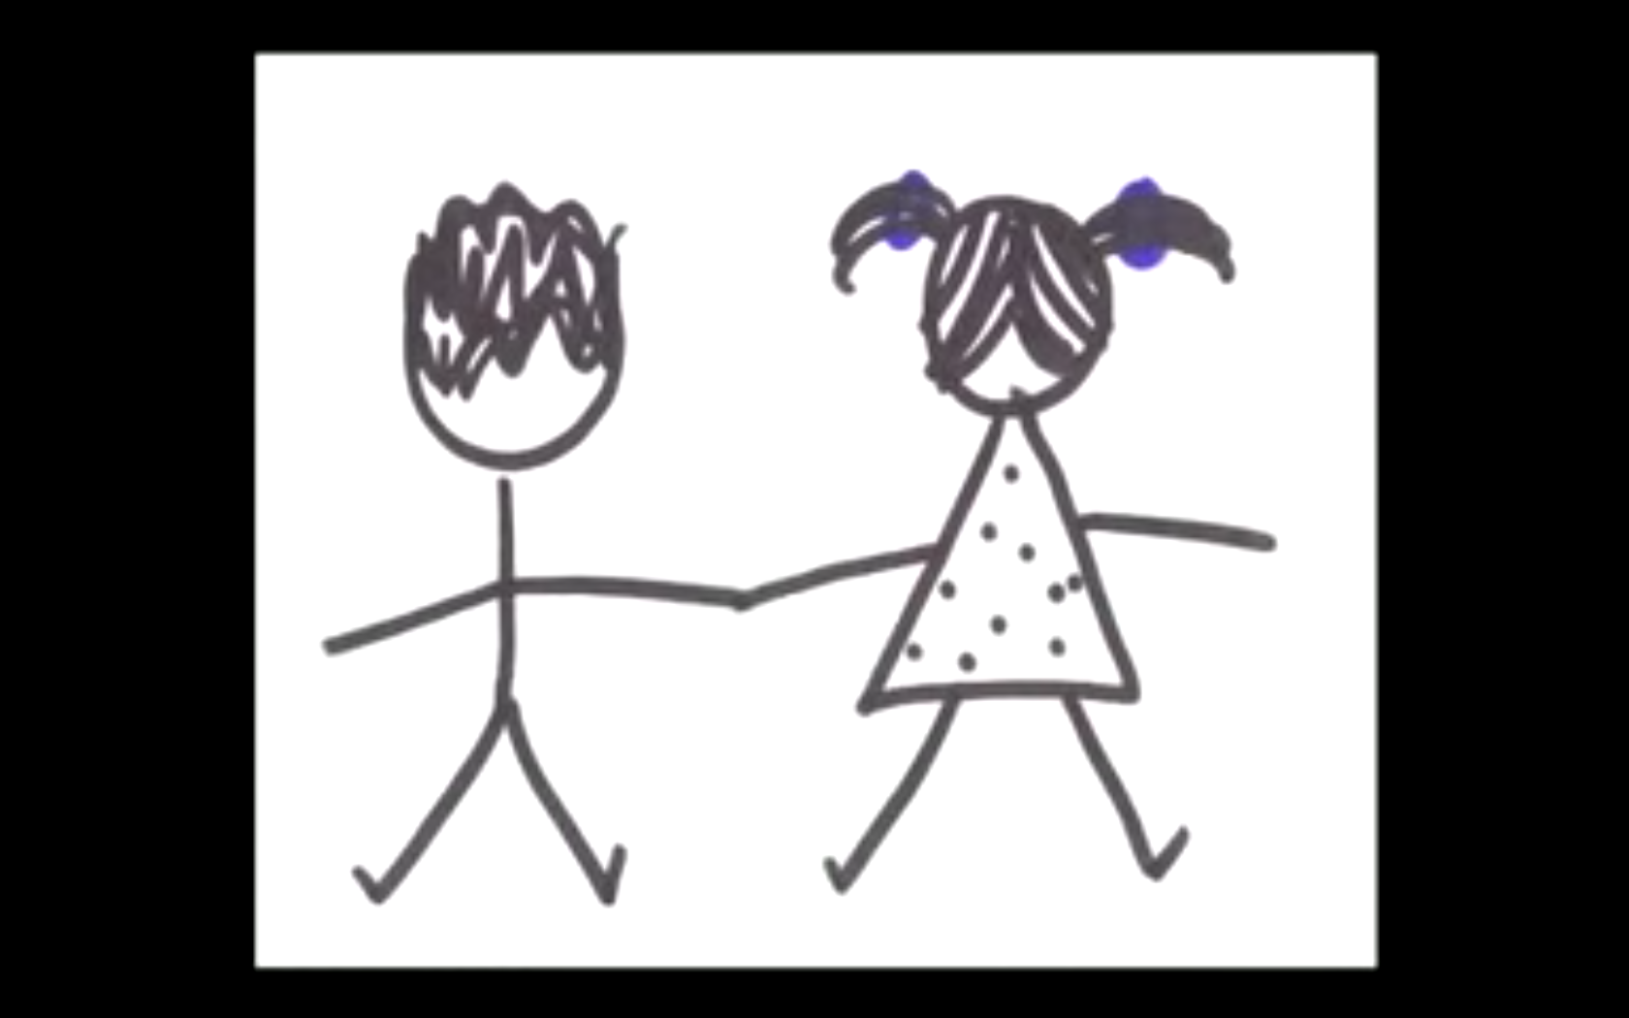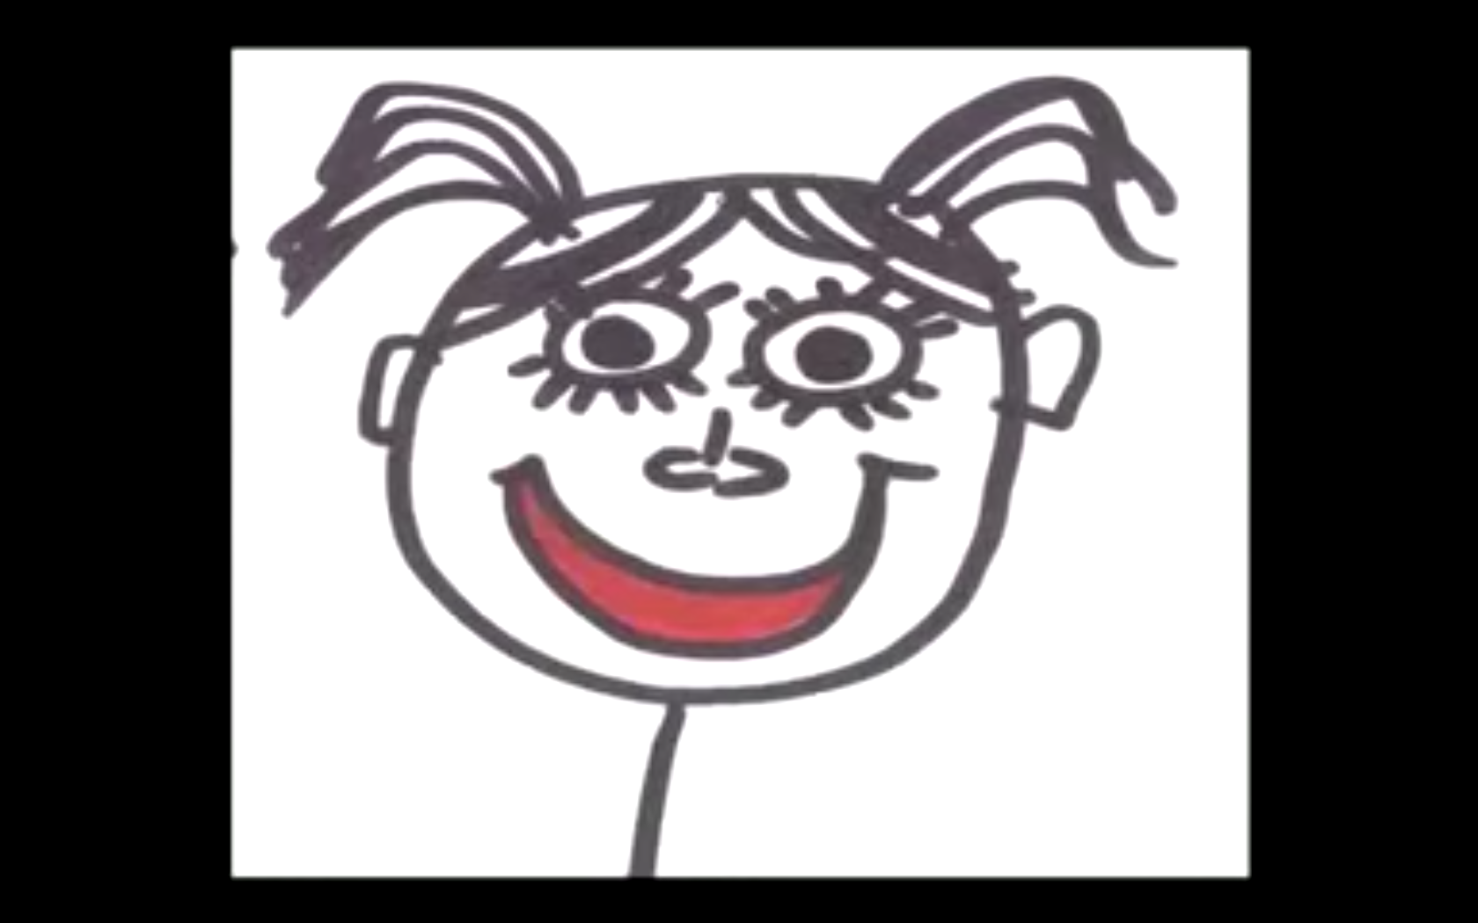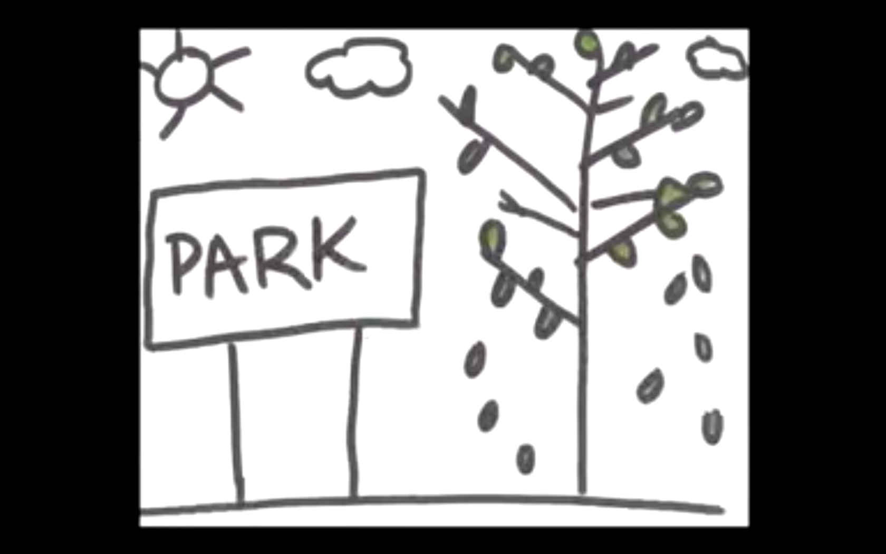
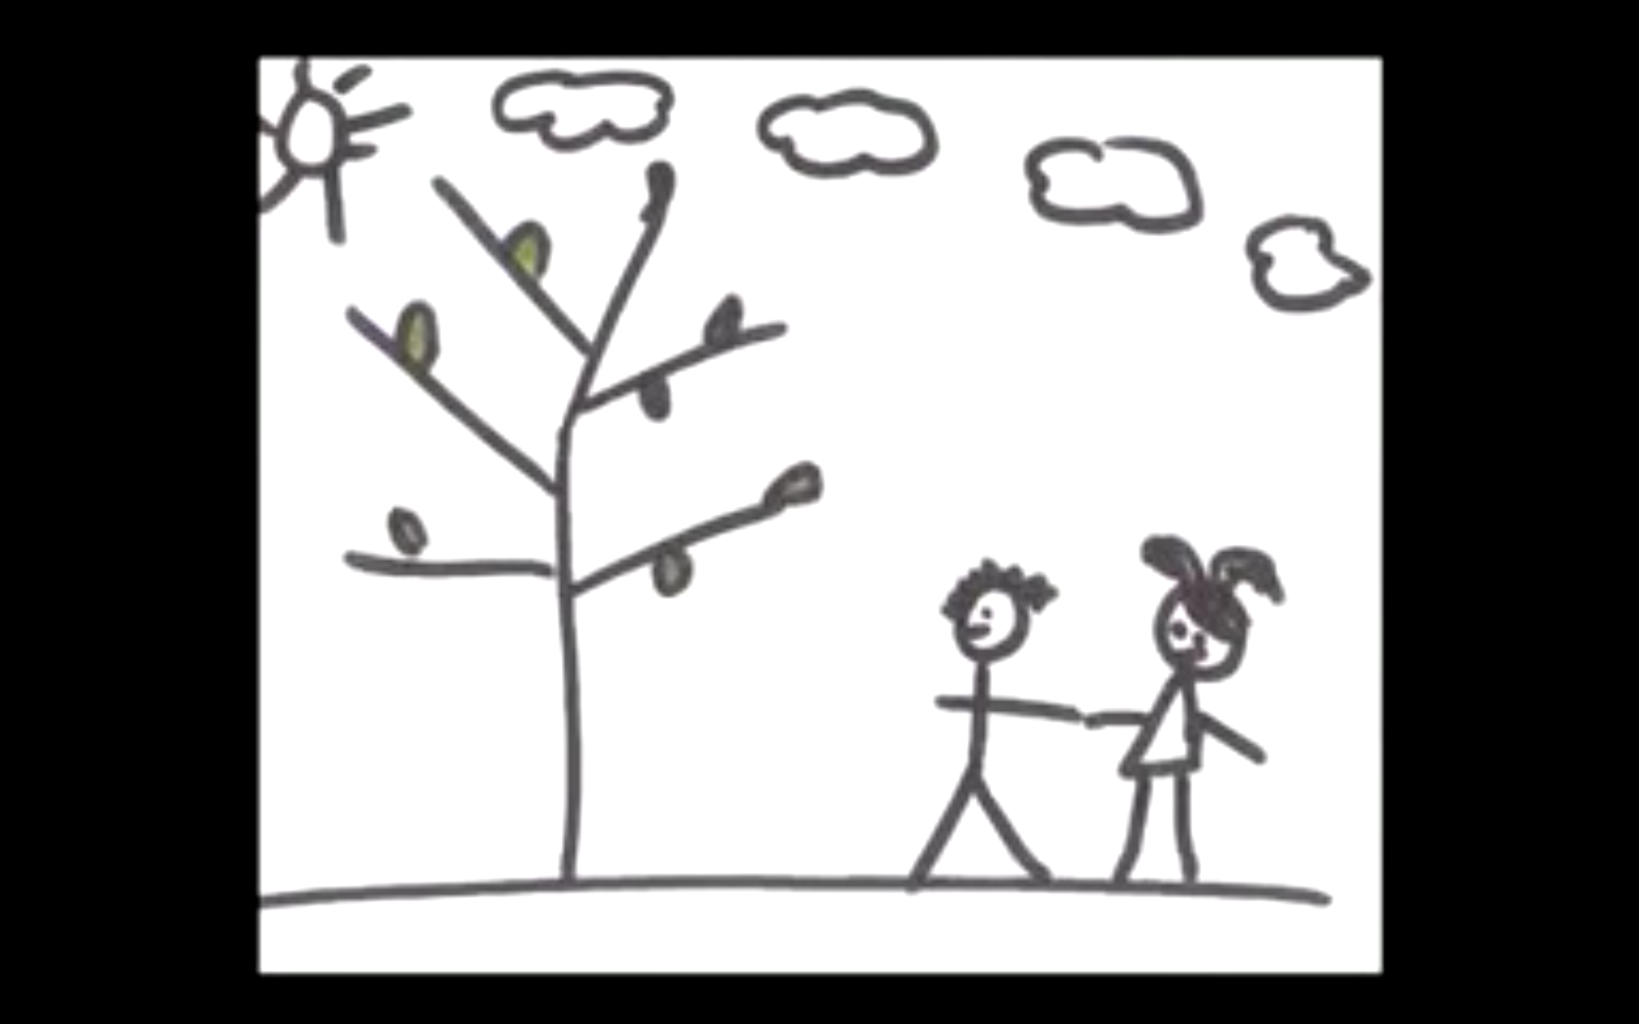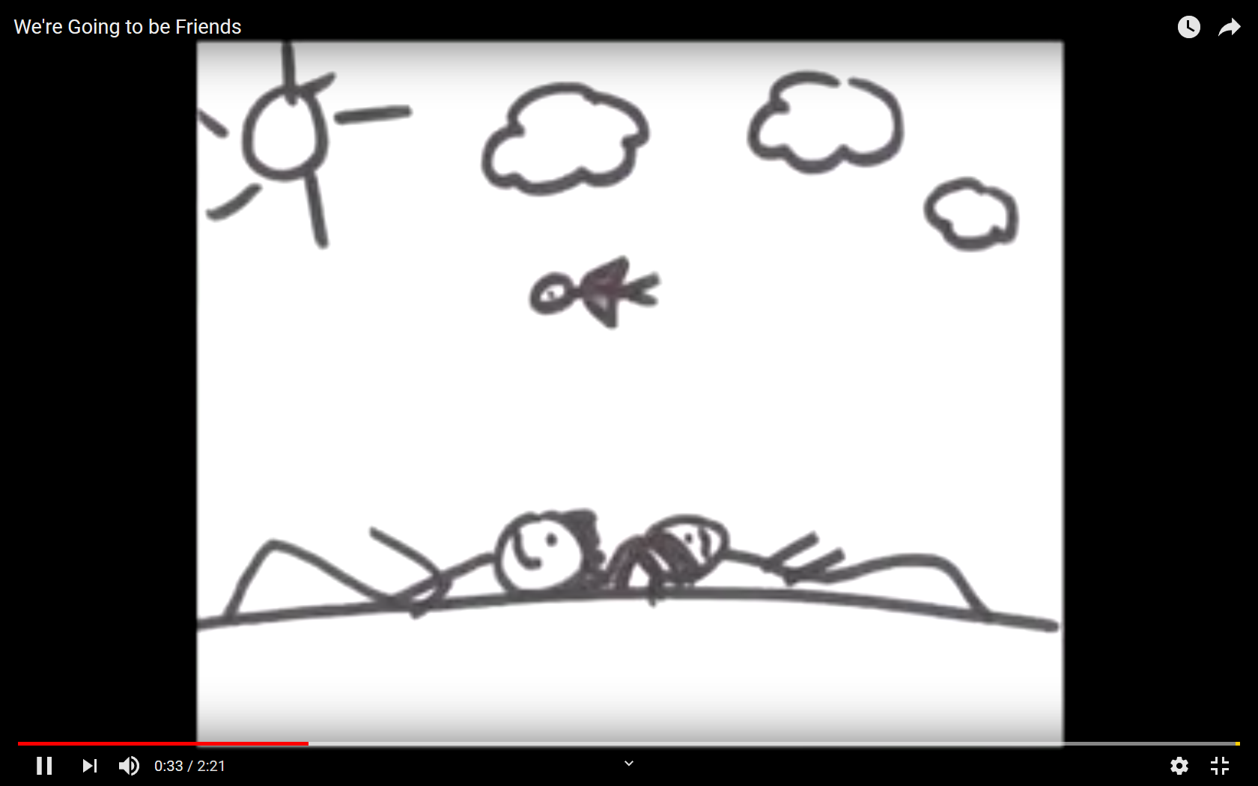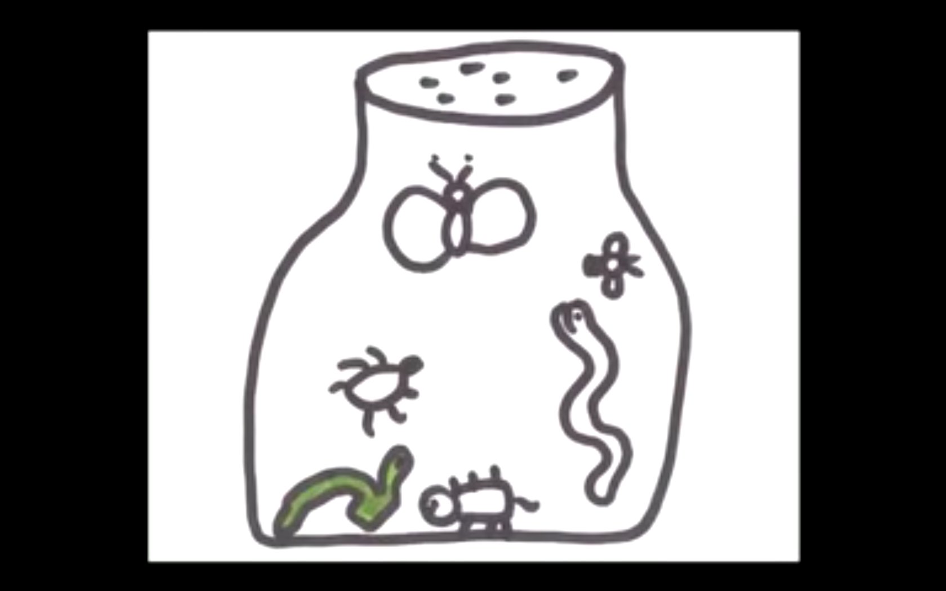
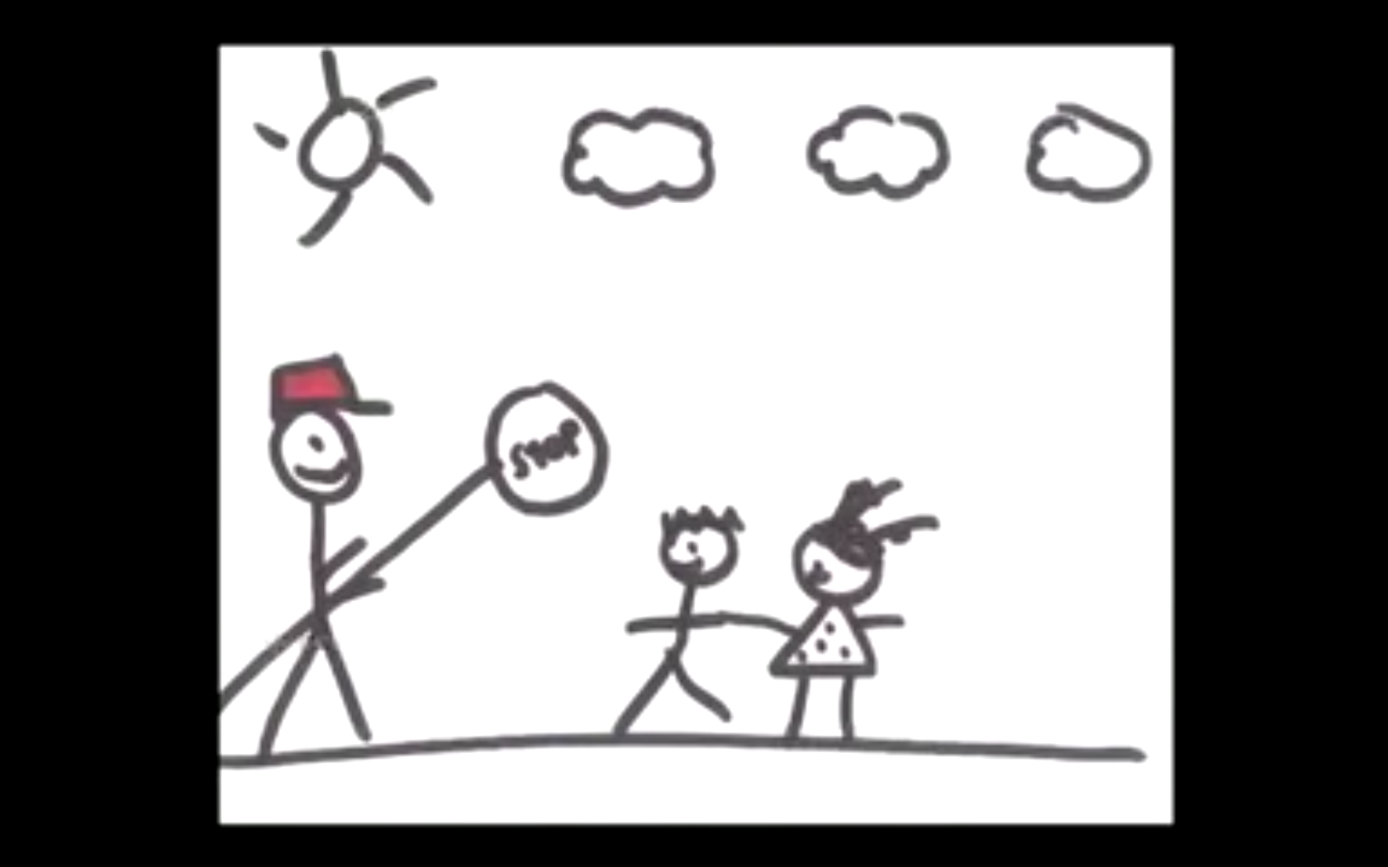

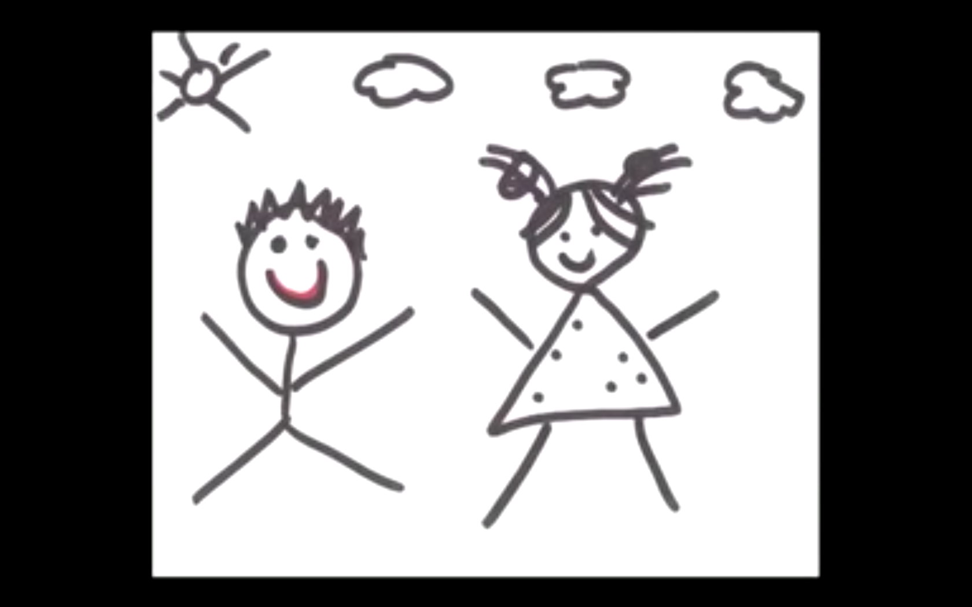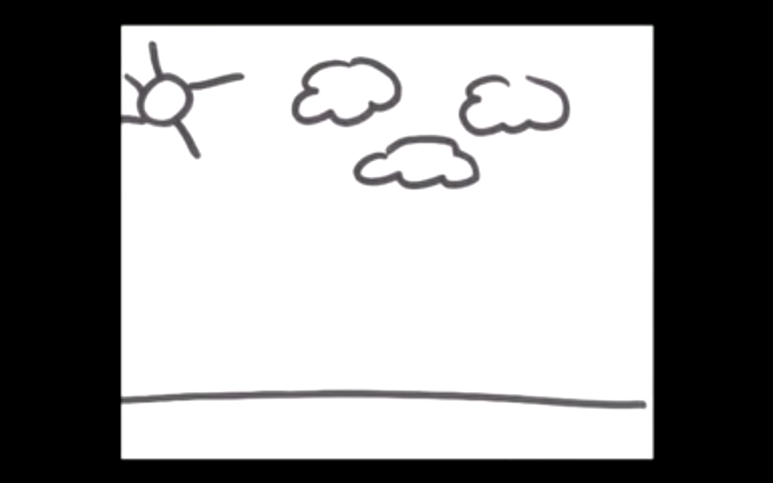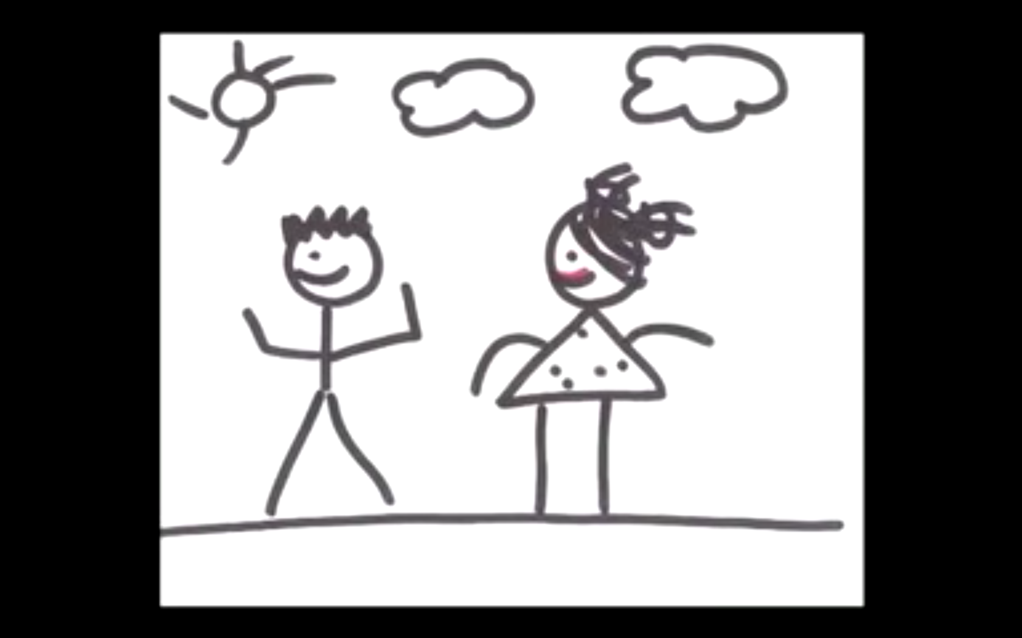
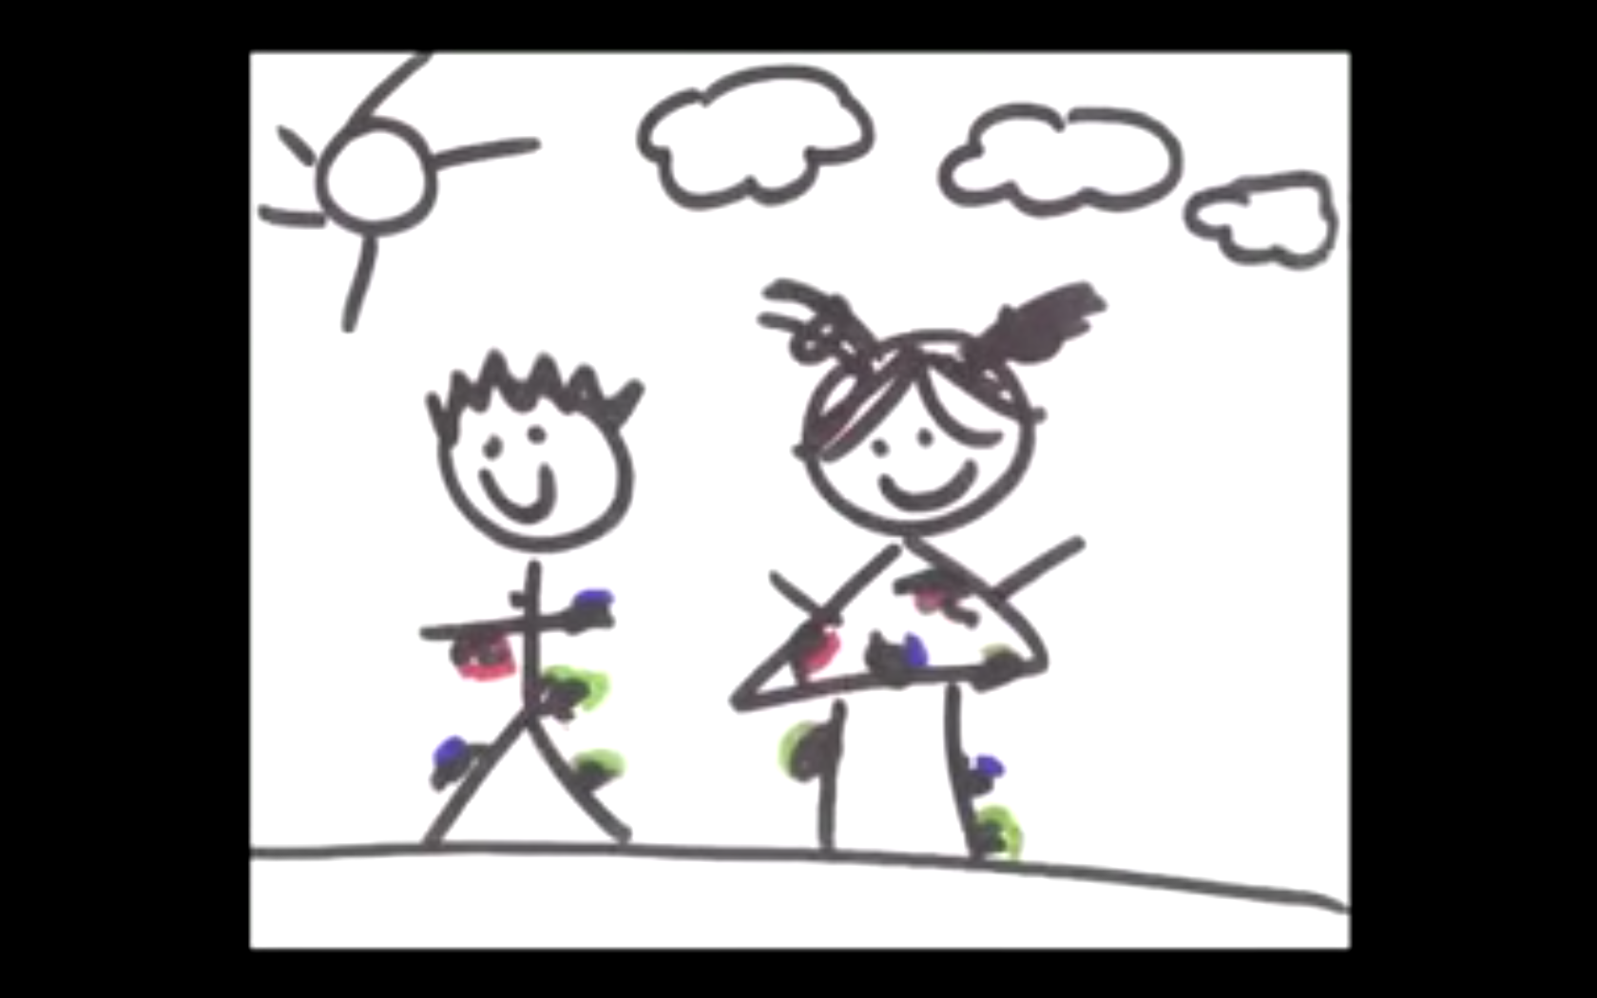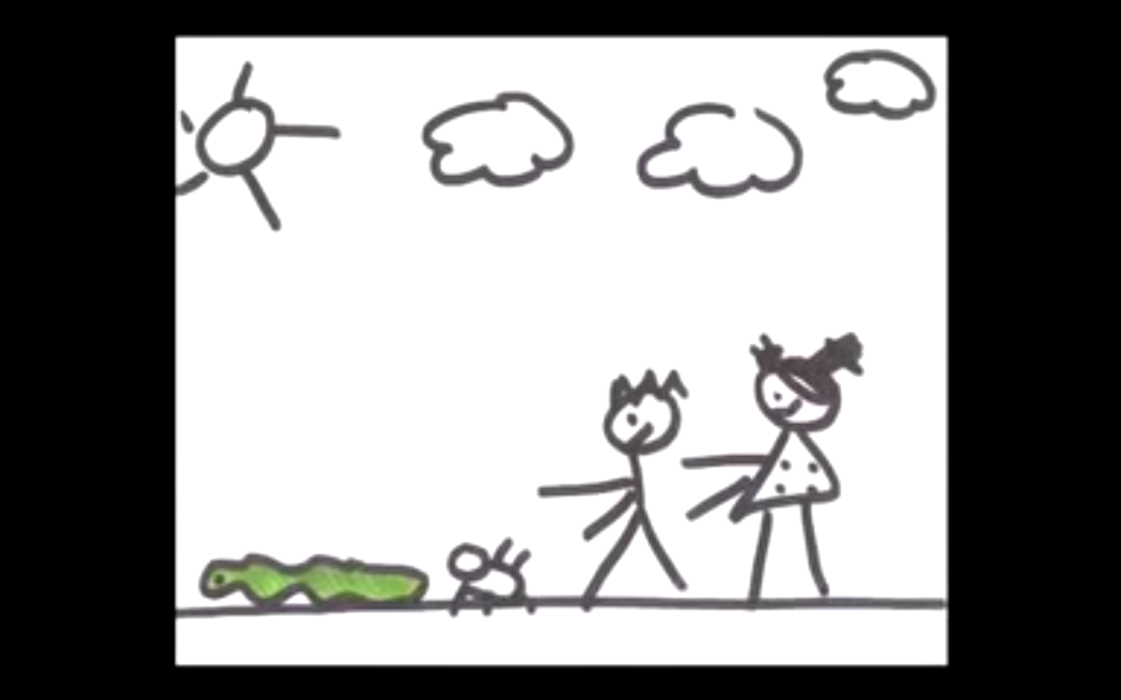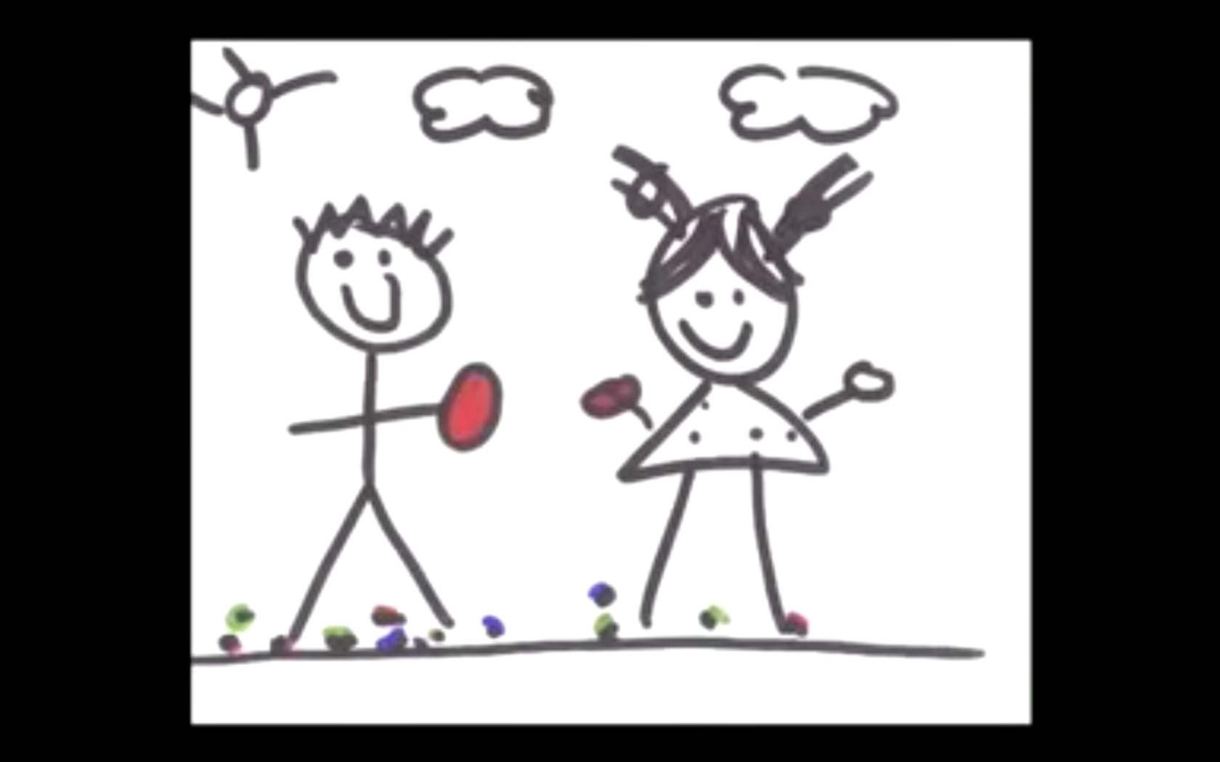

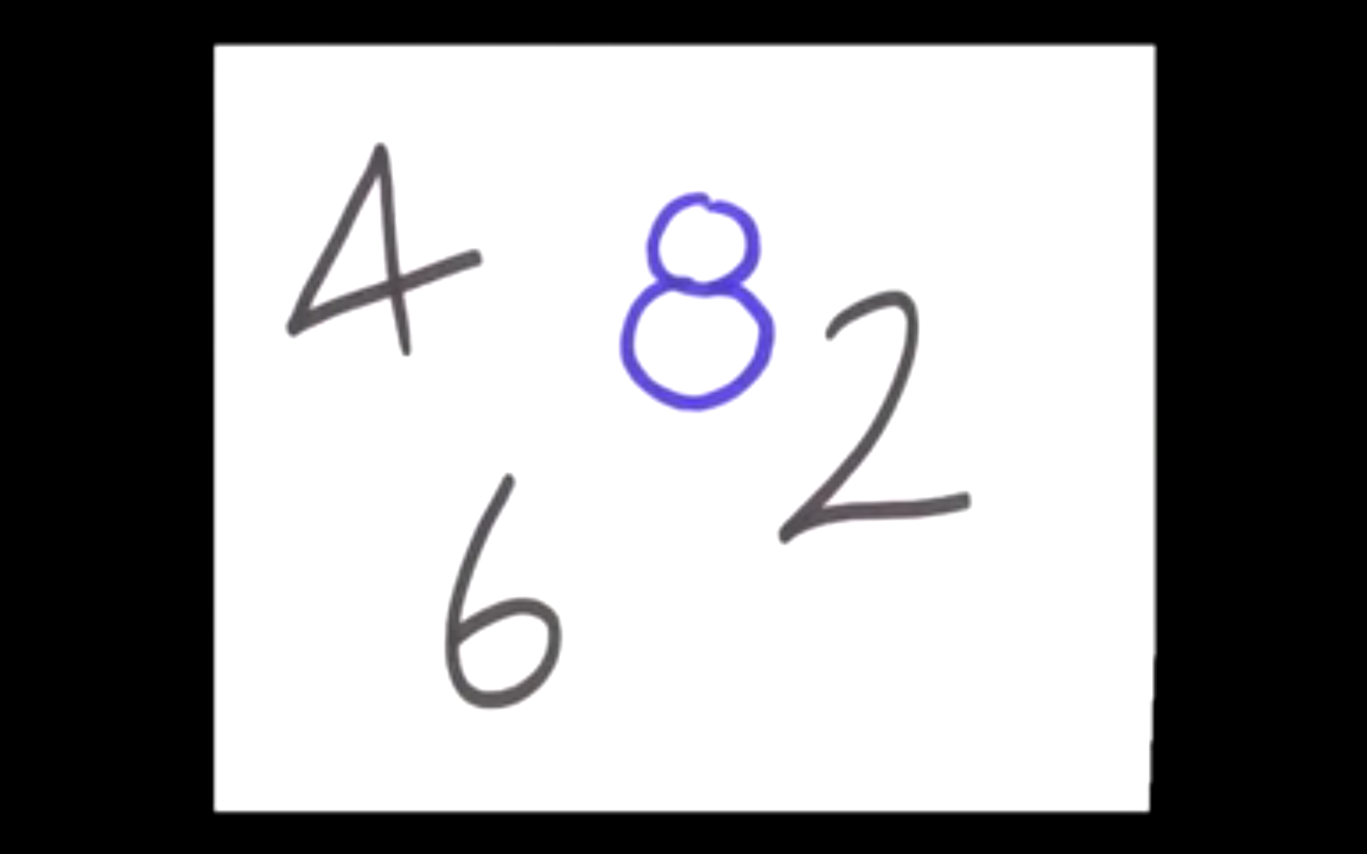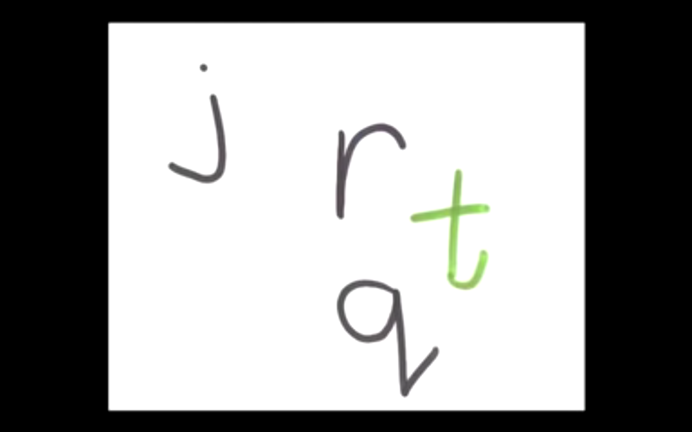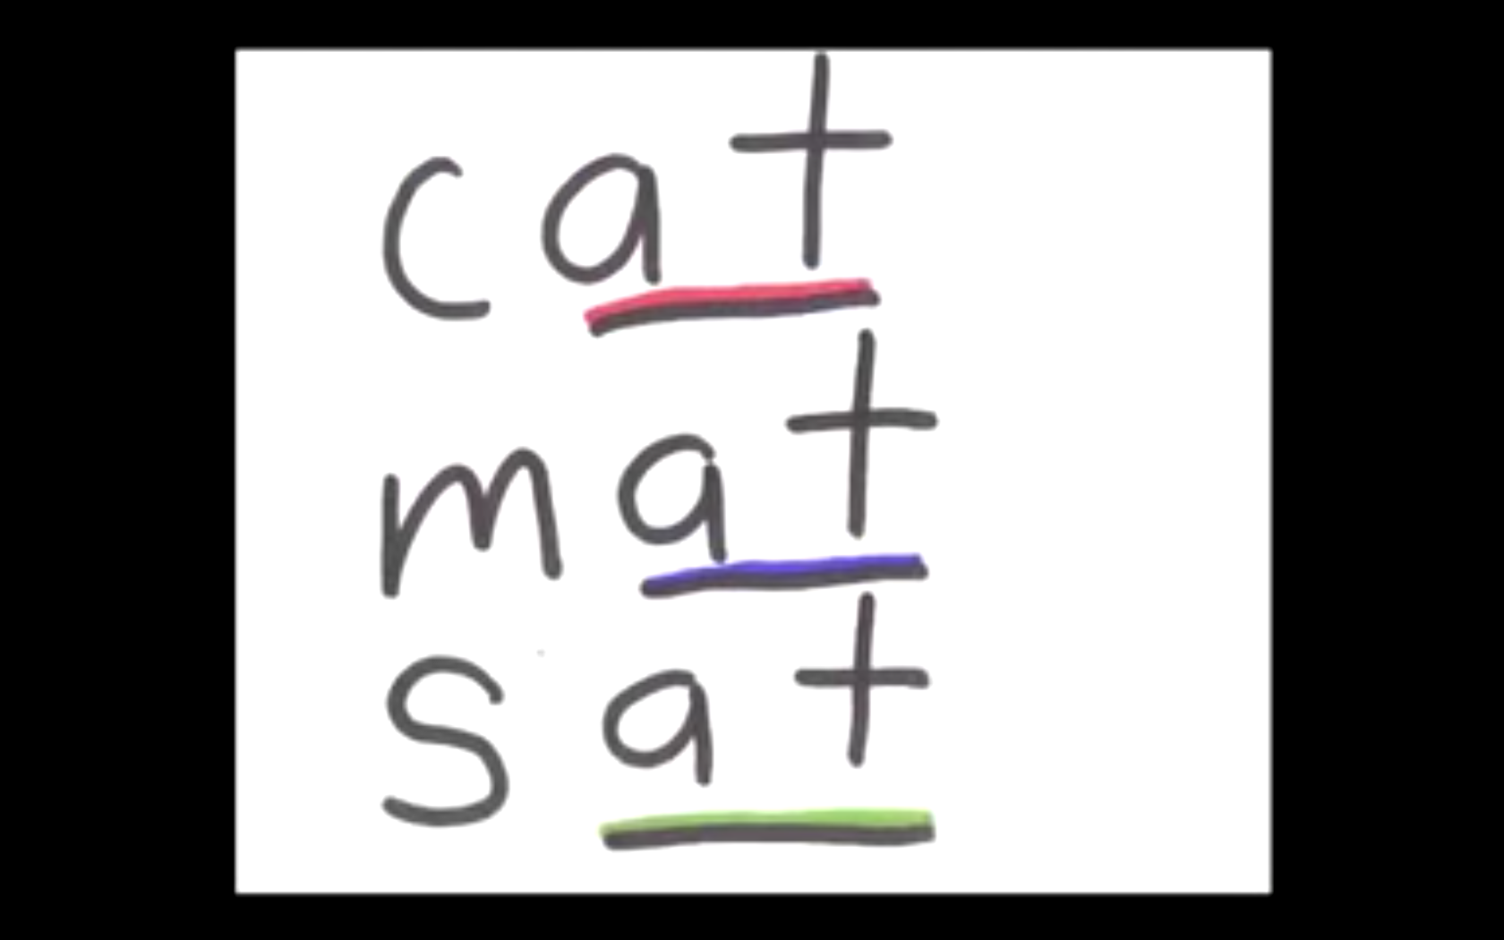
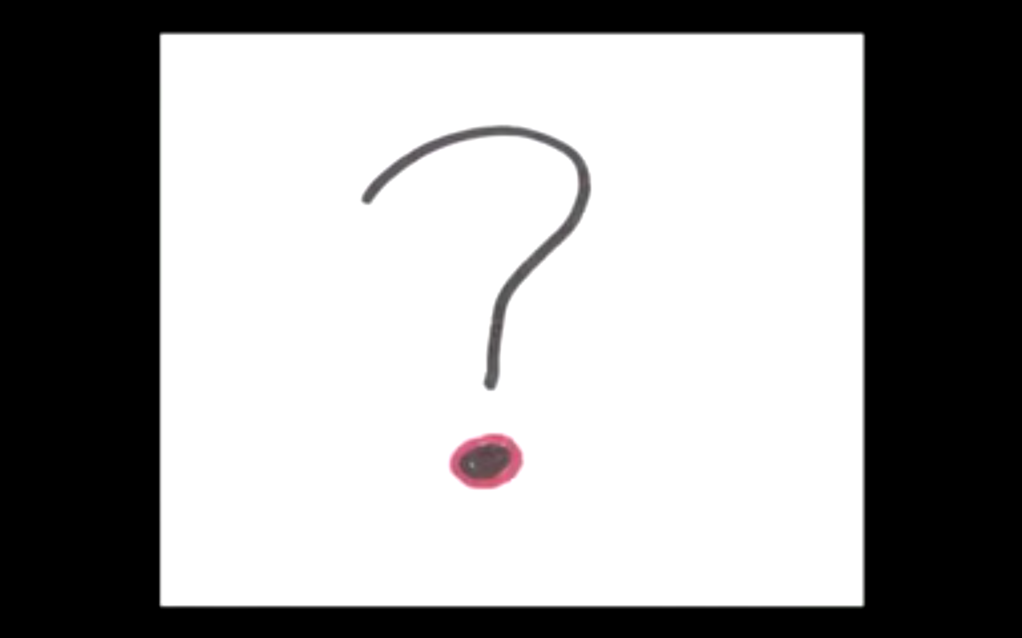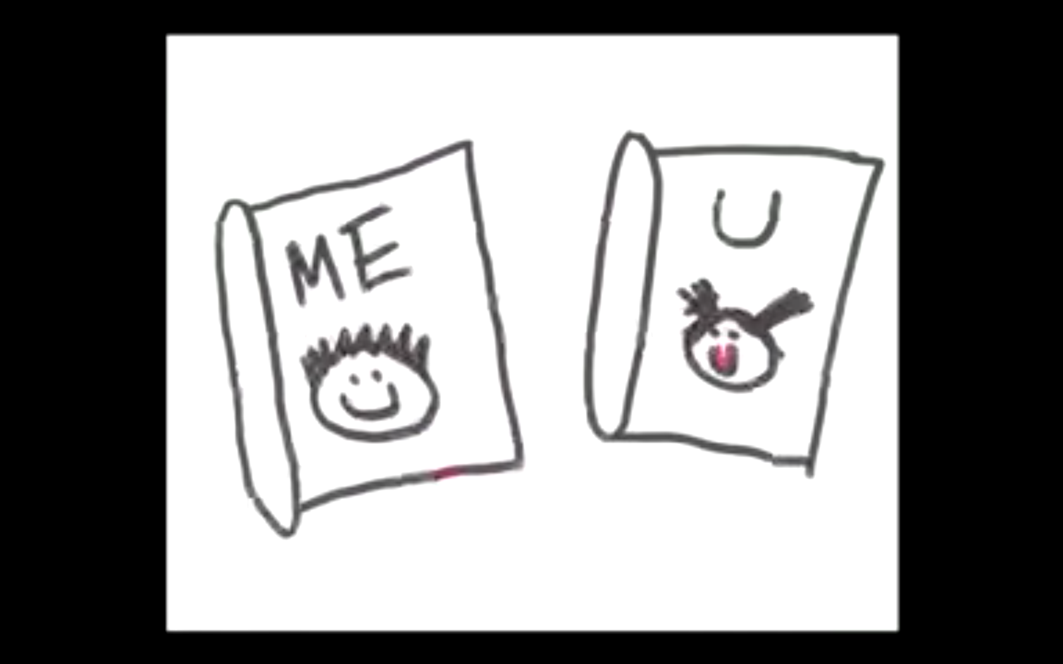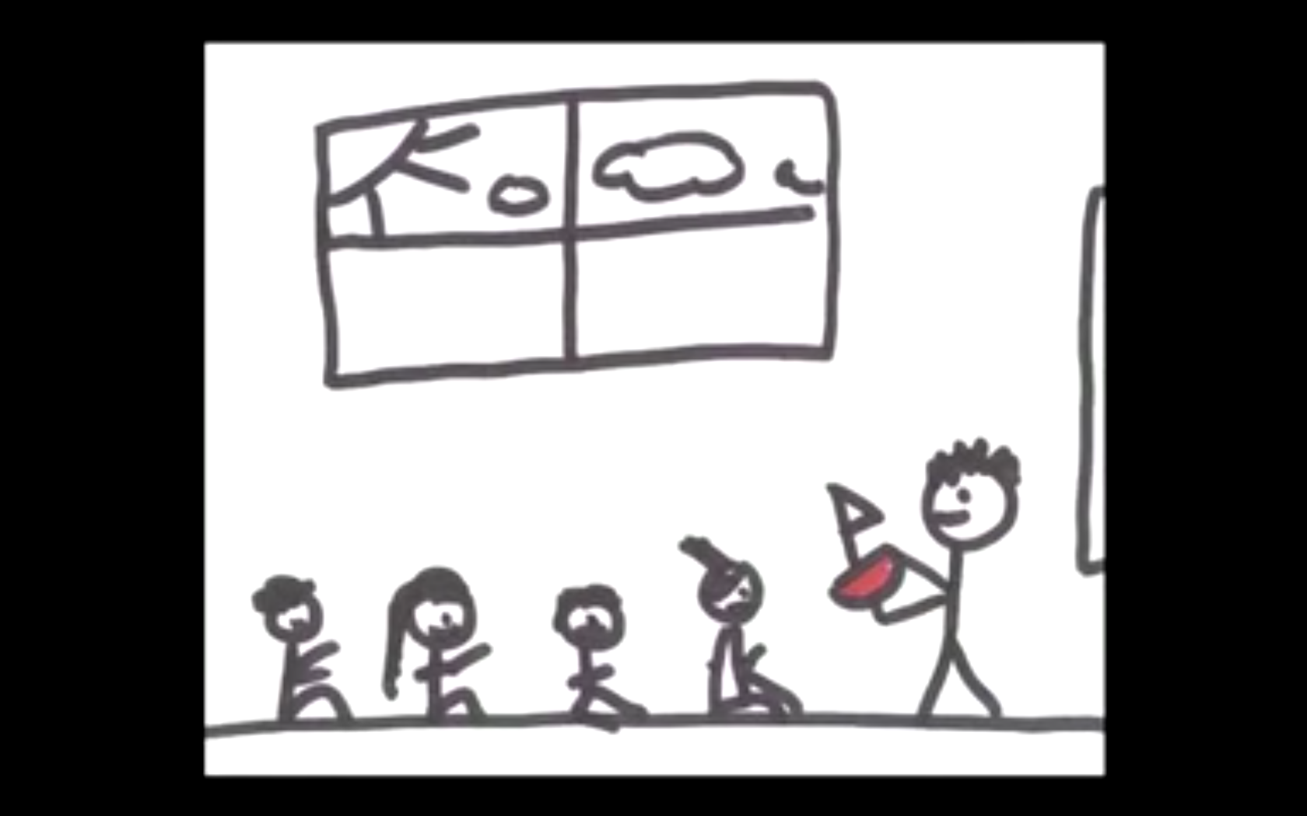
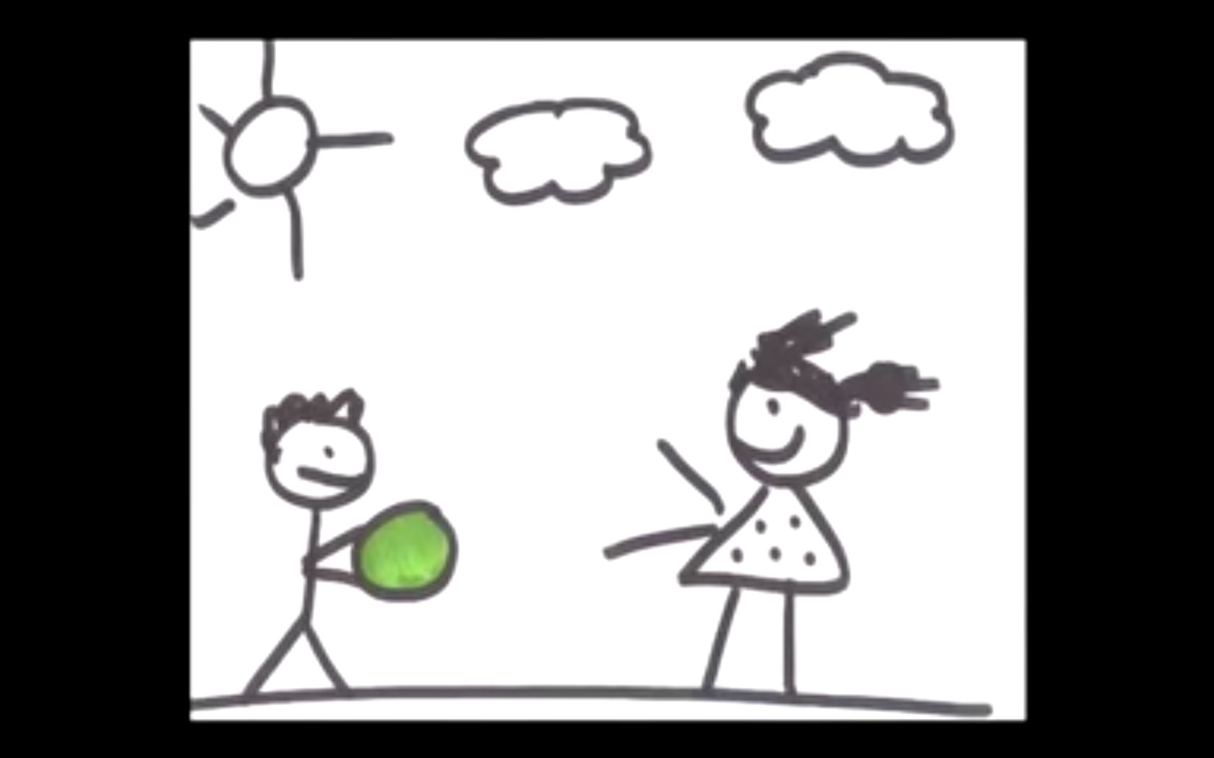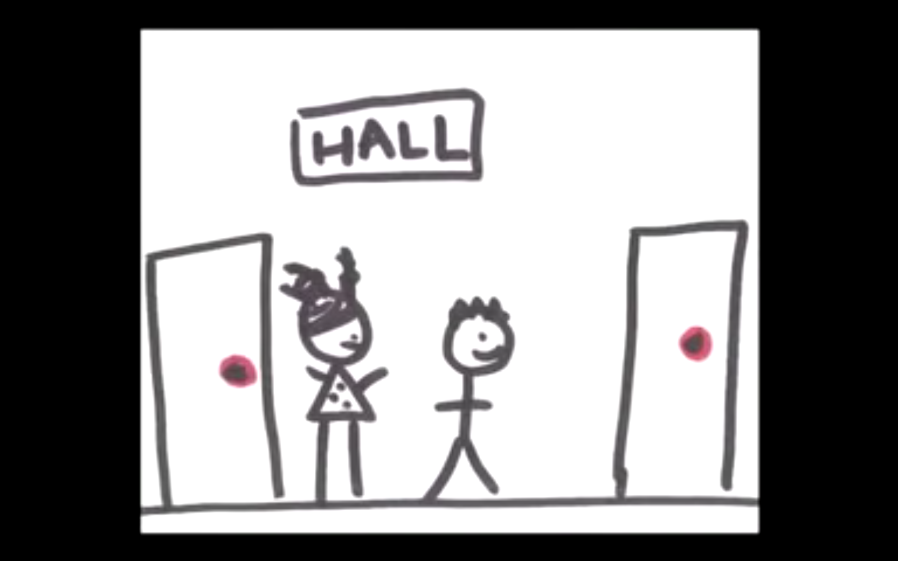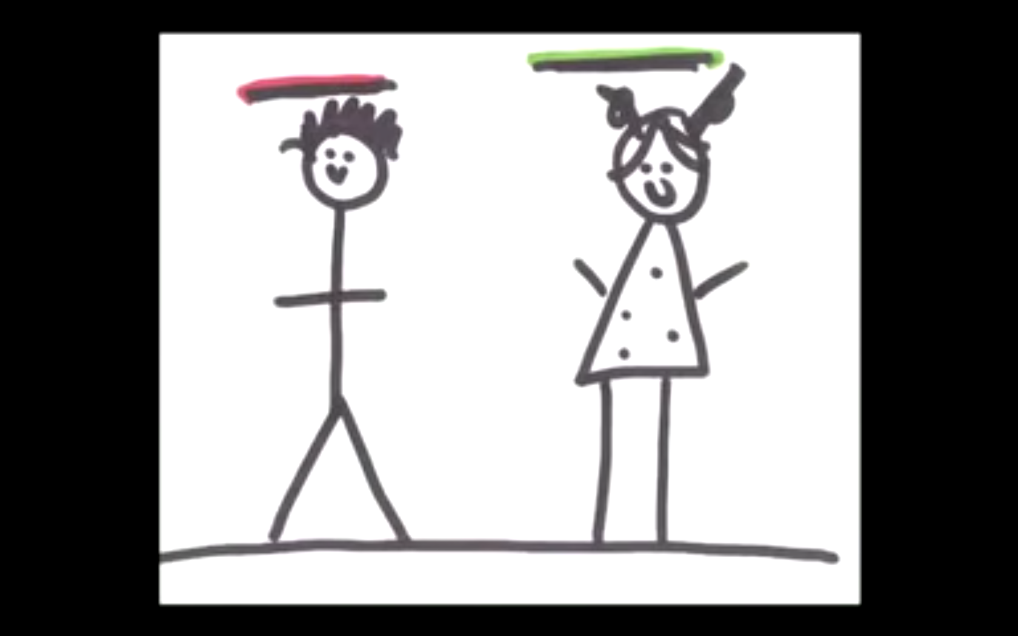

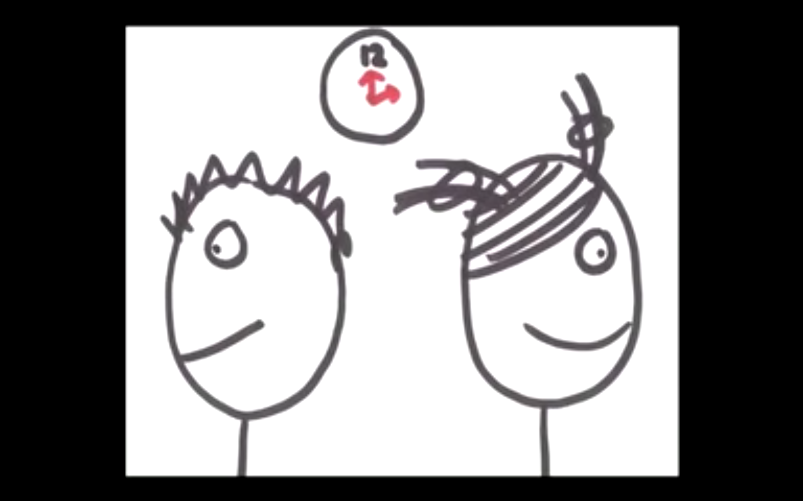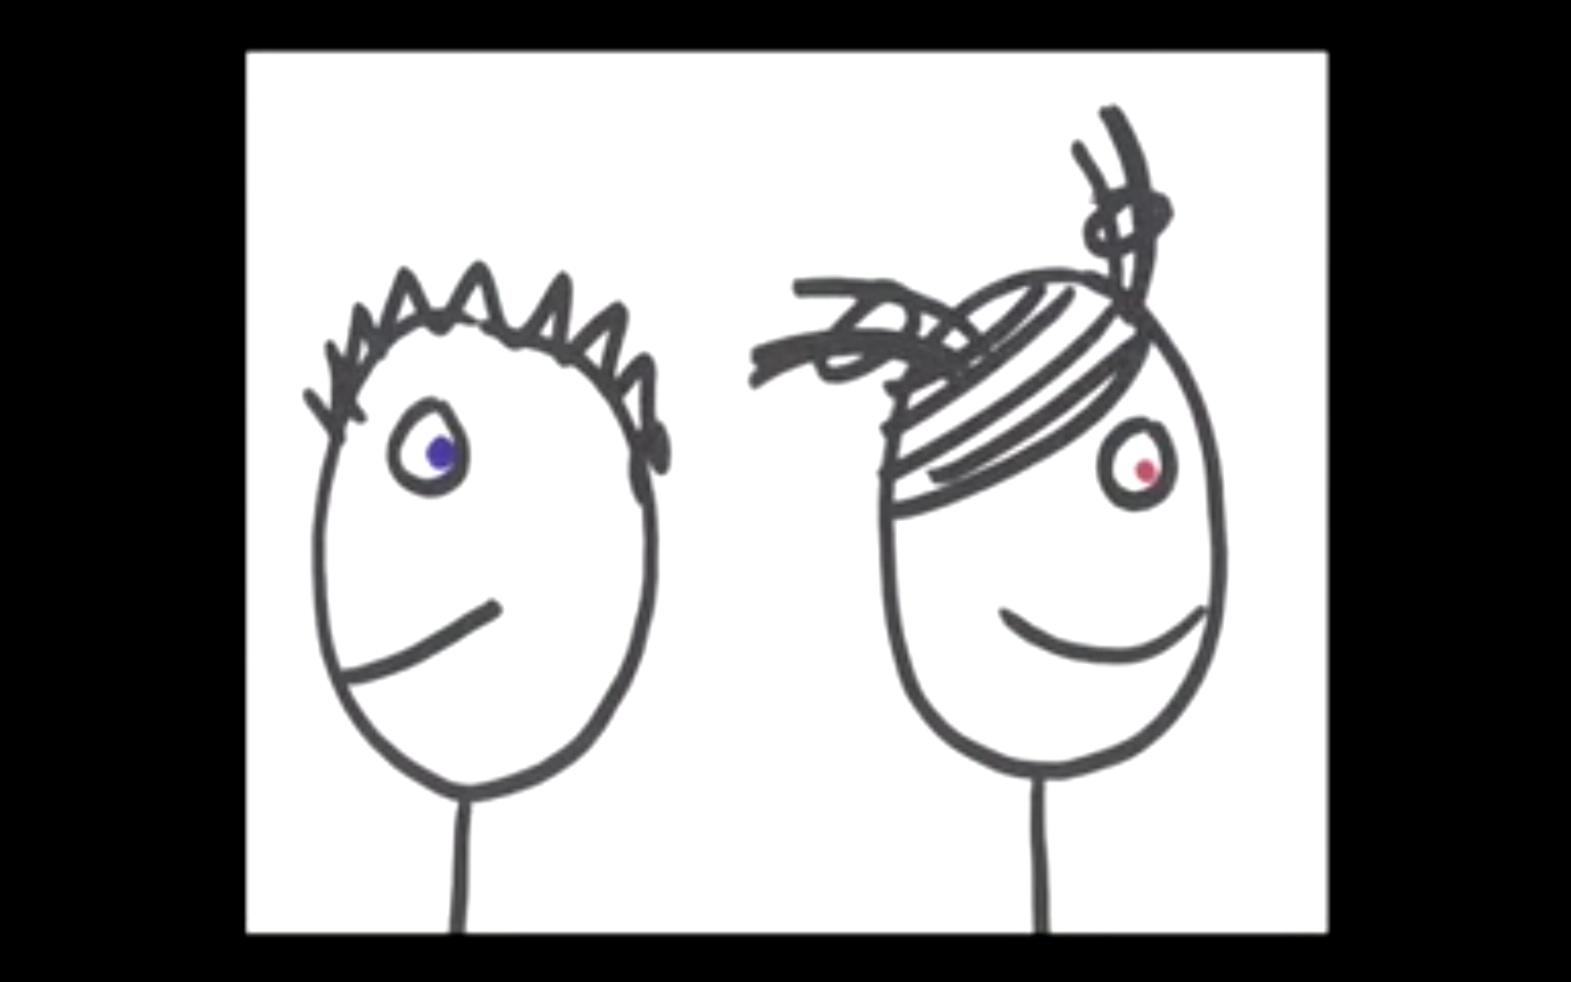
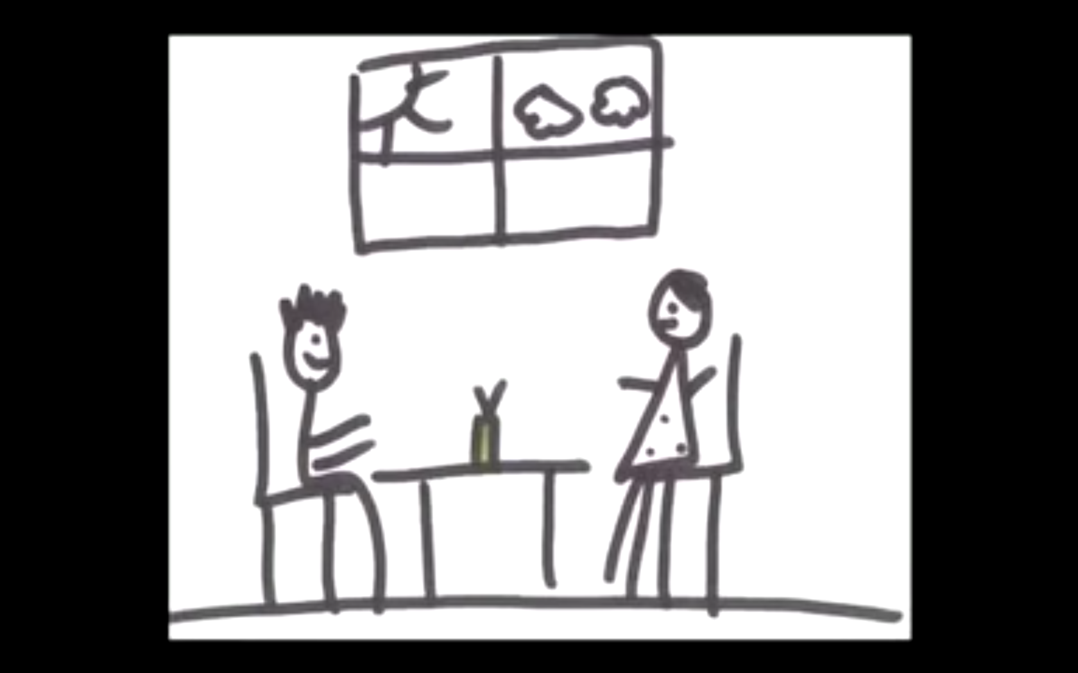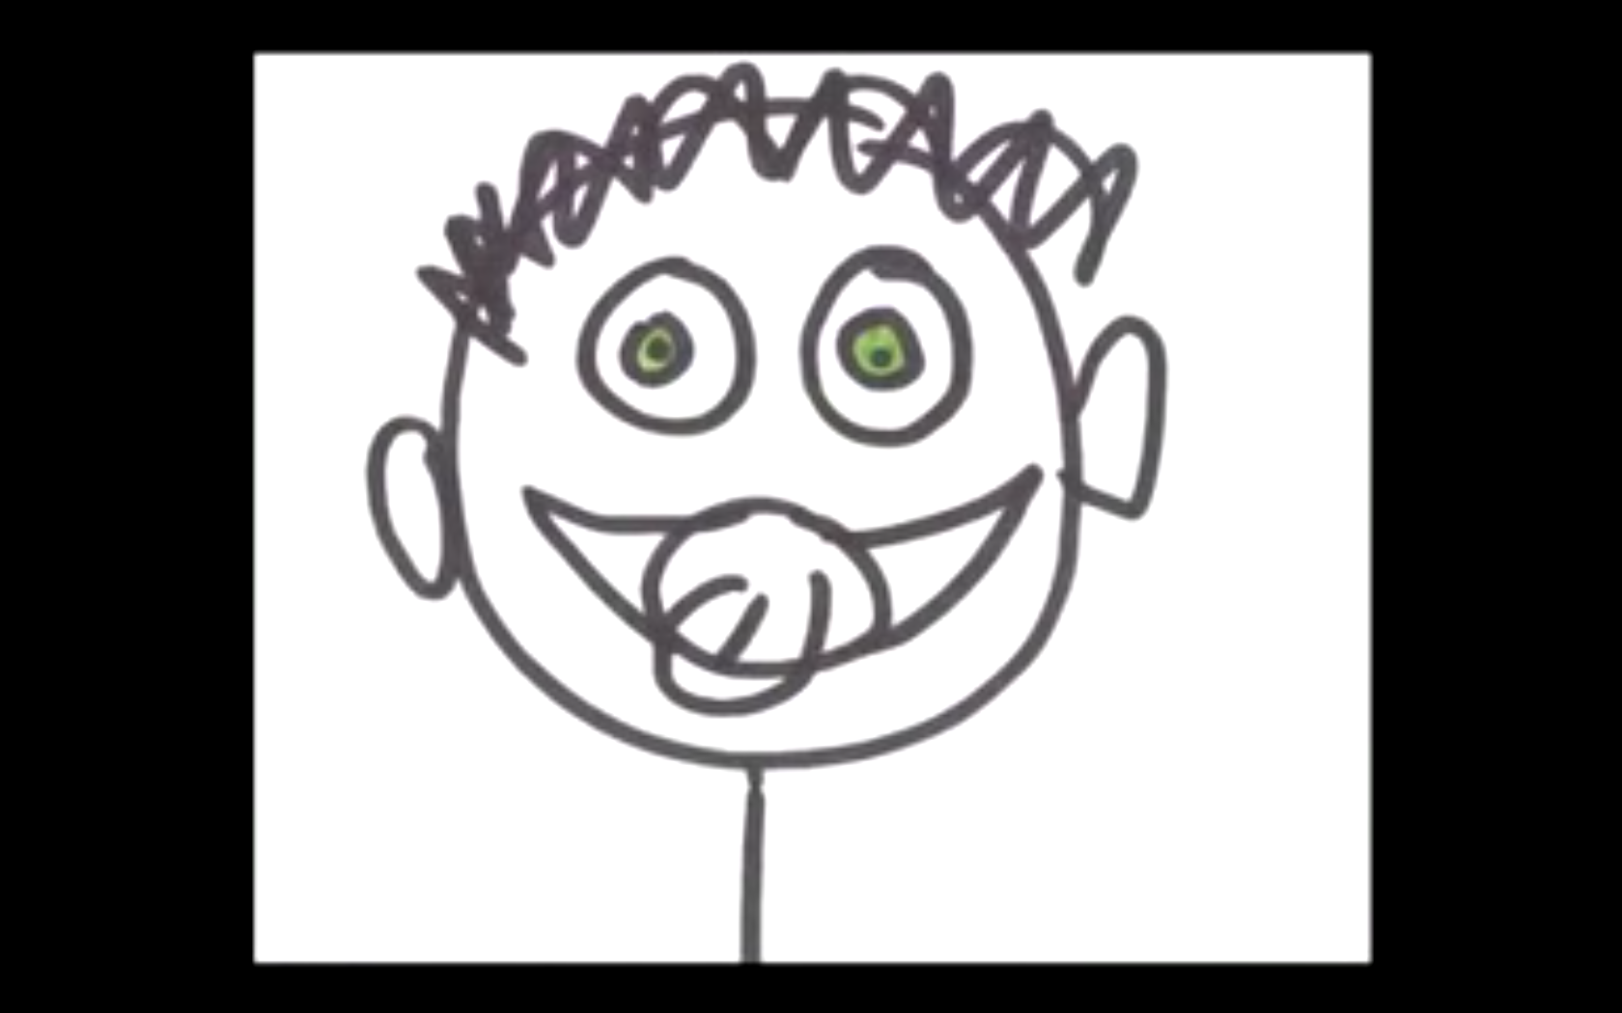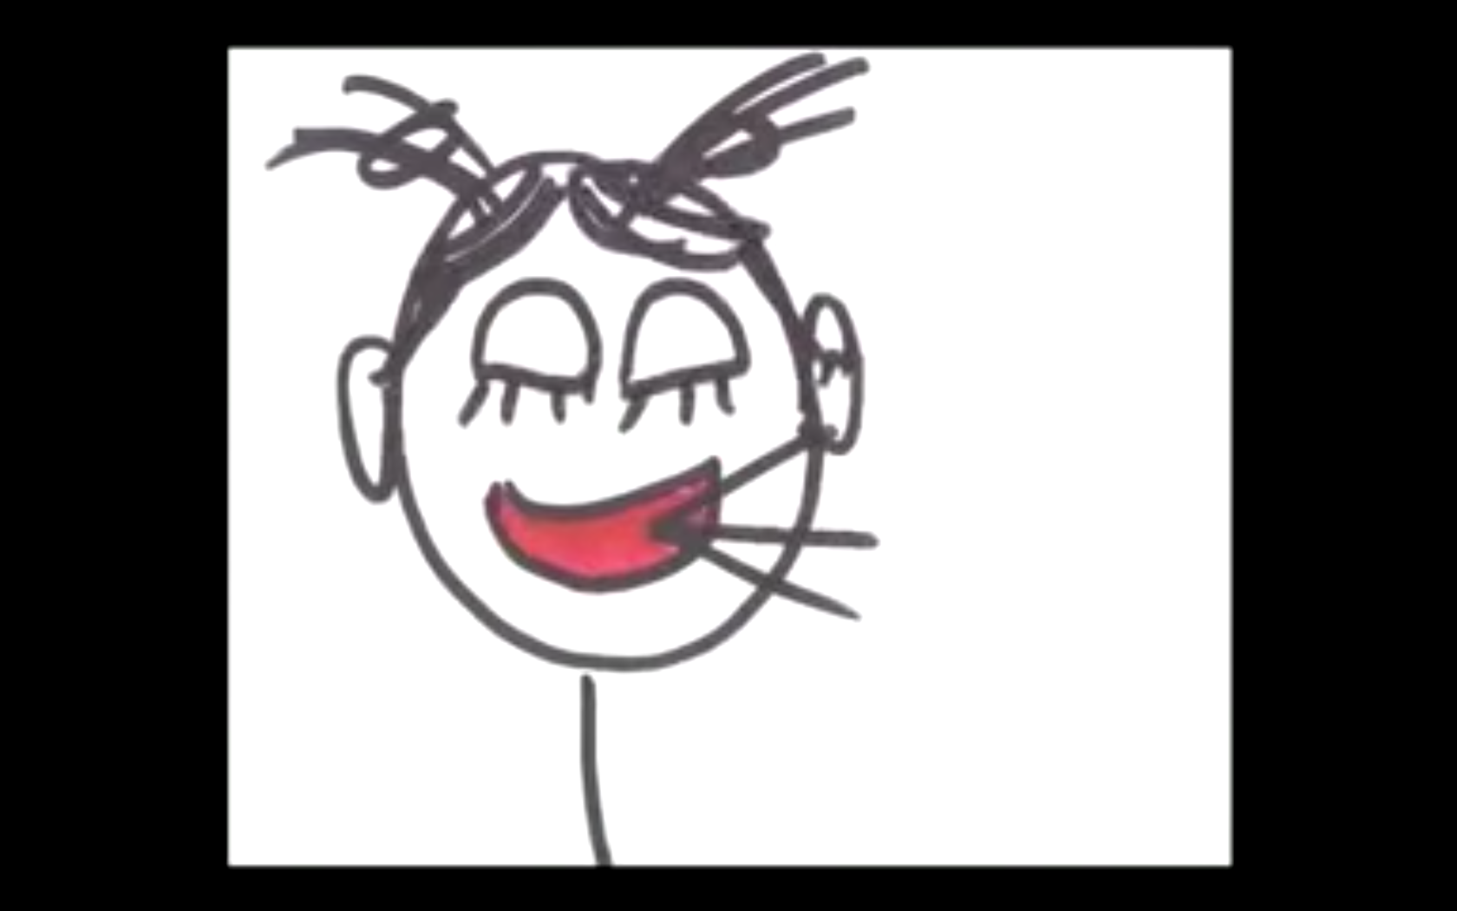
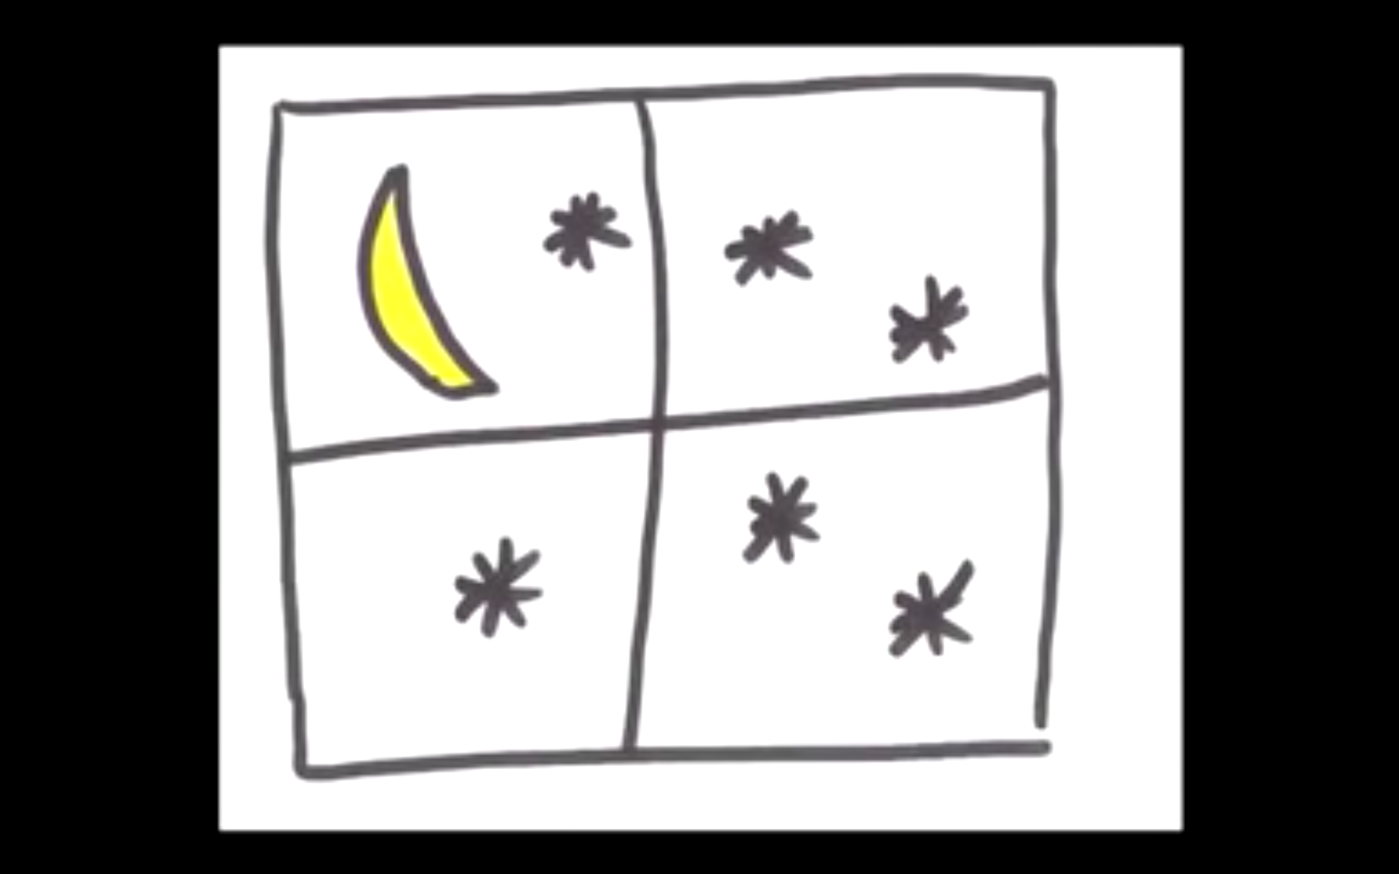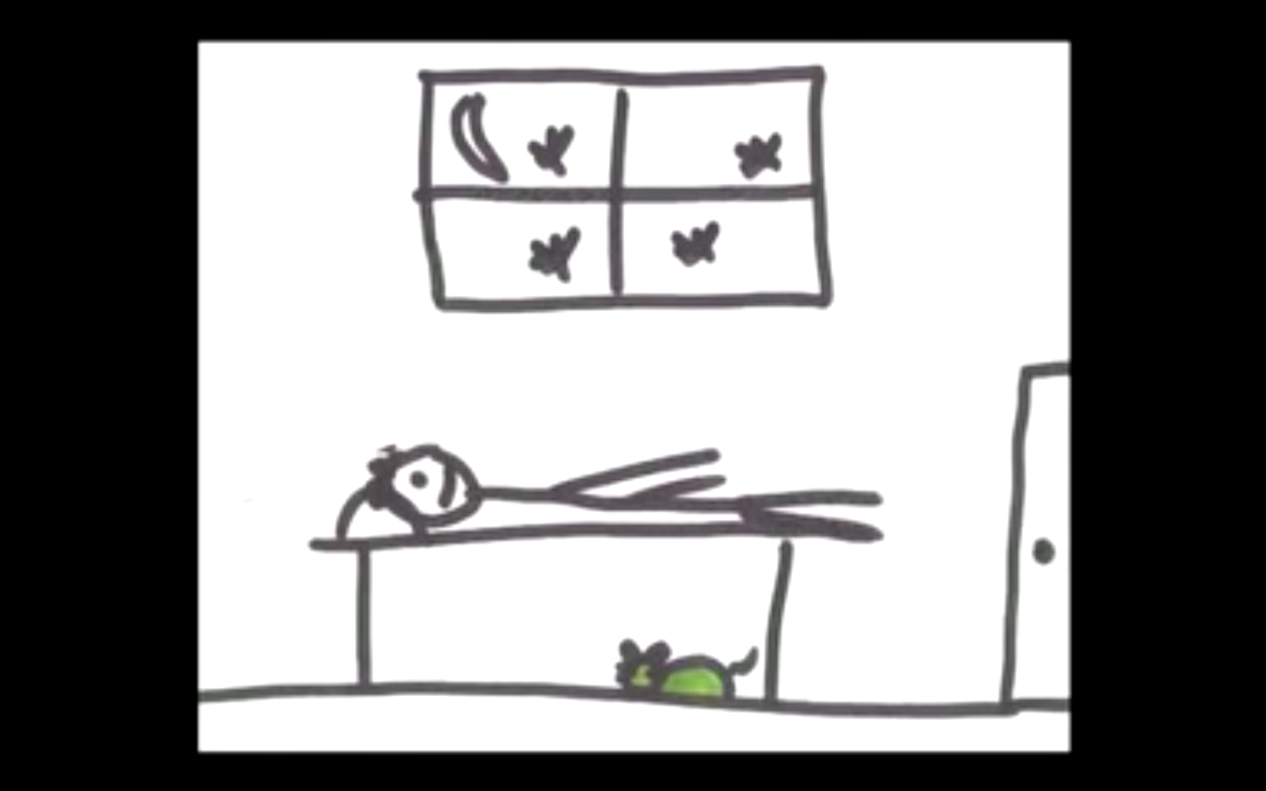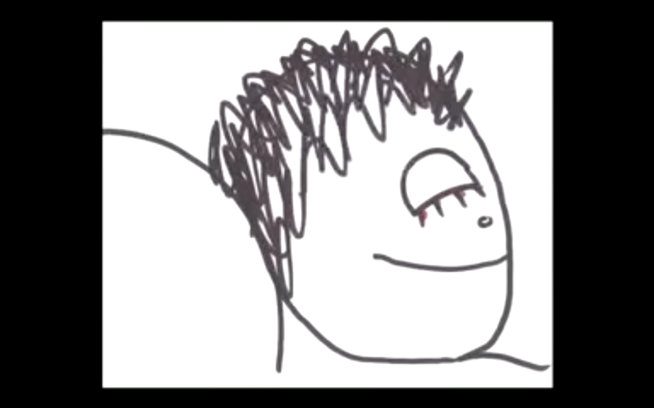
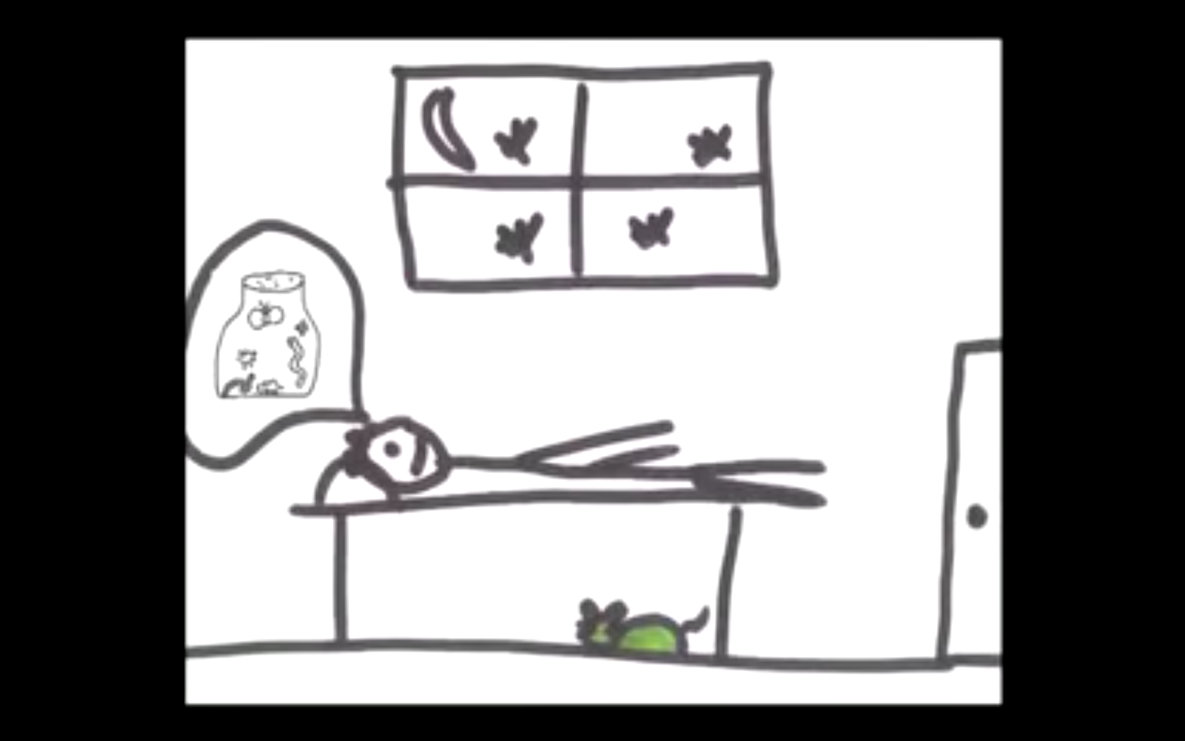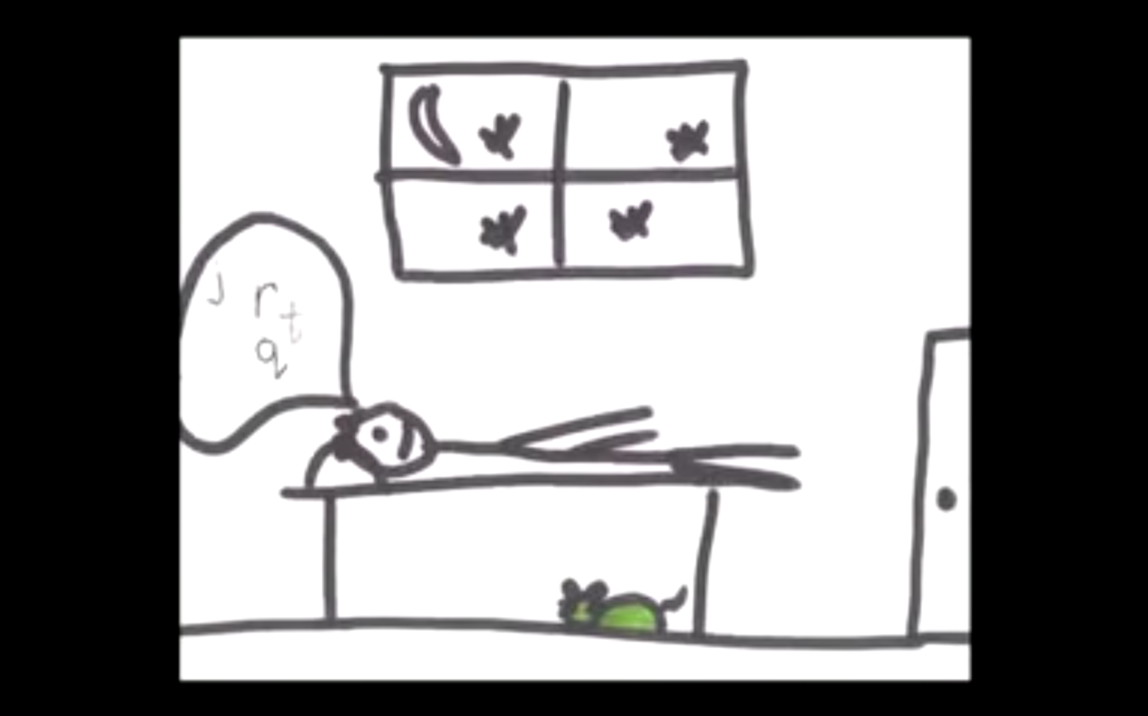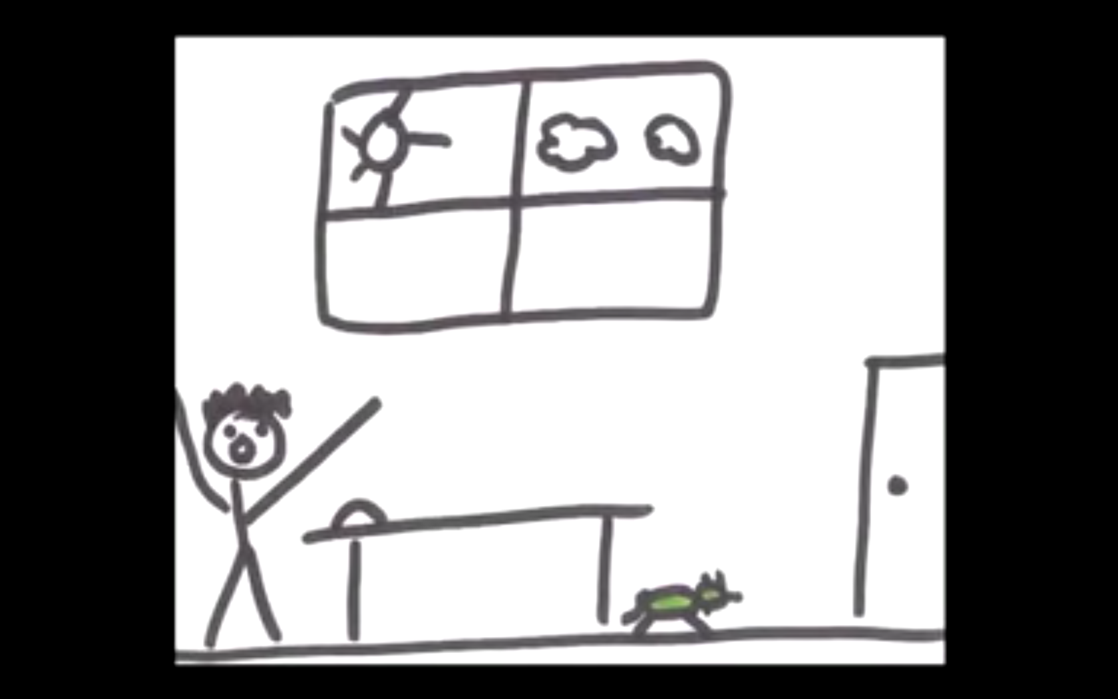
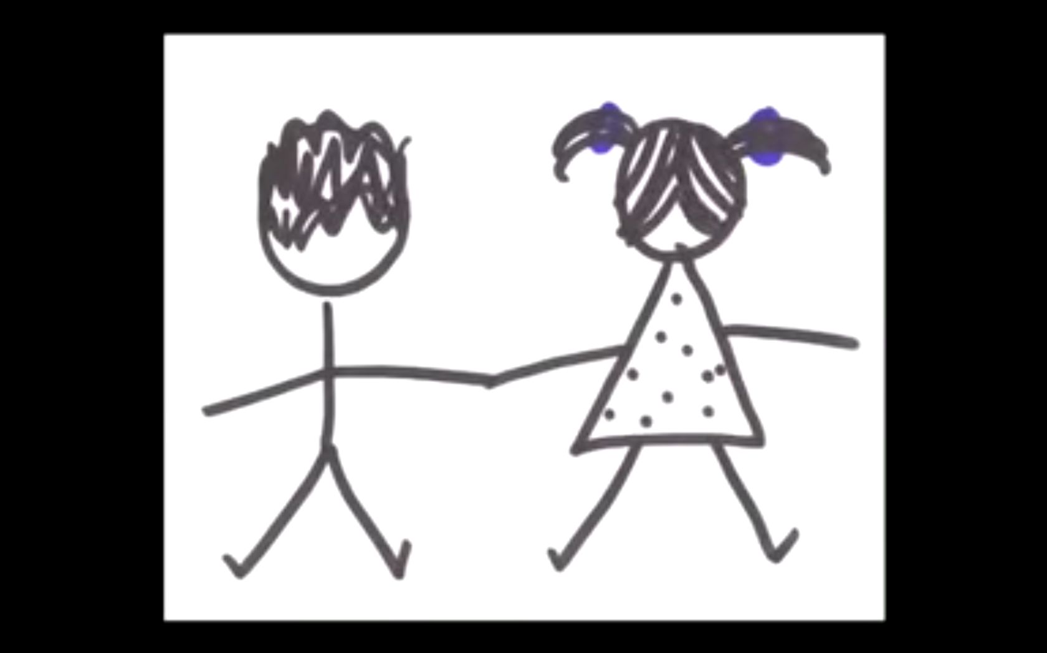

Activity 1 :
Listen to the song on the blog and look at the comic strip. Then, fill in the mindmap with your ideas about what the song tells (écris dans le cahier après avoir mis la date)
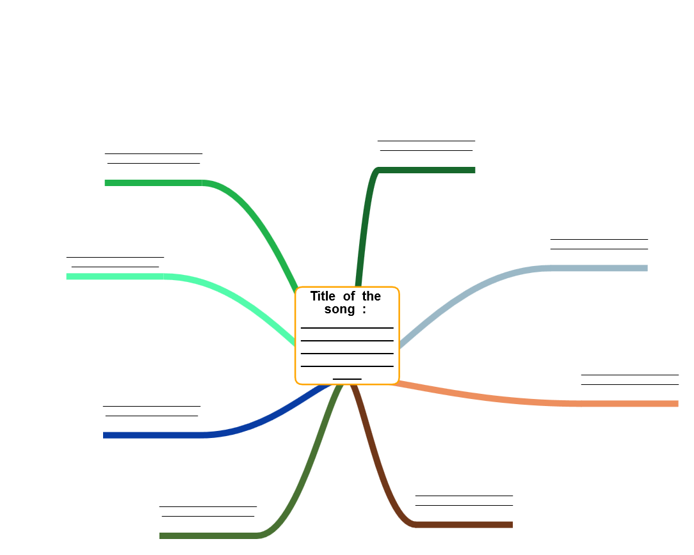
"We're Going To Be Friends"
Numbers, letters, learn to spell
Nouns, and books, and show and tell
Playtime we will throw the ball
Back to class, through the hall
Teacher marks our height against the wall
Teacher marks our height against the wall
Here we are, no one else
We walked to school all by ourselves
There's dirt on our uniforms
From chasing all the ants and worms
We clean up and now it's time to learn
We clean up and now it's time to learn
Fall is here, hear the yell
Back to school, ring the bell
Brand new shoes, walking blues
Climb the fence, books and pens
I can tell that we are gonna be friends
I can tell that we are gonna be friends
Walk with me, Suzy Lee
Through the park and by the tree
We will rest upon the ground
And look at all the bugs we found
Safely walk to school without a sound
Safely walk to school without a sound
Tonight I'll dream while I'm in bed
When silly thoughts go through my head
About the bugs and alphabet
And when I wake tomorrow I'll bet
That you and I will walk together again
I can tell that we are gonna be friends
Yes I can tell that we are gonna be friends.
We don't notice any time pass
We don't notice anything
We sit side by side in every class
Teacher thinks that I sound funny
But she likes the way you sing
Activity 2 :
Look at the comic strip at the top. Read the verses (=paragraphs) and put them in the correct order with the help of the comic strip.
Activity 3 :
Look at the words in italics. Try to guess (=imagine) the meaning (=sense) of these words (ne cherche pas sur internet!):
Height :
Dirt :
Fall :
Yell :
Fence :
Ground :
Bugs :
Thoughts :

In French :
Dis ce que tu as compris de la chanson : qui, quoi, où…. Et essaie de dire le message que veut donner le chanteur. Minimum 8 lignes

Send your work to englishprof25@hotmail.fr or put it in Discord (remise de travaux anglais)

