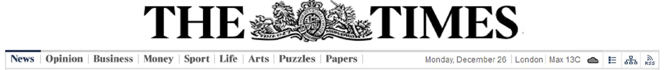
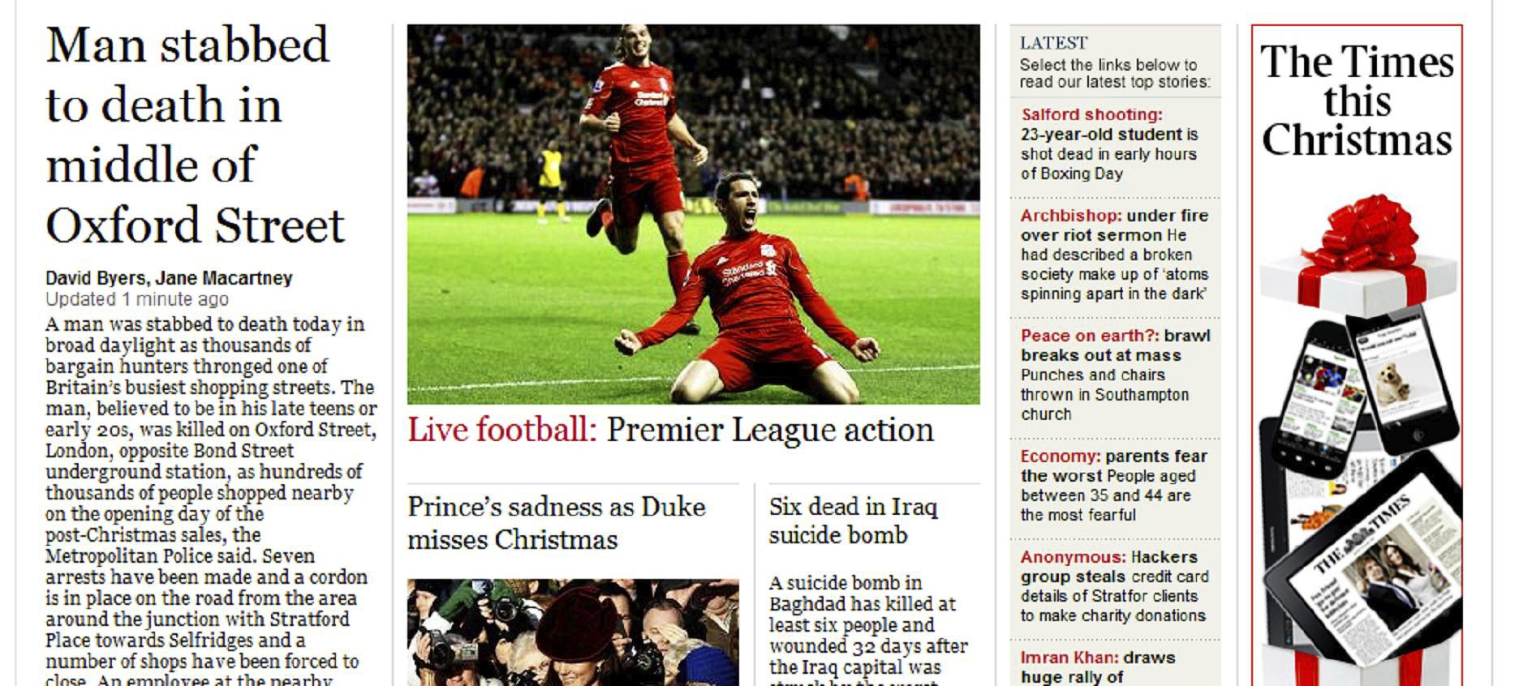
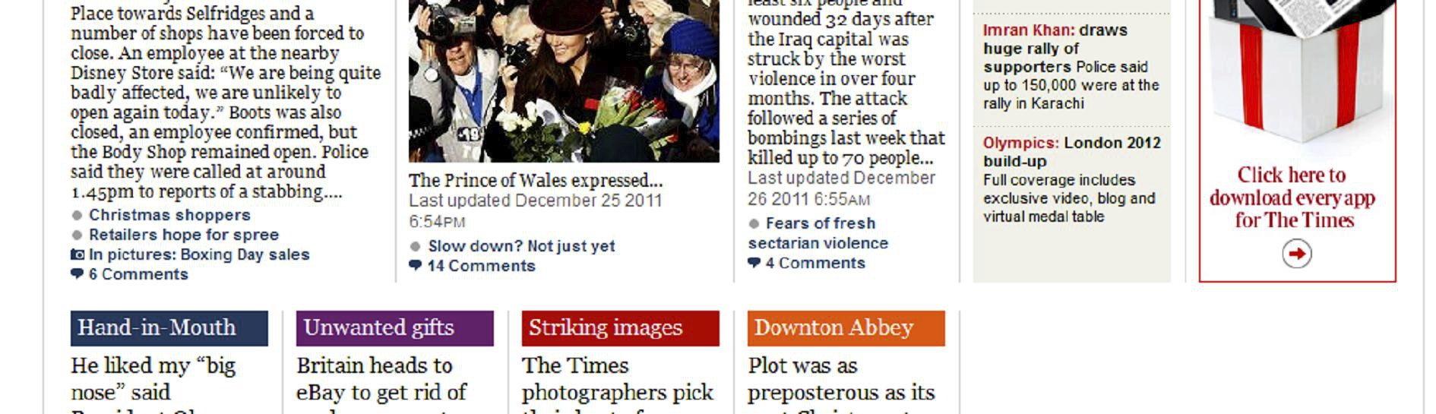
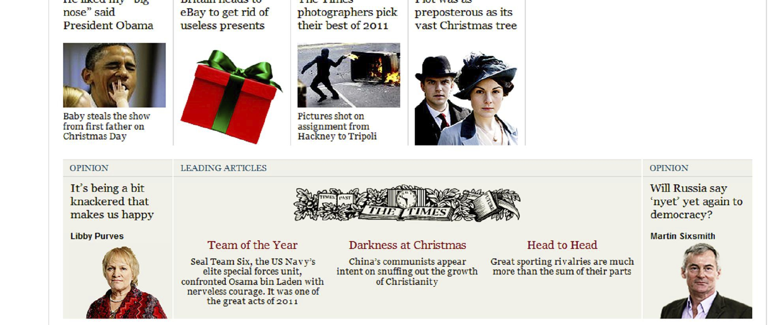
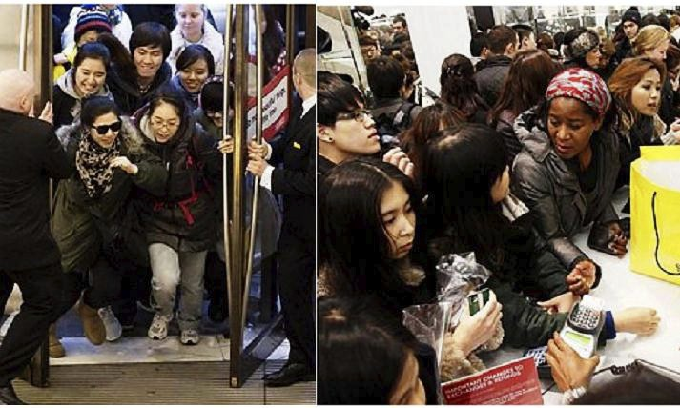

December 11th, 2001

Bank Robber
Left His ID With
Teller
The police is asking for help
catching a bank robber,
Timothy Burke, who struck
in West Bromwich. Police
say the suspect entered the
bank at 258 Turner St at
5:18 p.m. Friday. 'Biggest sales rush in history':
prices are cut by up to 80%
It wasn't the crime of the
century: he handed over his The robber drove away from
driver's license to a bank the bank at a high
teller in order to open an speed. He was last seen
account, but whoops!, said driving west on Green
he changed his mind and Greets Road.
was actually there to rob the
bank. He lifted up his shirt to
reveal a gun in his The suspect is described as a
waistband. The robber white male, mid to late 20's,
placed his right hand on the between 5-feet-7 and 6-feet-
gun and tapped on it, while 1, slim build, wearing a
demanding money from the baseball cap and sunglasses,
teller. The teller being blue jeans, black and white ÆPage 5
concerned for her personal sneakers.
safety placed the money on
the counter. The robber took He has criminal records,
the money - approximately with charges including hit
£100,000- off of the counter and run, and marijuana
and ran out of the bank possession. Authorities warn
through the same door he he is "armed and
originally entered through. dangerous." Police say the
best thing people can do to
help catch him is to keep
Witnesses saw him get into their eyes open. If you see
the driver's side of a late this male do not approach
model gray Mercury four- him but call 911.
door car.

Go to the site wordreference on google and look for the vocabulary in yellow :

Teller : struck : account :

Gun : waistband charges :

Now do the AP WRITTEN UNDERSTANDING document with this article.

