**Tool box**

**Vocabulary which can be useful :**

**Mohawk hairstyle** :  **leather jacket** : 

**Strict *= rigid = severe*** / **Town hall *= mairie*** / **weird *= strange***

**ancient *= old*** / **eccentric**

**Neighbours or strangers?**

British are said to be the opposite of the French. ***Unlike*** the French, they are eccentric and you can see a lot of people looking weird in London streets, for instance. Moreover, ***contrary to*** the French, they aren't good at cooking. A lot of people find British food disgusting, ***whereas*** the French cooking is said to be the best in the world. It's a matter of taste! ***On the one hand***, we can assume that our two countries are different ***but on the other hand,*** we are neighbours and are quite the same people! ***However***, this little battle doesn't seem to be over. So, let's fight against stereotypes ***instead of*** using them!

**Observe les mots soulignés.**

**De quoi s'agit-il? Qu'est ce qu'ils expriment? :**

Quels mots veulent dire :

|  |  |  |  |  |  |
| --- | --- | --- | --- | --- | --- |
| **Alors que** | **D’une part…**  **D’autre part** | **Contrairement à** | **Au contraire de(s)** | **Au lieu de** | **Cependant** |
|  |  |  |  |  |  |

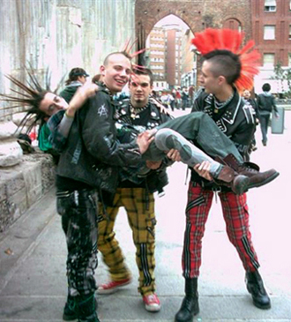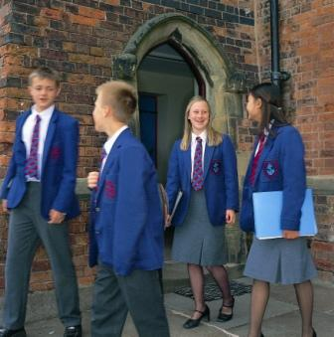

**Young punks British Students**

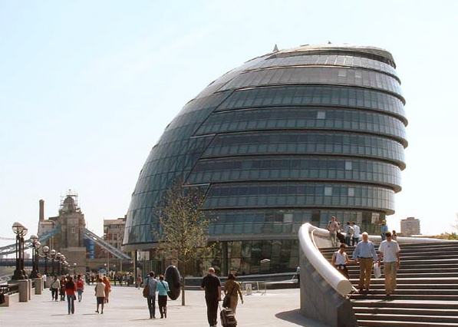 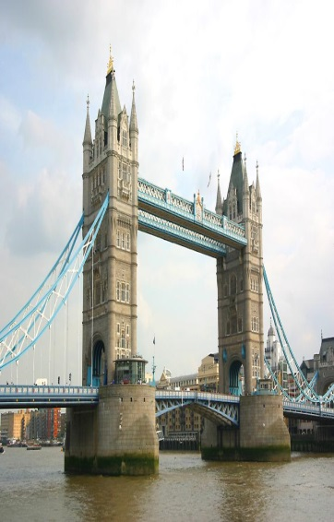

**London City Hall London Tower Bridge**

**Utilise les mots ou groupes de mots du tableau pour faire 5 phrases pour comparer les images ci-dessus :**