Video : British Symbols : Sky News report

- What type of document is it? Where is it taken from?
......................................................................................................................................................................................................................................................................................................................................................................
- Listen carefully and fill in the blanks:
If you could pick one thing which sums ___________ up to you, what would it be? We're being asked to __________ for the objects that most ___________ Englishness, to help create an on-line ___________ of English icons. The first __________ have been announced, so we can have a look at the highlights here.

- Watch the video and identify the top 9 English symbols. Write the corresponding symbol next to the pictures.

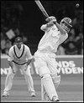
______________________
______________________

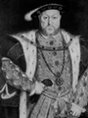

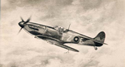

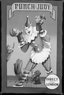
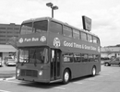
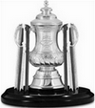
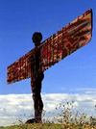
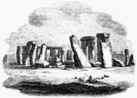
______________________
______________________
______________________
______________________
______________________
______________________
______________________
______________________
______________________
______________________
______________________
______________________
______________________
______________________

- What is the ninth symbol mentioned in the video? ______________________

- This video is about what symbolizes the British best through British eyes.
Which is for you what symbolizes the British best? Justify:

- Give what for you symbolizes France best. Then, compare France with Britain using the structures you have learnt. Make at least 5 sentences :

