Video : France vs UK :

- Watch the video and take notes :

- Organize your notes with the chart :

 | 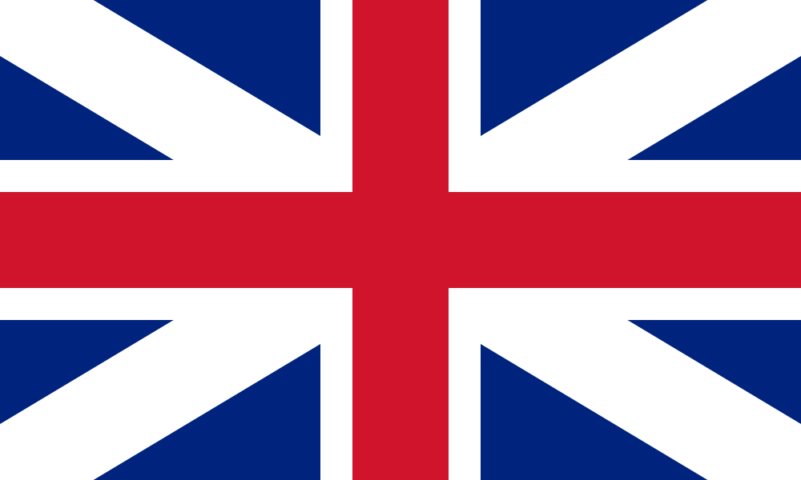
Education :  -  -  -  - | Education :  -  -  -  -
Employment :  -  -  -  - | Employment :  -  -  -  -
Health :  -  -  -  - | Health :  -  -  -  -
Happiness and life satisfaction :  -  -  -  - | Happiness and life satisfaction :  -  -  -  -
Safety and security :  -  -  -  - | Safety and security :  -  -  -  -

- Now with the elements from the chart, compare France and Britain using the expressions you have learnt in the lesson (activity 14 : unlike, whereas…) Make a paragraph :

