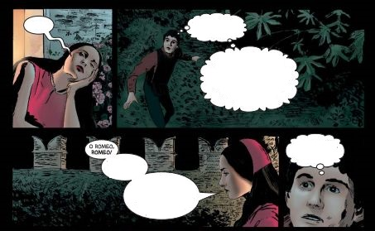
- With framindmap, make a mindmap of what this picture inspires you. Be as precise as possible :
https://framindmap.org/mindmaps/index.html
When you have finished paste the mindmap here :

- Imagine the conversation between the two characters :

- Read the following document : Highlight :
The characters
The places
The situation (what)

- 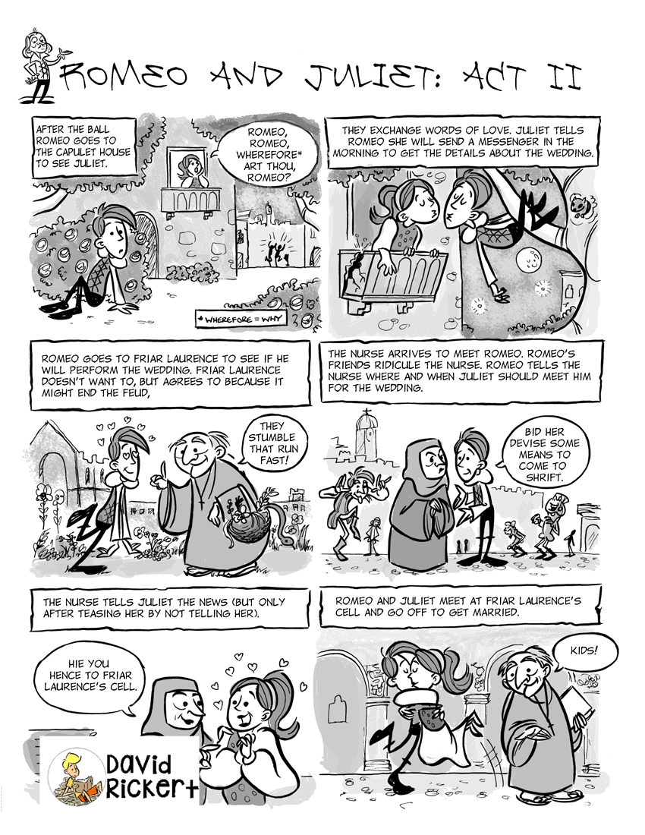
Now, make a paragraph :
Sum up the text and say, in your opinion what we are going to do in this lesson
(8 lines minimum) :

