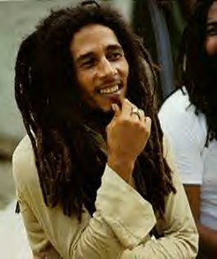
Biography : Bob Marley

Look at the text : it’s a biography of Bob Marley, but it’s not in the good order.
- Highlight 6 words you don’t understand and look for their signification on wordreference and copy it (recopie le mot et sa traduction ci-dessous) :
https://www.wordreference.com/fr/

- Underline in the text all the dates or time markers (marqueurs de temps)
- Finally reorder the text (remets les paragraphes dans l’ordre) to have a good biography of Bob Marley

The death of Bob Marley, aged 36, from cancer yesterday robs Jamaican music of its first ambassador, and popular

The Wailers' first album ‘Catch a Fire’ was released in 1973 and sold well.
Robert "Bob" Nesta Marley is the greatest ever reggae singer. He spread reggae and his message of love and unity to a worldwide audience.
Marley was born in 1945 in a small village in Jamaica to a white father and black mother.
He died of cancer in 1981, aged 36.
The racist bullying he received as a child had an impact on his songwriting. He left school at the age of 14 to make music.
It took several years before they became famous.
He was given a state funeral in Jamaica according to the Rastafari tradition.
In 1975, Marley released his breakthrough song ‘No Woman, No Cry’, still regarded as a classic today.
Marley left Jamaica for England in 1976 to record his ‘Exodus’ and ‘Kaya’ albums.
Another album followed a year later which included the song ‘I Shot The Sheriff’
He continues to be an important influence on today’s music.
He met members of his future band The Wailers at a jam session.

