Activity 16 : part 2
Gender Role stereotypes

Watch the video carefully and then do the following activities:
- First part of the video : Give with YOUR WORDS a definition of “gender role stereotype”:

- With the second part of the video, fill in the chart :
If we follow the gender role stereotypes, in the past :

Males were expected to be : | 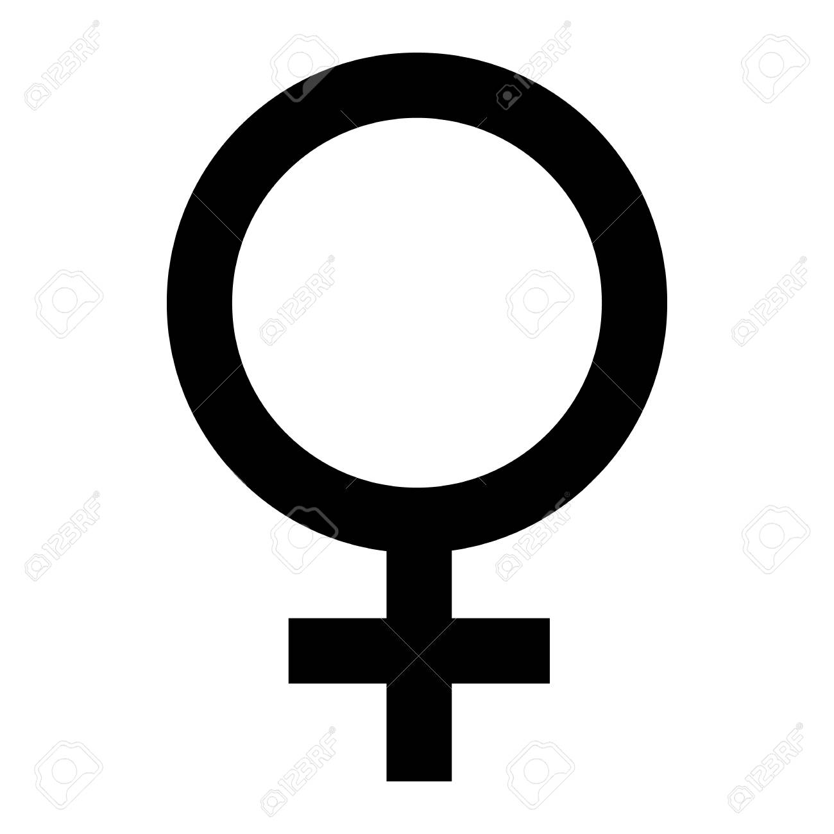Females were expected to be:

- Fill in the following sentence with VERBS or groups of VERBS from the video :

Because of the stereotypes shared by the media, people try to conform to what they see on TV. For example, they ______________________, or _________________________ or even _______________________________________.

- In terms of EMOTIONS :
Males were expected to be (or not) : | Females were expected to be (or not) :

- At the end of the video, it is said that fortunately, the situation has changed : explain it in YOUR WORDS :

- Finally give your opinion on gender role stereotype : use all the expressions you worked on with activity 16, part 1 :

