Article :
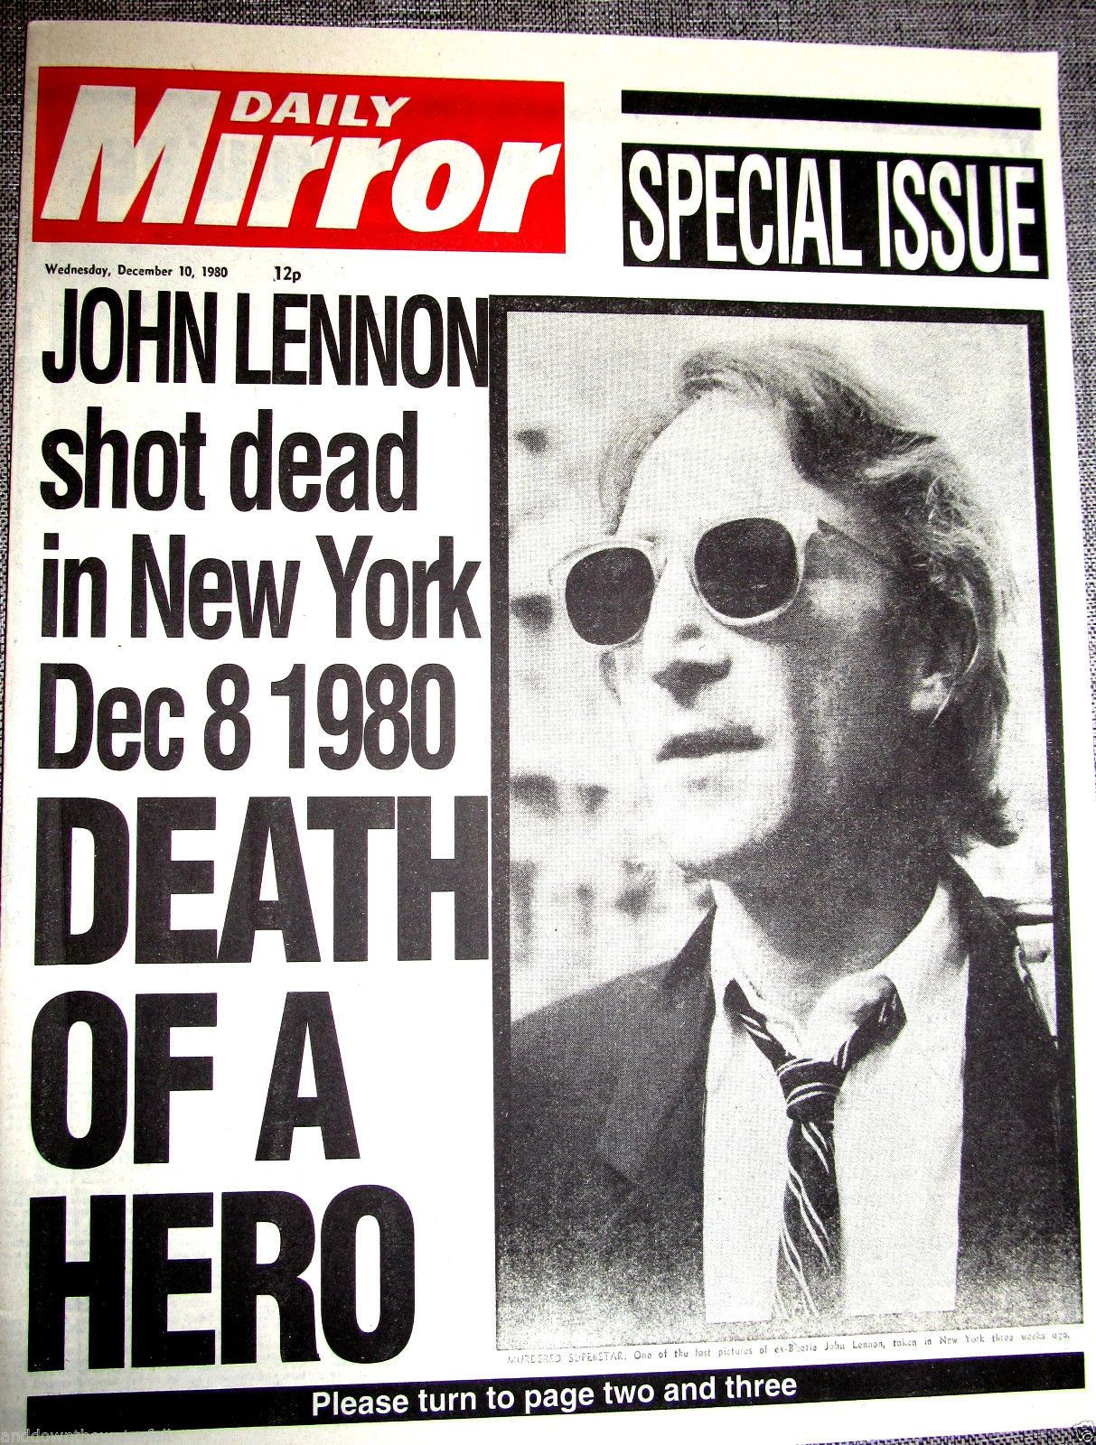

December 9, 1980
Yesterday in New York, a madman assassinated John Lennon, the world-famous singer-songwriter. Millions of fans all around the world watched in horror as the reporter announced the news on television.
John Lennon was born on October 9, 1940 in Liverpool, England. From 1960 to 1970, he played with the Beatles, the most successful rock group in history. The Beatles travelled all around the world from 1983 to1970 and they played in hundreds of different places. Then in 1970, the Beatles separated. At the time they didn't explain why. Lennon married Yoko Ono in1969 and he moved to the United States with his family. He composed and recorded songs like I Don't Want to Be a Soldier and the very famous song Imagine during the 70s.
For the whole world, Lennon symbolized peace and love.

December 9, 1980
Yesterday in New York, a madman assassinated John Lennon, the world-famous singer-songwriter. Millions of fans all around the world watched in horror as the reporter announced the news on television.
John Lennon was born on October 9, 1940 in Liverpool, England. From 1960 to 1970, he played with the Beatles, the most successful rock group in history. The Beatles travelled all around the world from 1983 to1970 and they played in hundreds of different places. Then in 1970, the Beatles separated. At the time they didn't explain why. Lennon married Yoko Ono in1969 and he moved to the United States with his family. He composed and recorded songs like I Don't Want to Be a Soldier and the very famous song Imagine during the 70s.
For the whole world, Lennon symbolized peace and love.

