My friend was ...

My friend was strong and beautiful.
One day, he met a girl friend.
They fell in love
Deeply in love!
They had a lot of success!
He offered her a new ring.
She was moved!
She offered him a new bike.
He was so happy and delighted!
They made love...
and got a little kid!
Their kid was ugly and so weak that
people made fun of him
he got so depressed
that he committed suicide!

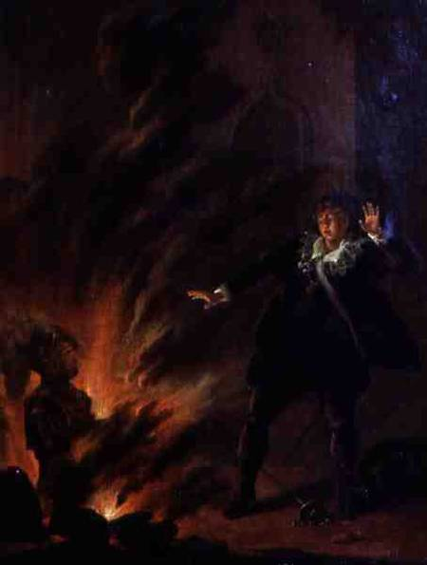
Collège Lucie Aubrac 5°1
Evan Roche and Marc da Costa

Hamlet and the gost of his father
Moscow Pushkin Museum

