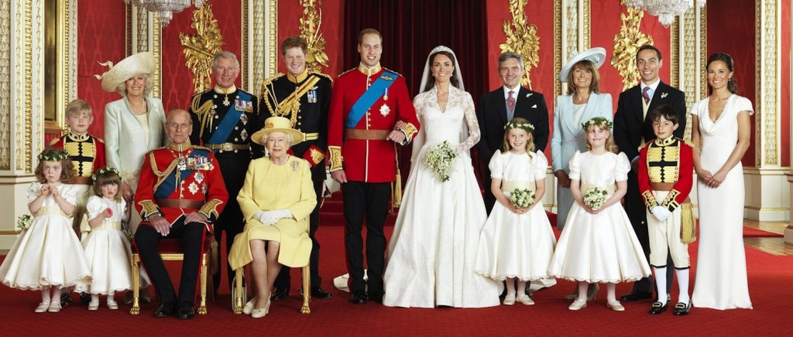

Number in line to the throne.

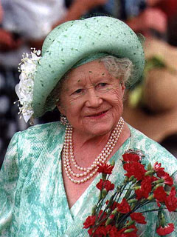

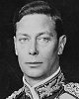

**Elizabeth Bowes –Lyon** **( 1900 - 2002)**

**( = Queen Mother )**

**King George VI ( 1895 – 1952)**

**Reign : 1936- 1952**

**2 CHILDREN**

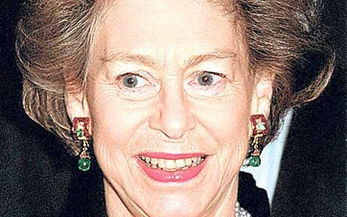

1947

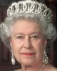

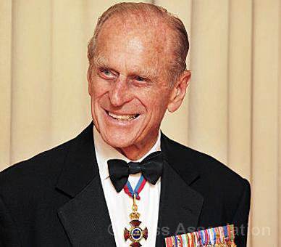

**Philip Mountbatten**

**( 1921 - )**

**Duke of Edinburgh**

**Queen Elizabeth II ( 1926 - )**

**Reign : 1952 -**

**In 2013, she’s been the Queen for 61 years.**

**Princess Margaret ( 1930- 2002 )**

4 children

M 1981

D 1996

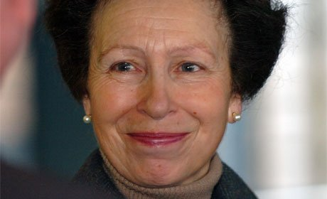

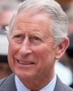

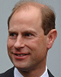

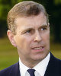

2005

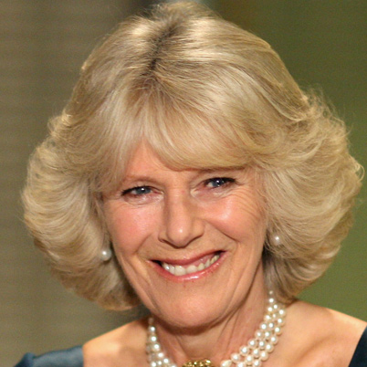

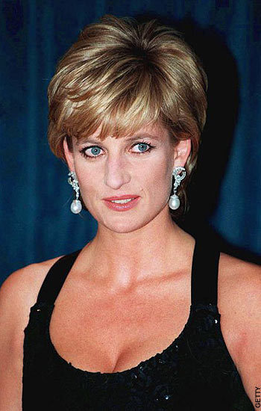

Prince Charles 1st

( 1948 - )

Prince of Wales

Prince Andrew

( 1960- )

Princess Anne

( 1950 - )

Lady Diana Spencer

( 1961 – 1997 )

died in a car crash in Paris.

Camilla Parker Bowles

( 1947 - )

Duchess of Cornwall

Prince Edward

( 1964 - )

2 children

2011

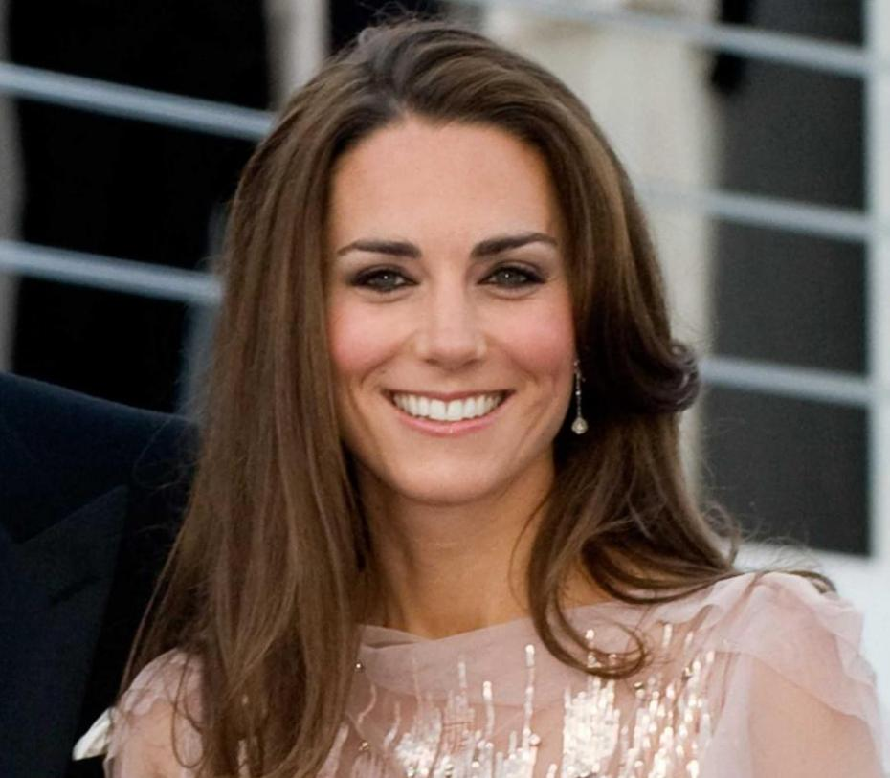

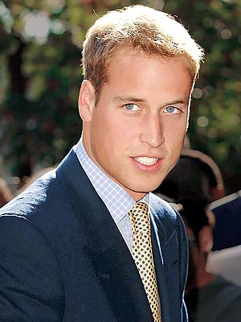

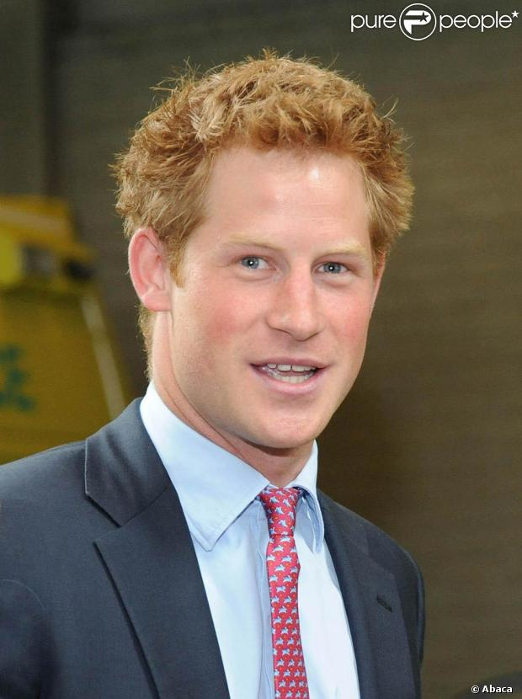

Prince Harry 4th

( 1984 - )

Prince Henry of Wales

Prince William 2nd

( 1982 - )

Duke of Cambridge

Kate Middleton

( 1982 - )

Duchess of Cambridge

One child

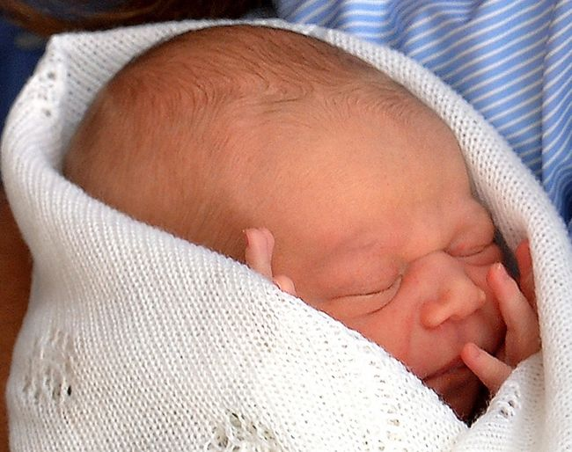

Prince George Alexander Louis 3rd

(born on July 22nd in 2013