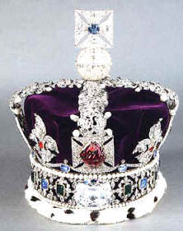
The Imperial State Crown is one of the Crown Jewels of the United Kingdom and symbolises the sovereignty of the monarch. The crown has existed in several versions since the 15th century. The modern version of the Imperial State Crown is of a design somewhat similar to that of St Edward's Crown, but shorter and encrusted with jewels: it includes a base of four crosses pattée alternating with four fleurs-de-lis, above which are four half-arches surmounted by a cross. Inside is a purple velvet cap with an ermine border. The Imperial State Crown includes many precious gems, including 2,868 diamonds, 273 pearls, 17 sapphires, 11 emeralds, and 5 rubies. [1]
The crown includes several famous jewels: the cross at the top is set with a stone known as St. Edward's Sapphire, a sapphire taken from the ring (or possibly coronet) of Edward the Confessor; the Black Prince's Ruby (actually a spinel) is set on the front cross pattée; the famous Cullinan II, or Second Star of Africa, is set on the front of the band, replacing, in 1909, the 104-carat (21 g) Stuart Sapphire, which now sits at the back.[1] The crown also contains Queen Elizabeth’s Pearls.
The Crown is 31.5 centimetres (12.4 in) tall and weighs .91 kilograms (2.0 lb).[2] When not in use, it is kept with the other Crown Jewels on display at the Jewel House in the Tower of London.[2] The frames of the old Imperial State Crowns of Kings George I, George IV and Queen Victoria, among others, are also kept in the Tower.

