Halloween Workshop

Name: ____________________________________________________ Date: ____________

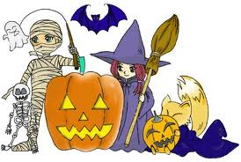
I . Reading Comprehension:
On 31st October, the night before All Saints' Day, Americans, Scots and Irish people celebrate Hallowe'en : they dress up as witches and ghosts, have parties, tell ghost stories and play games. Hallowe'en is the second biggest celebration in America after Christmas. Every year Americans spend more than $2.5 billion on sweets, cards, costumes and decorations. More than 66 per cent of houses are decorated.
Hallowe'en was originally a Celtic festival called Samhain celebrating the New Year. Celts believed that the dead could come back to the world on that day. So people wore costumes like witches and ghosts. Today, Irish and Scottish kids dress up for Hallowe'en, and they visit houses and sing a song or tell a joke. If they don't get sweets, they play a trick.
Irish and Scottish immigrants took Hallowe'en to America. American kids started celebrating Halloween in the 1950s.
Questions:
1. What’s the origin of Halloween?
_____________________________________________________________________________________
2. What’s the meaning of trick or treat?
_____________________________________________________________________________________
3. What are some typical costumes for Halloween?
_____________________________________________________________________________________
II. Write the Words Below:

