A Christmas Carol
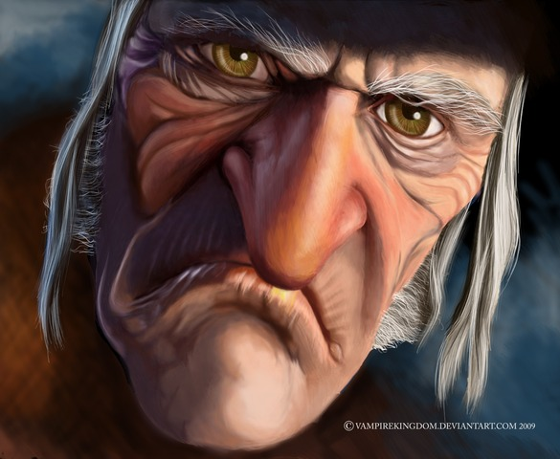
(Charles Dickens)
1/ Identify the document and its goal: _________________________________________________
________________________________________________________________________________
2/ Look at the old man’s portrait and describe him. His name is Scrooge. How does he look?
________________________________________________________________________________
________________________________________________________________________________
3/ Watch the beginning and imagine what is behind the door (trying to open it): _______________
________________________________________________________________________________
4/ Who is this creature, eventually (= finalement)? ______________________________________
5/ What is the old man’s “second chance”? Imagine why. _________________________________
________________________________________________________________________________
----------------------------------------------------------------------------------------------------------------------------

A Christmas Carol
(Charles Dickens)
1/ Identify the document and its goal: _________________________________________________
________________________________________________________________________________
2/ Look at the old man’s portrait and describe him. His name is Scrooge. How does he look?
________________________________________________________________________________
________________________________________________________________________________
3/ Watch the beginning and imagine what is behind the door (trying to open it): _______________
________________________________________________________________________________
4/ Who is this creature, eventually (= finalement)? ______________________________________
5/ What is the old man’s “second chance”? Imagine why. _________________________________
________________________________________________________________________________

KEY
A Christmas Carol
(Charles Dickens)
1/ Identify the document and its goal: The document is a trailer. It aims at making people want to see the film.
2/ Look at the old man’s portrait and describe him. His name is Scrooge. How does he look? The old man looks nasty, grumpy and mean. He has got a long nose, a protruding chin and bushy eyebrows. His teeth are grey and look dirty. He has got wrinkles.
SCROOGE = grippe-sou, rapiat, radin.
3/ Watch the beginning and imagine what is behind the door (trying to open it): I guess / I suppose / maybe it is…
4/ Who is this creature, eventually (= finalement)? It is a ghost.
5/ What is the old man’s “second chance”? His second chance is to get his life right, probably because he is not so good in his actual / present life....

