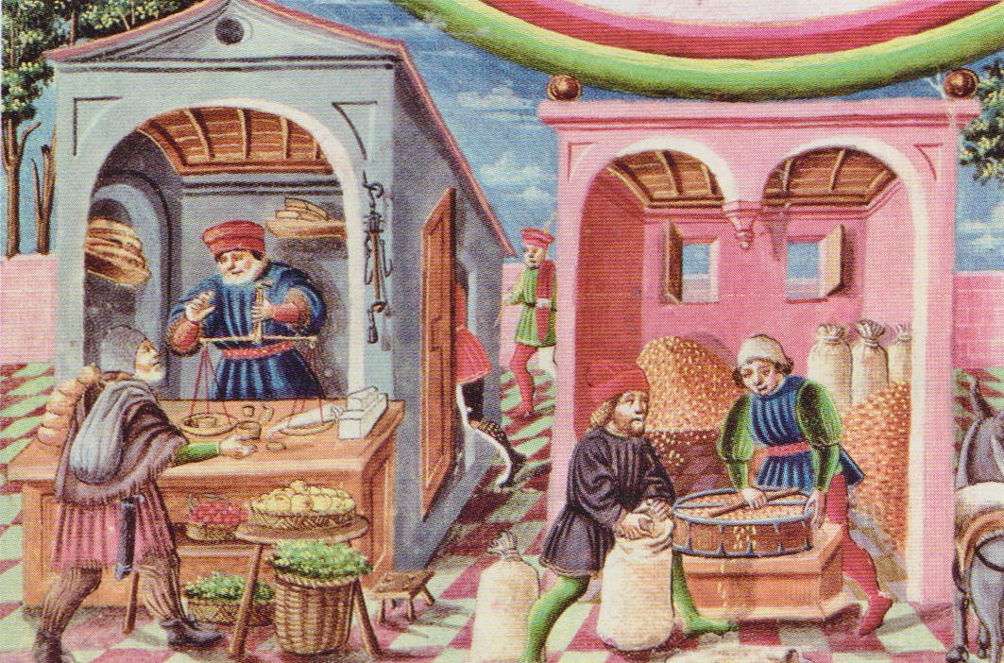
5H4

INTRODUCTION

A2

M. Desmares

C7.1 / Poser des questions, se poser des questions sur un problème, une situation précise
Bordas 2016

Doc. 1 / L’essor des activités urbaines,
miniature, XVe siècle, Lyon

1- …………………………………………………………………………………………………………………………………………………………………………………………………………
1- …………………………………………………………………………………………………………………………………………………………………………………………………………
2- …………………………………………………………………………………………………………………………………………………………………………………………………………
1- …………………………………………………………………………………………………………………………………………………………………………………………………………
3- …………………………………………………………………………………………………………………………………………………………………………………………………………
1- …………………………………………………………………………………………………………………………………………………………………………………………………………
4- …………………………………………………………………………………………………………………………………………………………………………………………………………
1- …………………………………………………………………………………………………………………………………………………………………………………………………………
5- …………………………………………………………………………………………………………………………………………………………………………………………………………
1- …………………………………………………………………………………………………………………………………………………………………………………………………………
6- …………………………………………………………………………………………………………………………………………………………………………………………………………
1- …………………………………………………………………………………………………………………………………………………………………………………………………………

Correction

1- …………………………………………………………………………………………………………………………………………………………………………………………………………
1- …………………………………………………………………………………………………………………………………………………………………………………………………………
2- …………………………………………………………………………………………………………………………………………………………………………………………………………
1- …………………………………………………………………………………………………………………………………………………………………………………………………………
3- …………………………………………………………………………………………………………………………………………………………………………………………………………
1- …………………………………………………………………………………………………………………………………………………………………………………………………………
4- …………………………………………………………………………………………………………………………………………………………………………………………………………
1- …………………………………………………………………………………………………………………………………………………………………………………………………………
5- …………………………………………………………………………………………………………………………………………………………………………………………………………
1- …………………………………………………………………………………………………………………………………………………………………………………………………………
6- …………………………………………………………………………………………………………………………………………………………………………………………………………
1- …………………………………………………………………………………………………………………………………………………………………………………………………………

