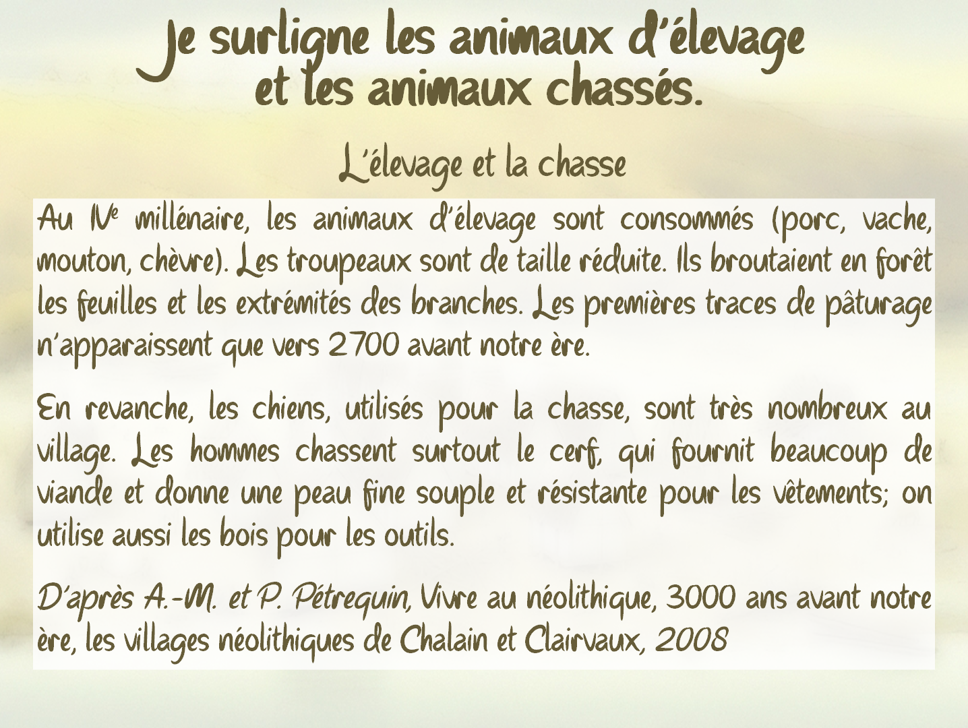
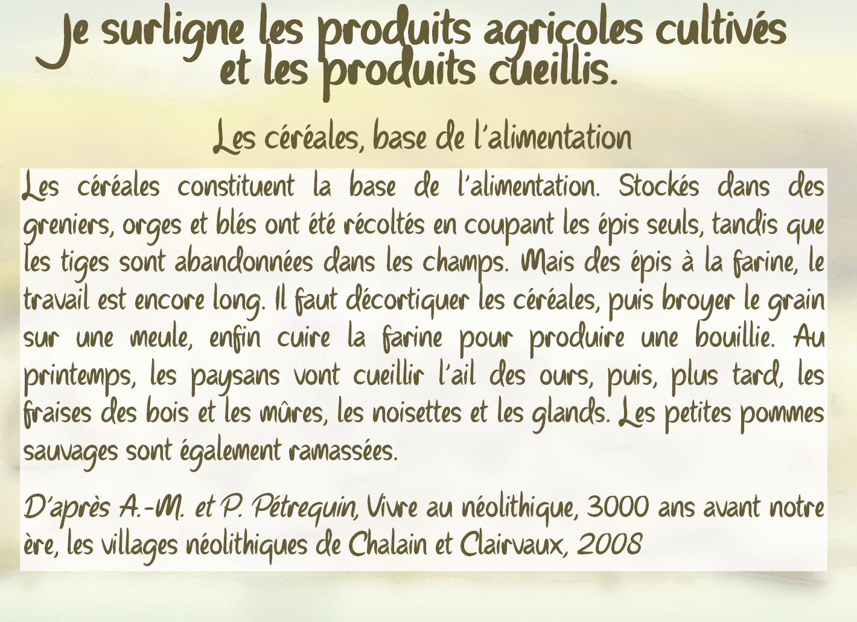
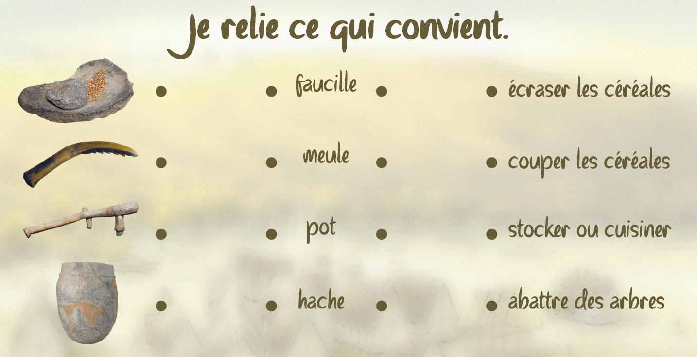
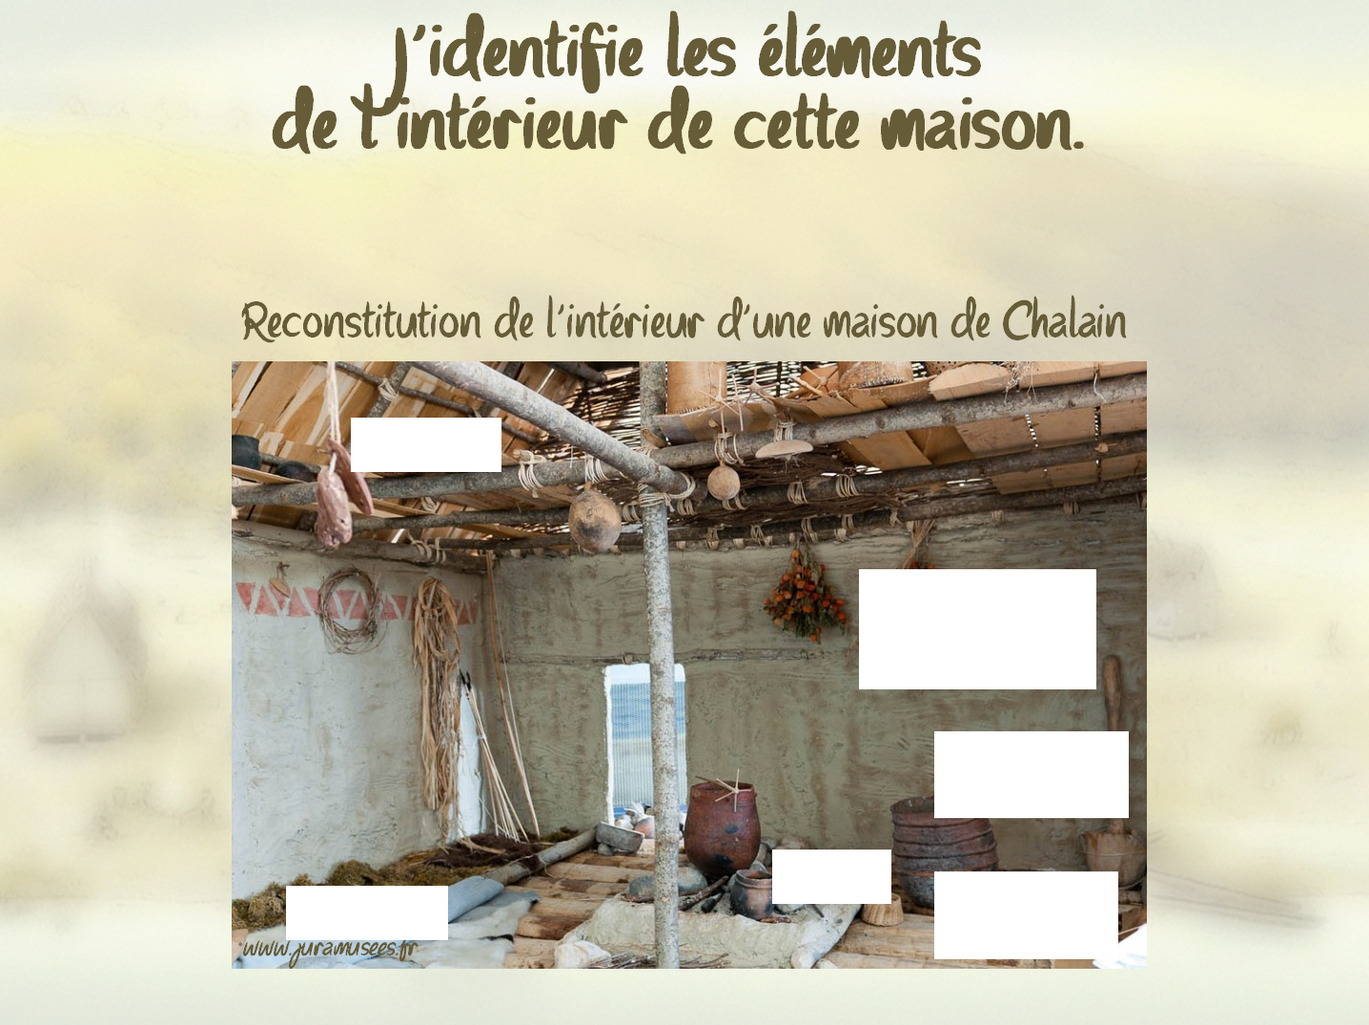
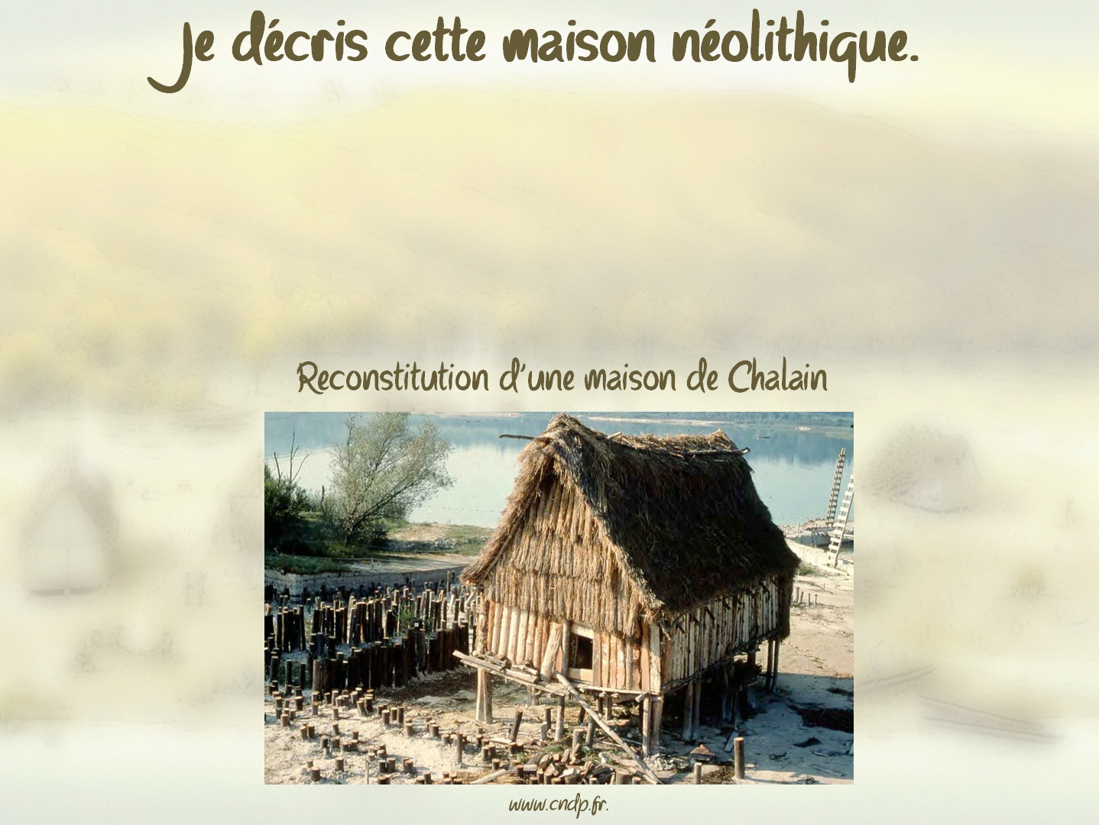
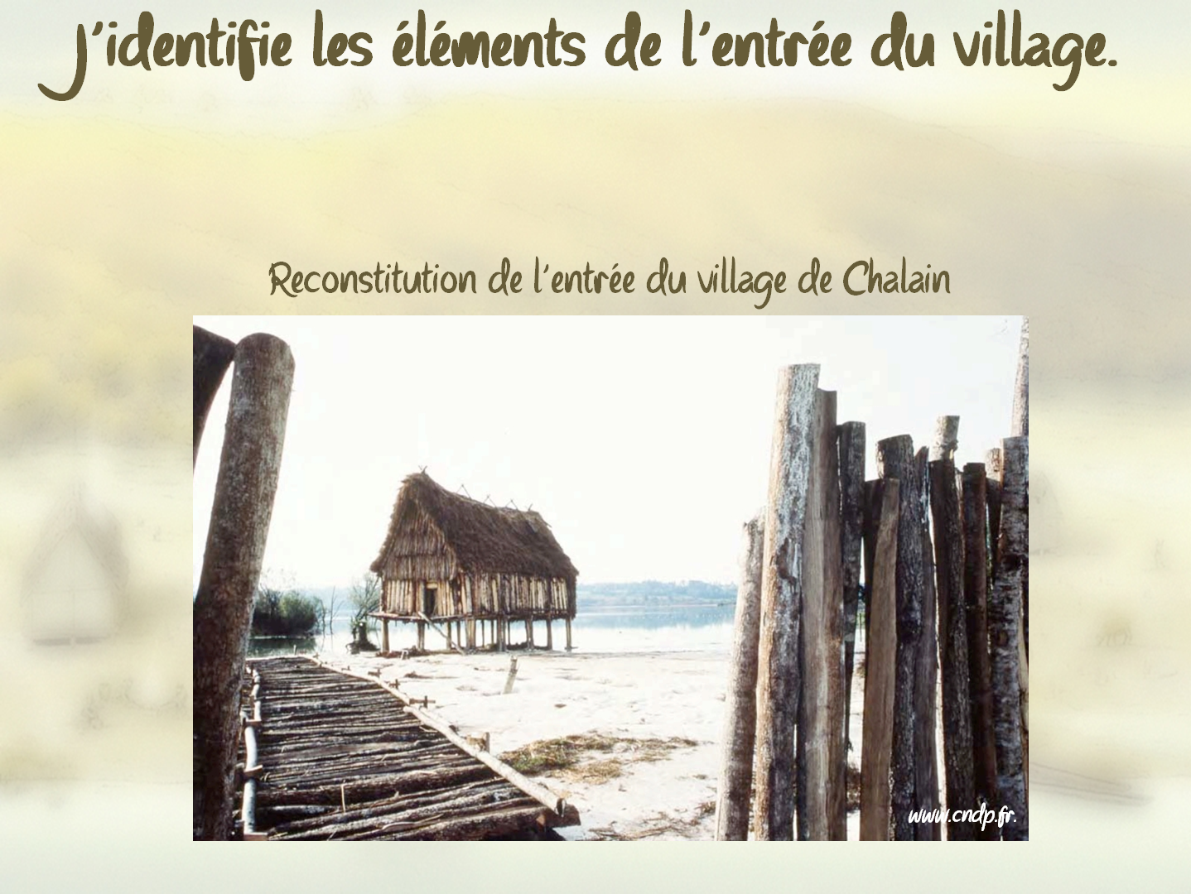
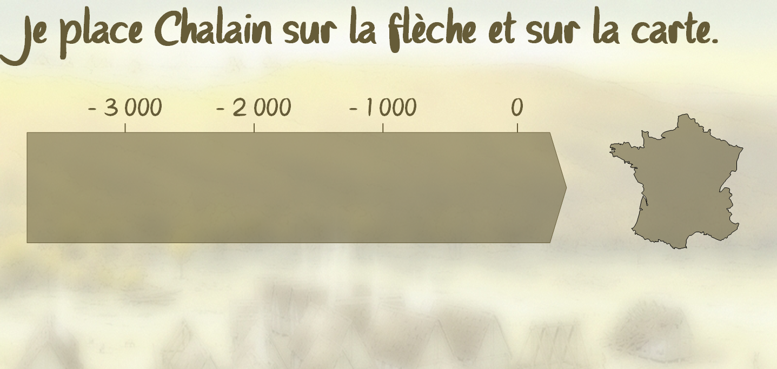
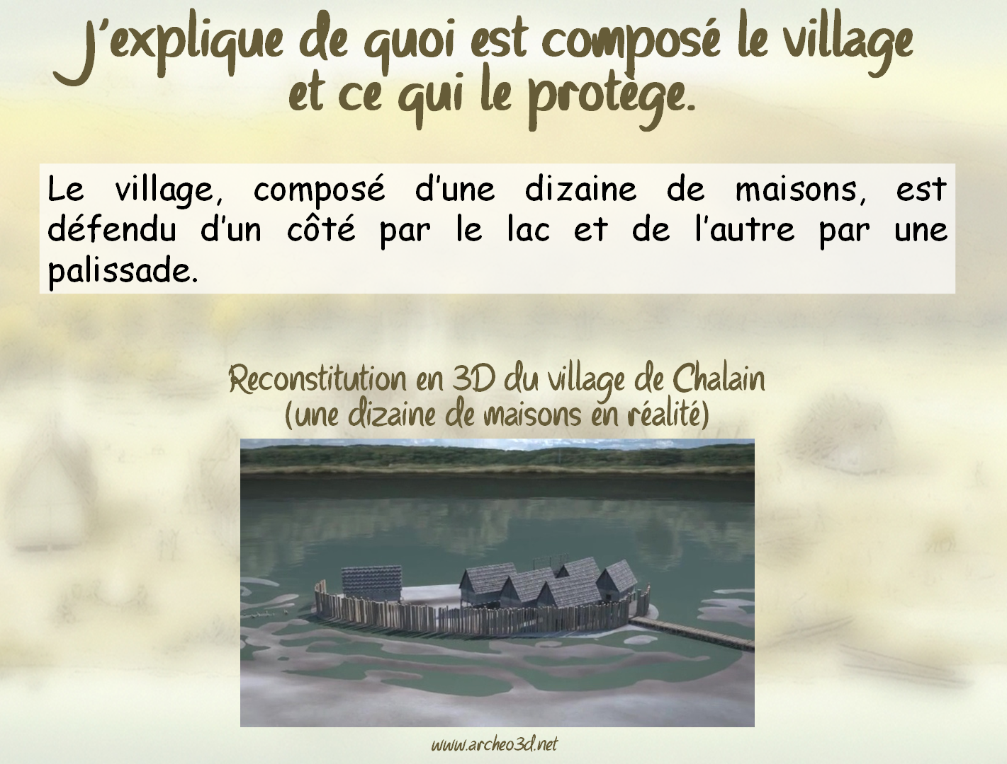
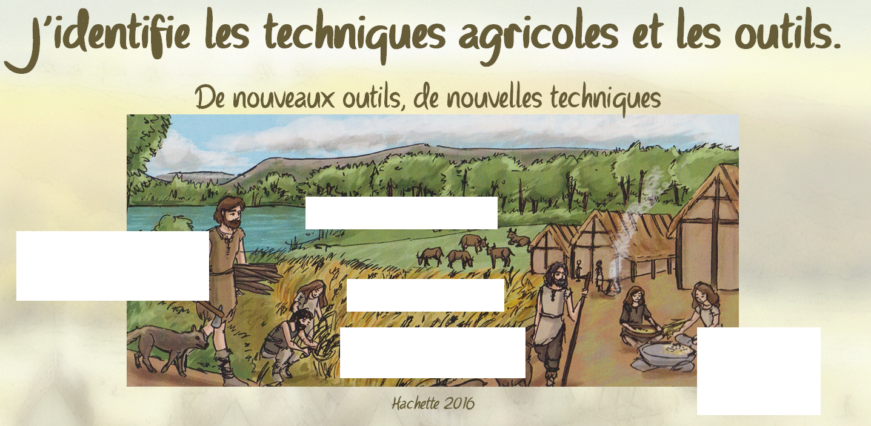
6H2

CHALAIN, UN VILLAGE NEOLITHIQUE

A2

M. Desmares

……………………………………………………………………………………………………………………....
……………………………………………………………………………………………………………………....
……………………………………………………………………………………………………………………....

……………………………………………………………………………………………………………………....
……………………………………………………………………………………………………………………....
……………………………………………………………………………………………………………………....

