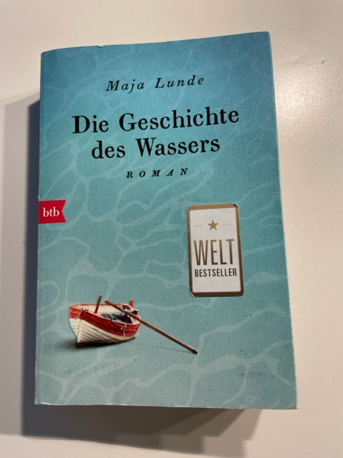

During the Covid Pandemic year, in the time of mostly no live lessons, it was forbidden to meet in groups of different classes. The problem was, our students of the club were from different classes, therefore the club didn`t take place.
In order to give them an idea of our topic and to give them a possibility to deal with the topic , I bought the book “ Die Geschichte des Wassers”, the german translation of the book “Bla” from Maja Lunde. All students of the club got it as a present and should read it in their free time. For example in the summer holidays.
The book tells the story of missing water in the world in episods of two different years (2017 and 2041) and the problems having no water.

