Malala Yousafzai addresses United Nations Youth Assembly
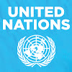
https://www.youtube.com/watch?v=3rNhZu3ttIU

United Nations, New York, 12 July 2013 – Education activist Malala Yousafzai marks her 16th birthday, on Friday, 12 July 2013 at the United Nations by giving her first high-level public appearance and statement on the importance of education.
Malala became a public figure when she was shot by the Taliban while travelling to school last year in Pakistan -- targeted because of her committed campaigning for the right of all girls to an education. Flown to the United Kingdom to recover, she is now back at school and continues to advocate for every child's right to education.
In support of the UN Secretary-General's Global Education First Initiative (GEFI), on 12 July -- declared as "Malala Day" -- the President of the UN General Assembly and the UN Special Envoy for Global Education with the support of A World at School initiative are organizing the UN Youth Assembly, where more than 500 young leaders from around the world will convene to accelerate the goal of getting all children, especially girls, in school and learning by 2015.

*******************************************************************************
In the name of God, The Most Beneficent, The Most Merciful.
Honourable UN Secretary General Mr Ban Ki-moon,
Respected President General Assembly Vuk Jeremic
Honourable UN envoy for Global education Mr Gordon Brown,
Respected elders and my dear brothers and sisters;
Today, it is an honour for me to be speaking again after a long time. Being here with such honourable people is a great moment in my life.
I don’t know where to begin my speech. I don’t know what people would be expecting me to say. But first of all, thank you to God for whom we all are equal and thank you to every person who has prayed for my fast recovery and a new life.
[…]
Dear brothers and sisters, do remember one thing. Malala day is not my day. Today is the day of every woman, every boy and every girl who have raised their voice for their rights. There are hundreds of Human rights activists and social workers who are not only speaking for human rights, but who are struggling to achieve their goals of education, peace and equality. Thousands of people have been killed by the terrorists and millions have been injured. I am just one of them.
So here I stand.... one girl among many. I speak – not for myself, but for all girls and boys. I raise up my voice – not so that I can shout, but so that those without a voice can be heard.
Those who have fought for their rights. Their right to live in peace. Their right to be treated with dignity. Their right to equality of opportunity. Their right to be educated.
Dear Friends, on the 9th of October 2012, the Taliban shot me on the left side of my forehead. They shot my friends too. They thought that the bullets would silence us. But they failed. […]
I do not even hate the Talib who shot me. Even if there is a gun in my hand and he stands in front of me. I would not shoot him. This is the compassion that I have learnt from Muhammad-the prophet of mercy, Jesus Christ and Lord Buddha. This is the legacy of change that I have inherited from Martin Luther King, Nelson Mandela and Muhammad Ali Jinnah. This is the philosophy of non-violence that I have learnt from Gandhi Jee, Bacha Khan and Mother Teresa. And this is the forgiveness that I have learnt from my mother and father. This is what my soul is telling me, be peaceful and love everyone.
Dear sisters and brothers, we realise the importance of light when we see darkness. We realise the importance of our voice when we are silenced. In the same way, when we were in Swat, the north of Pakistan, we realised the importance of pens and books when we saw the guns.
The wise saying, “The pen is mightier than sword” was true. The extremists are afraid of books and pens. The power of education frightens them. They are afraid of women. The power of the voice of women frightens them. And that is why they killed 14 innocent medical students in the recent attack in Quetta. And that is why they killed many female teachers and polio workers in Khyber Pukhtoon Khwa and FATA. That is why they are blasting schools every day. Because they were and they are afraid of change, afraid of the equality that we will bring into our society.
[…]
Honourable Secretary General, peace is necessary for education. In many parts of the world especially Pakistan and Afghanistan; terrorism, wars and conflicts stop children to go to their schools. We are really tired of these wars. Women and children are suffering in many parts of the world in many ways. In India, innocent and poor children are victims of child labour. Many schools have been destroyed in Nigeria. People in Afghanistan have been affected by the hurdles of extremism for decades. Young girls have to do domestic child labour and are forced to get married at early age. Poverty, ignorance, injustice, racism and the deprivation of basic rights are the main problems faced by both men and women.
Dear fellows, today I am focusing on women’s rights and girls’ education because they are suffering the most. There was a time when women social activists asked men to stand up for their rights. But, this time, we will do it by ourselves. I am not telling men to step away from speaking for women’s rights, rather I am focusing on women to be independent to fight for themselves.
Dear sisters and brothers, now it's time to speak up.
So today, we call upon the world leaders to change their strategic policies in favour of peace and prosperity.
We call upon the world leaders that all the peace deals must protect women and children’s rights. A deal that goes against the dignity of women and their rights is unacceptable. We call upon all governments to ensure free compulsory education for every child all over the world. We call upon all governments to fight against terrorism and violence, to protect children from brutality and harm. We call upon the developed nations to support the expansion of educational opportunities for girls in the developing world.
We call upon all communities to be tolerant – to reject prejudice based on cast, creed, sect, religion or gender. To ensure freedom and equality for women so that they can flourish. We cannot all succeed when half of us are held back.
We call upon our sisters around the world to be brave – to embrace the strength within themselves and realise their full potential.
Dear brothers and sisters, we want schools and education for every child’s bright future.
We will continue our journey to our destination of peace and education for everyone. No one can stop us. We will speak for our rights and we will bring change through our voice. We must believe in the power and the strength of our words. Our words can change the world. Because we are all together, united for the cause of education. And if we want to achieve our goal, then let us empower ourselves with the weapon of knowledge and let us shield ourselves with unity and togetherness.
Dear brothers and sisters, we must not forget that millions of people are suffering from poverty, injustice and ignorance. We must not forget that millions of children are out of schools. We must not forget that our sisters and brothers are waiting for a bright peaceful future. So let us wage a global struggle against illiteracy, poverty and terrorism and let us pick up our books and pens. They are our most powerful weapons.
One child, one teacher, one pen and one book can change the world.
Education is the only solution. Education First.

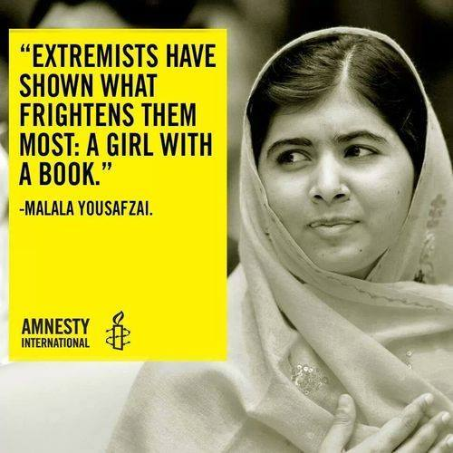

The 16-year-old education campaigner has been named an

Amnesty International Ambassador of Conscience
September 2013

